DEPARTMENT OF MINNESOTA



MINNESOTA

Administrative Manual
&
Membership/Forms Appendix

UTILIZE THE CHAIN OF COMMAND

The Department Headquarters Team is always ready to assist Posts and Districts in every way possible to help accomplish all of your membership and program goals.

Department Headquarters receives phone calls, letters and emails daily from Legionnaires seeking help on any number of issues. In most cases, we are able to take care of the problem or refer the question to the proper parties who can help. But problems can arise when questions are brought to us on matters which headquarters has no jurisdiction. As a basic “rule of thumb”, Department can most readily help with issues related to membership, American Legion programs, Legionnaire Insurance programs and veterans’ benefits questions. Headquarters can advise with Post elections, problems with operating a Post business (bar or restaurant) or concerns of a personal or civil nature. The question will be asked, what does your Constitution and Bylaws state and are they followed? These matters can best be resolved at the Post, County and District levels, or in some cases with help from civil authorities.

A second “rule of thumb” to bear in mind is that questions can often be most easily answered by using the “chain of command" just like in the military. Effective use of the chain of command increases efficiency at all levels of the organization. Your Post’s first resource for answers is always your District officers. They often have the answer readily available on issues like Post elections and the conduct of meetings. By directing a problem to the District organization, District officers will be better equipped to assist other Posts with similar questions.
Using the chain of command allows each level of the organization to become better informed as to the activities within the Districts across the state. All levels become better equipped to handle challenges. Your Constitution and Bylaws and Manuals, such as this one, distributed at Packet Pickup, also hold many answers. All resources are available at mnlegion.org.

Questions should not be posed directly to the National Headquarters. Directing questions to the National headquarters will only delay receiving a direct answer. National headquarters in Indianapolis simply refers questions back to Department headquarters, who refers it to the appropriate District officers who then provides guidance to the Post. This is all in the interest of promoting efficient operations and maintaining the chain of command. So, whenever possible, use the chain of command and the Department Directory. The directory is available on our website at mnlegion.org; under the ‘Department” tab click on ‘Department Officers’.
The Department Headquarters Team is always ready, willing and able to assist in every way we can. We urge you to use mnlegion.org as a resource.

REMEMBER: The most current information regarding Programs and Forms will be found on the Department of Minnesota Website at mnlegion.org.

Michael Maxa
Department Adjutant

The American Legion, Department of Minnesota ~ 20 West 12th St, Room 300A, St Paul, MN 55155-2000
Phone 651-291-1800 Toll Free 866-259-9163 Fax 651-291-1057
Email: department@mnlegion.org or find a listing of employee emails at the Department website: mnlegion.org
Manual created 2022, Updated 2024

HOW TO USE THE ADMINISTRATIVE & MEMBERSHIP MANUAL

THIS MANUAL IS TO BECOME A PERMANENT DOCUMENT OF YOUR POST, TO BE PUT IN A BINDER AND HANDED OVER TO NEW LEADERSHIP AS CHANGES OCCUR. IT SHOULD BE AT EACH POST MEETING, AS IT IS LAID OUT MONTHLY AS TO WHAT NEEDS TO BE DONE AND WHEN.

This manual is provided for the Post and District Commanders & Adjutants to use in conjunction with National Publications such as the Post Adjutants Manual, Officers Guide and Manual of Ceremonies. This manual is intended as a guide to assist you with handling The American Legion business affairs of the Post or District. It provides efficient service to your members, provides for two-way communication regarding administrative matters pertaining to reports and programs and is also available at mnlegion.org.

This manual is divided into monthly sections. Included in each month is a Consolidated Post Report (CPR) monthly worksheet which, if used monthly, will make it very easy to compile the National CPR report that is due June 1st. Reporting this information is crucial to The American Legion, as the information is used to show the legitimacy of the organization and allows for the continuation of the 501c19 non-profit status. The other form included monthly is the Renew & Rejoin Report which is used to track activities with those members that have not renewed or that have expired or belong to Post 1982. It is intended that you bring this manual to every meeting of the Post and District to work together as a team to complete reports, programs and administrative duties. It may benefit your team, for example, to work on the items due in July and August during the June meeting.
Working in advance allows your team to anticipate needs and gather volunteers to accomplish the mission.

For the more experienced Officers this may seem tedious; however, we have to work with new officers at all
Posts and Districts and this manual will help to standardize the Department as whole.

Please make the Department & National Publications available to all members. Make copies of forms you submit and retain a completed copy for your records. All forms are available at mnlegion.org and can be downloaded and printed from the site. Many forms are in a fillable format.

The Administrative & Membership Manual is a work in progress and will never be complete as long as suggestions and recommendations flow between National Headquarters, Department Headquarters, Districts and Posts. If you have ideas or suggestions on improving this manual, please contact your District Commander or Adjutant, or the Department Adjutant to discuss.

Table of Contents
April……………………………………………………............... | 144
August…………………………………………………………… | 47
Baseball………………………………………………………….. | 128
Blood Drive Information…………………………………............ | 121
Boys State……………………………………………………...... | 120
Brochures & Publications……………………………………….. | 6
Chartering & Canceling a Charter………………………………. | 12
Children & Youth Reporting……………………………………. | 113
Code of Conduct (Officer & Post Operations) ………………...... | 33
Community Service Reporting………………………………...... | 138
Consolidated Post Report………………………………………... | 140
Consolidated Squadron Report……………………….................. | 142
December....................................................................................... | 104
Department of Minnesota Program Contacts................................. | 41
District Committee Chairman Form.............................................. | 25
District Officer Reporting Form.................................................... | 24
Eagle Scout of the Year................................................................. | 72
Employment Awards..................................................................... | 50
February......................................................................................... | 124
Fire Fighter of the Year.................................................................. | 92
Fund for Hospitalized Veterans..................................................... | 99
Girls Fast Pitch………………………………………………….. | 129
Goose Egg...................................................................................... | 45
January........................................................................................... | 116
July................................................................................................. | 43
June................................................................................................ | 158
Kaisersatt....................................................................................... | 84
Law Enforcement Officer of the Year........................................... | 95
Legion Riders................................................................................. | 31
Legionville..................................................................................... | 34
March............................................................................................. | 131
May................................................................................................ | 150
Media & Communications............................................................. | 20
Membership Awards & Processing................................................ | 162
Military Achievement Award........................................................ | 108
Military Medals & Awards............................................................ | 7
Minnesota American Legion College............................................ | 38
Minnesota American Legion Foundation Donation Form............. | 8
National American Legion College............................................... | 37
November....................................................................................... | 99
October........................................................................................... | 81
Oratorical....................................................................................... | 77
Post Chartering, Incorporation & Non-Profit Status..................... | 10
Post Excellence Award.................................................................. | 149
Post Officer Reporting Form.......................................................... | 23
Post Service Officer Report........................................................... | 135
Recommendation of Protocol......................................................... | 21
Request for Commander Visit........................................................ | 22
ROTC Scholarship Program.......................................................... | 103
Scholarships................................................................................... | 86
September....................................................................................... | 68
Shooting Sports.............................................................................. | 78
Sons of the American Legion......................................................... | 26
Trophies & Awards........................................................................ | 155
Veterans Affairs & Rehabilitation Contacts.................................. | 40
Website Information...................................................................... | 39

BROCHURES AND PUBLICATIONS DEPARTMENT & NATIONAL

Many Brochures are no longer printed in mass quantities, or at all. This information is to guide you on how to obtain the items you need.

National Publications & Brochures:
All publications put together by National are available for purchase or download and printing at http://www.legion.org/publications. You are strongly encouraged to go to this website and look at the many tools available to you, to help achieve The American Legion, Department of Minnesota’s mission to provide service to veterans, their families and their communities. There are too many to list but some of the more notable ones are:
- Many Americanism and Children & Youth publications including comic books, Flag etiquette, the Declaration of Independence, and the Constitution of the United States of America
- Chaplain’s Books
- National Security Publications
- Handbook of Veterans Benefits
- How We Help

Department Publications & Brochures:
Some of the publications will be distributed in your District Packet Pickup. This manual, along with many other Department manuals can be found at mnlegion.org.
Some publications and brochures are also made available at the District Midwinter Conference and Department Convention. You can also request quantities of the items listed below from Department Headquarters, but please note that if it is a large amount you may be charged for the postage. You can also pick items up at the Headquarters office in St Paul. The following items are available:

- Why You Should Belong
- Member Benefits Fliers
- Membership Processing Forms, transmittals etc.
- Program Rack Cards- Great to have when promoting the organization at events.
- Legionville

Specific Program Manuals such as Oratorical, Boys State etc. are mailed out each year through contact lists.
Requests can be made by contacting Headquarters:
The American Legion Department of Minnesota
20 West 12th St Room 300A.
St Paul, MN 55155-2000
(651) 291-1800

MILITARY MEDALS AND AWARDS
Requests for the issuance or replacement of military service medals, decorations and awards should be directed to the specific branch of the military in which the veteran served. However, for Air Force (including Army Air Corps) and Army personnel, the National Personnel Records Center will verify the awards to which a veteran is entitled and forward the request, with the verification, to the appropriate service Department for issuance of the medals.

The Standard Form (SF-180), Request Pertaining to Military Records, is recommended for requesting medals and awards. This form is available at archives.gov. Use the addresses listed below to mail your requests. This process does change from time to time so for current information go to http://www.archives.gov/ veterans/replace-medals.html.

BRANCH WHERE TO WRITE FOR MEDALS (As of 2018)

ARMY National Personnel Records Center 1 Archives Drive
St. Louis, MO 63138

AIR FORCE Air Force Reference Branch NCPMF 1 Archives Drive
St. Louis, MO 63138

NAVY/MARINE National Personnel Records Center
1 Archives Drive
St. Louis, MO 63138

COAST GUARD Coast Guard Personnel Service Center
4200 Wilson Blvd., Suite 900
Arlington, VA 20598-7200

Medals and decorations to which an individual is entitled are listed on their DD Form 214. The DD Form 214 shows all medals, including those earned while assigned to a classified unit or engaged in classified activity. If, because of incomplete records or clerical errors, all medals are not listed on the DD Form 214, the individual can request correction of the DD Form 214 by submitting an Application for Correction of Military or Naval Records, DD Form 149. (See your County Veterans Service Officer for this form)

Minnesota American Legion
20 West 12th St. Room 300A St Paul, MN 55155
651-291-1800
http://mnlegion.org/

Make a safe and secure donation to Minnesota American Legion Foundation today.

We have an outstanding score of 91 on Charity Navigator.

Thanks to the support of generous donors like you to our Foundation, the Minnesota American Legion can continue to provide much needed assistance to troubled or disabled veterans, military families facing unexpected financial hardships, troops recovering from wounds and illnesses and the children of fallen troops and disables veterans. From Legionville Safety Patrol Camp to the Oratorical Contest to Boys State and from Scouting to Legion Baseball (let’s not forget the many scholarships, too) the Minnesota American Legion is mentoring youth across the state. Our work is done the right way with true success.

We like to say: The American Legion cares for the whole veteran – the veteran, his or her family and his or her community. Help us keep The American Legion Department of Minnesota strong.
To Donate online click here, or go to mnlegion.org to donate.

There is also the option of mailing a check to:
Minnesota American Legion Foundation
20 W. 12th St Room 300A
St Paul MN 55155

Here is a listing of our foundation’s funds, for the sake of making out your check:
In the Pay to Order Line: Minnesota American Legion Foundation,
In the Memo Line: The Fund number you want your donation to go to.
You cannot just put the Fund Number in the Pay to Order, if your check is not correctly filled out, the check will be returned.
Fund 50 * MN AMERICAN LEGION FOUNDATION
Fund 52 * American Legion Baseball Fund
Fund 53 * Fund for Hospitalized Veterans
Fund 54 * John Zgoda Memorial Deer Hunt
Fund 56 * Boys Scout Scholarship Fund
Fund 60 * Fastpitch Softball
Fund 61 * National Emergency Fund
Fund 63 * ROTC / CAP Scholarship Fund
Fund 65 * Pheasant Feed Dinner
Fund 66 * Nurses Scholarship Fund
Fund 75 * Oratorical Scholarship Fund
Fund 76 * American Legion Memorial Fund
Fund 77 * Minnesota Boys State
Fund 78 * Minnesota Disaster Relief Fund
Fund 81 * Boys Scout Council Assistance Fund
Fund 82 * Dept Commander’s Project Fund
Fund 84 * MN AL Riders National Project Fund
Fund 85 * Minnesota Veteran Assistance Fund
Fund 86 * Rehab Veterans Outdoor Fund
Fund 87 * Junior Shooting Sports Fund
Fund 99 * SAL Commander’s Project Fund

YOUR POST CHARTERING, INCORPORATION

AND NON-PROFIT STATUS

Chartering

Questions come up from time to time concerning the relationship of the National Organization of The American Legion with the Department, Districts and Posts. Here is a review of some important issues for each level of The American Legion.

The National Organization is a United States corporation. Congress issued the federal charter creating the National organization of The American Legion on September 16, 1919 under Title 36 of the United States Code. It is a private corporation, and the corporate charter is part of United States law.

In accordance with this law, the National organization has the authority to establish state (Department), District and Post level organizations. These American Legion organizations at the state and local levels are established when the National organization issues a charter creating them. While each level runs their own “day to day” affairs, the Department has a general oversight responsibility. However, this oversight is not operational control.

Once created by charter, the Post, District or Department is authorized to conduct business, operate programs and use the name and emblem of The American Legion in accordance with established rules. Information on the use of The American Legion name and emblem can be found in the Officer’s Guide and Manual of Ceremonies.

Incorporation

The vast majority of Posts in Minnesota are incorporated. Incorporating a chartered American Legion Post is a legal process undertaken to be recognized by the State of Minnesota as a corporate body. This is done so that the people operating the corporation can avoid being held personally responsible for the actions of the corporation. Once properly incorporated, if a Post becomes liable for legal damages, it is the corporation that may be held liable, rather than the Post officers and members. Contact Department Headquarters if you have questions.

Tax Information and Requirements

Federal Tax Regulations require that every American Legion entity, whether Post, District or Department file an Annual IRS Return – Form 990 and have an Employer Identification Number (EIN). Each Post, District or Department has a responsibility to determine the extent of its tax liability and file the necessary annual forms and reports. Consult a professional tax advisor as needed.

Non-Profit and Tax-Exempt Status

The American Legion is a non-profit organization and is Income tax-exempt under Section 501 c
- of the Internal Revenue Code as part of a Group Exemption. The Group Exemption Number assigned to The American Legion and its subordinates is 0925. When filing the Annual IRS Return – Form 990 this number is entered on the form under Heading – Item G. Posts that have lost their tax-exempt status for failing to file the required Annual IRS Return – Form 990 are no
longer part of the Group Exemption and will be assigned their own number by the IRS once their tax-
exempt status is restored.

Employer Identification Number (EIN) can be obtained by using IRS Form SS-4. However, records of some of the Employer Identification Numbers (EIN) are maintained at Department Headquarters. If you believe you need an EIN, contact Department Headquarters to make sure there has not already been an EIN issued.

Tax Deductibility

The IRS also allows individuals who make voluntary contributions to support The American Legion to claim the donations as tax-deductible. This provision is found under Section 170 (c) 3 of Title 26 US Code which characterizes The American Legion as a “war-time” veteran’s organization.

State of Minnesota Sales Tax

Tax Issues for Veterans in Minnesota
In Minnesota, certain items may be exempt from Minnesota sales tax. Items that are exempt include most clothing, groceries (candy and soda pop are not considered groceries) and prescription drugs. Medical devices and medical services are also exempt. Veterans are not entitled to any exemption on sales tax due to their status as veterans.
A sales tax exemption for periodic or occasional sales of property does exist. Retail sale of property that are occasional do qualify. But, be careful with this. Having a weekly sale of used items or a weekly garage sale may not qualify. Seek the advice of a licensed accountant. Do not tempt the fates by messing with tax law and the Minnesota Department of Revenue.
The Minnesota Department of Veterans Affairs shares the following information about valuable tax benefits for veterans:
- Military Pension Subtraction. Taxpayers may subtract military retirement pay (including pensions) from their Minnesota taxable income.
- Credit for Military Service in a Combat Zone. Taxpayers may qualify for this credit if they served in a combat zone or qualified hazardous duty area on or after January 1, 2014.
- Credit for Past Military Service. Veterans of the U.S. military, including the National Guard and Reserves, may qualify for a tax credit up to $750 for past service.
- Active-Duty Military Pay Subtraction. Taxpayers may be able to subtract federally taxable active-duty military pay from their Minnesota taxable income.
- Filing Extensions. Taxpayers may qualify for an extension if they are serving in the U.S. military and cannot file or pay their Minnesota income tax by the due date.
- Market Value Exclusion on Homesteads of Disabled Veterans. Honorably discharged Veterans may qualify for a property tax exclusion on their homestead if they have a service-connected disability rating of 70 percent or higher.
For those with more tax questions, see the military service members page at the Minnesota Department of Revenue website or consult with a licensed accountant.

CHARTERING AND CANCELING A CHARTER

To Charter a new Post, use the below checklist:

__________________________________________________________________________________________________________________________________
Date Completed: __________________

- Are there other options the post can accomplish to save the post charter?
- If there is a building, would the sale of the building help in reviving the post?
- Is there an American Legion program the post can get involved in and support to revive the post?
- Are there restructuring efforts of the post that could help revive the post?
- Would a change of meeting place help revive the post?
Date Completed: __________________
- Have all efforts been made to find the posts membership a new post home or transferred in to the post at large 1982?
Date Completed: __________________

Department Area Vice and District Commanders recommendations;
We recommend the following actions based upon our research and efforts to save Post ______.
___ Revitalize and reorganize the post.
___ Charter a new post for the area or community.
___ Merge existing membership with a newly chartered post.
___ Cancel the post charter after all the business of the post has been completed and forward the required documents to The American Legion Department of Minnesota Executive Committee for approval and forwarded onto The American Legion National Headquarters Executive Committee for final approval.
Signed this date: ____________

________________________________ ________________________________
Department Area Vice Commander District Commander

The American Legion Department of Minnesota have received Post ______ Charter and colors and have reviewed the documents provided by the post and district. With all the business of Post ______ been completed, The American Legion Department of Minnesota Executive Committee concur with the recommendations of the Department Area Vice and District Commanders. The American Legion Executive Committee voted on this date: __________20___
and by the authority of the TALMN-DEC give approval for Post _____ charter cancellation and recommend forwarding the request to The American Legion National Headquarters National Executive Committee for final approval.

We certify that the actions have been completed:
ATTESTED this date: ____________

_______________________________ ________________________________
Department Commander Department Adjutant

The American Legion Department of Minnesota
Department Post Revitalization Checklist |  |  |  |  |  | Date Started:
Post # |  | Post Name
Post Address
Post Phone #
Post email
Post Officers |  |  |  | Phone Numbers |  |  | email
Post Commander
Post Adjutant
Post Finance Officer
Post Vice Commander
Post Vice Commander
Post Vice Commander
Membership Director
Chaplain
Sgt At Arms
Executive Board Member
Executive Board Member
Executive Board Member
Place an * next to an officer who
is also a member of the Executive Board.
Membership |  |  |  | Notes
Current Members
# Members overdue
# Suspended Post Members
1982 Members Current
1982 Members Overdue
# Suspended 1982 Members
All Time High Membership |  | Date:
Total Post Membership | 1 | 2 | 3 | 4 | 5
Past Five (5) Years
Charter Information | Date | Cancel Date
Temporary Post Charter
Permanent Post Charter
Date of Incorporation
Membership Notification
Mail/Email | Date C/W
Current Post Membership |  |  |  | Notes
Current 1982AD Membership
Current 1982MN Membership
Suspensded Membership
Membership overdue past 3yrs
Phone Follow-up Call
Results
Number 1982AD Transfers |  |  |  | Notes
Number 1982MN Transfers
Suspended Members renewed
Overdue Members Renewed
Elections | Date
Scheduled
Results
TALMN Notified of New Officers

The American Legion Department of Minnesota
Department Post Charter Cancelation Checklist |  |  |  |  |  | Date Started:
Post # |  | Post Name
Post Address
Post Phone #
Post email
Post Officers |  |  |  | Phone Numbers |  |  | email
Post Commander
Post Adjutant
Post Finance Officer
Membership |  |  |  | Notes
Current Members
# Members overdue
# Suspended Post Members
1982 Members Current
1982 Members Overdue
# Suspended 1982 Members
All Time High Membership |  | Date:
Total Post Membership | 1 | 2 | 3 | 4 | 5
Past Five (5) Years
Charter Information | Date | Cancel Date
Temporary Post Charter
Permanent Post Charter
Date of Incorporation
Notification
of Post Charter Cancellation | Date | Contact
Post Membership
Post ALA
Post SAL
Post ALR
District Commander
District Membership Director
TAL Department of MN
ALA Department of MN
SAL Department of MN
Assets | Value
Savings Accounts |  |  |  | Notes
Checking Accounts
CD's
Investments
Bonds
*Furniture
*Kitchen Equipment
*Office Equipment
Building
*Other Valued Items
Total Assets
Military Equipment | Qty | Caliber |  | Notes
Number of Ceremonial Rifles
Qty Amount of Ammunition
Sets of Uniforms
for Color/Honor Guard
*Static Display Rifles
*Memorial Static Equipment |  | Equipment the post is responsible to maintain.
*= Separate detailed Listing on separate document needed

MEDIA & COMMUNICATIONS

The Media and Communications Committee ensures that Legionnaires of Minnesota are knowledgeable in communications of both print and electronic media. Committee members work with the Posts and Districts to find members who would be interested in covering events regarding communications for the Department of Minnesota. The Committee maintains a well-connected Department of Minnesota by highlighting activities throughout the state using various forms of media, which will amplify the voices of members and their mission.

Public Relations Toolkit
There is a Public Relations Toolkit available, developed by National. It includes PR Tools, Conducting Public Information Campaigns, Media Pitching, Advertising, Media Interview Techniques and much more. Visit legion.org/prtoolkit.

Press Release Template
For Immediate Release

Contact: Name of Contact Here with phone number

Title of Press Release (Try and keep title short and concise)

CITY (DATE) – Body copy of press release should start here.
Quotation marks are used to set off direct quotes from the rest of the writing i.e. John Smith,
Commander of Post 123 in Hometown said, “quoted words” or “quoted words,” said Smith.
It is recommended the last paragraph remain consistent across the Department. First sentence should be post specific, the remainder of the last paragraph should be state specific as follows – The American Legion, Department of Minnesota is the state’s largest veterans’ service organization with over 60,000 members and over 500 posts in communities across Minnesota. The American Legion has been serving veterans, their families and their communities since 1919. For more information on the Legion’s programs and membership, visit mnlegion.org.

RECOMMENDATIONS ON PROTOCOL

The below recommendations are for a visit to your post by the Department Commander or any other Officer of The American Legion.

It is recommended that:
  - The Commander is given the privilege of selecting the time of his/her appearance.

  - No other Department Officer appears on the program before the Commander with the exception that, at a District Conference, the Department Adjutant and/or the Department Service Officer may give a short report before the Commander.
Reason: The Department Commander, as titular head of the organization, outlines the program which should be followed by the District or Post and by the various committee chairmen. Under such circumstances, he/she is the keynote speaker and as such, he/she sets the tone for the program.

  - The Commander should be met by a person charged with the responsibility of looking after the needs and comfort of the Commander. This person should be conversant with the details of the function and not leave the Commander by him/herself.

  - Meals and hotel accommodations for the Commander and his/her spouse, if it is necessary to stay overnight, should be paid for by the Post.

  - Those courtesies which are usually extended to a visitor in your home, must be accorded the Commander, and the host organization must make every effort to see that such amenities are extended.

6. A “Request for visit by Department Commander” form (see next page) must be filled out and
submitted to Department Headquarters as a proper invitation. Please do not contact the Department Commander directly for an invite to your Post. The Department maintains and updates the Commanders calendar and deconflicts his schedule.

REQUEST FOR COMMANDER VISIT

Date of event: City:___________________________________
Occasion:_______________________________________________________________________________________
Type of appearance:_______________________________________________________________________________
(Post, District Meeting/Luncheon, Club/Civic Affair/other)
Location of event:_________________________________________________________________________________
(Post, Civic Building, Local Supper Club etc.)
Address:_________________________________________________________________________________________
Time of appearance:______________________________________________________________________
Who will compose the audience?______________________________________________________________________
(Legionnaires/Auxiliary/General Public/Youth Group/Other)
Will the Commander be the main speaker? ☐ Yes ___________________________________ ☐ No
How long will he/she be speaking?
Will the Commander function in other capacities?________________________________________________________
Does the event allow for the Commander to bring a guest? ☐ Yes ☐ No
Is the event a dinner, luncheon or other gathering?________________________________________________________
Type of attire:_____________________________________________________________________________________
(Formal with Legion Cap/Semi-Formal with Legion Cap/ Casual with Legion Cap)
Type of attire for Commander’s guest:__________________________________________________________________
(Formal/Semi-Formal/Casual)
If the Commander is unable to attend, do you want a Vice Commander? ☐ Yes ☐ No
Is the Department Historian welcome to attend? ☐ Yes ☐ No
What news media will be present? ☐ Newspaper ☐ Press ☐ Radio ☐ TV ☐ Other
Is there a Press Conference arranged? ☐ Yes ☐ No
Name of the person who will meet the Commander:______________________________________________ Other information that will be of assistance:___________________________________________________________
Note: Protocol dictates that meals and hotel accommodations for the Commander and a guest should be paid for by the Post.
_________________________________ ___________ _________________________________
Name of Post/Post Number District Post Commander

________________________________________ ___________________________
Name of Person extending the invitation Phone Number

Signature
Return to: The American Legion ~ Attn: Commander Visit ~ 20 West 12th St ~ Room 300A, St Paul MN 55155-2000

POST OFFICERS REPORTING FORM

All Posts are to submit to Department Headquarters, a Post Officer Reporting Form each year following their annual Post Elections. Please complete the Department Post Officer Reporting Form located at www.mnlegion.org under the ‘Membership’ tab and then ‘Forms and Resources’ (print neatly). If you do not have a position filled, please leave it blank. Also, forward a copy of this form to your District Adjutants.
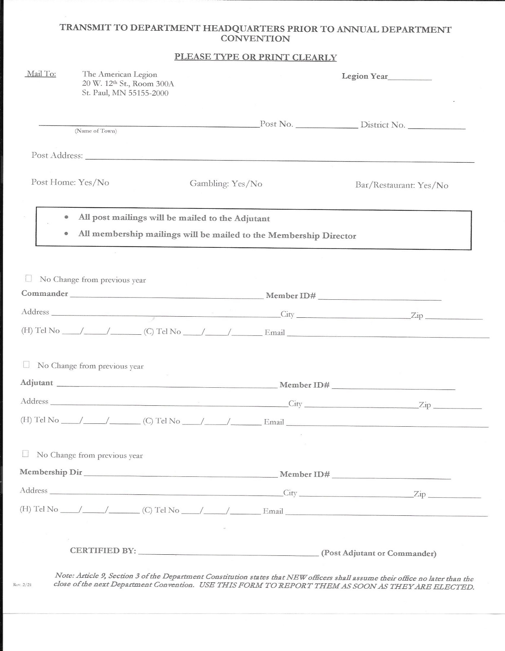

DISTRICT OFFICER REPORTING FORM

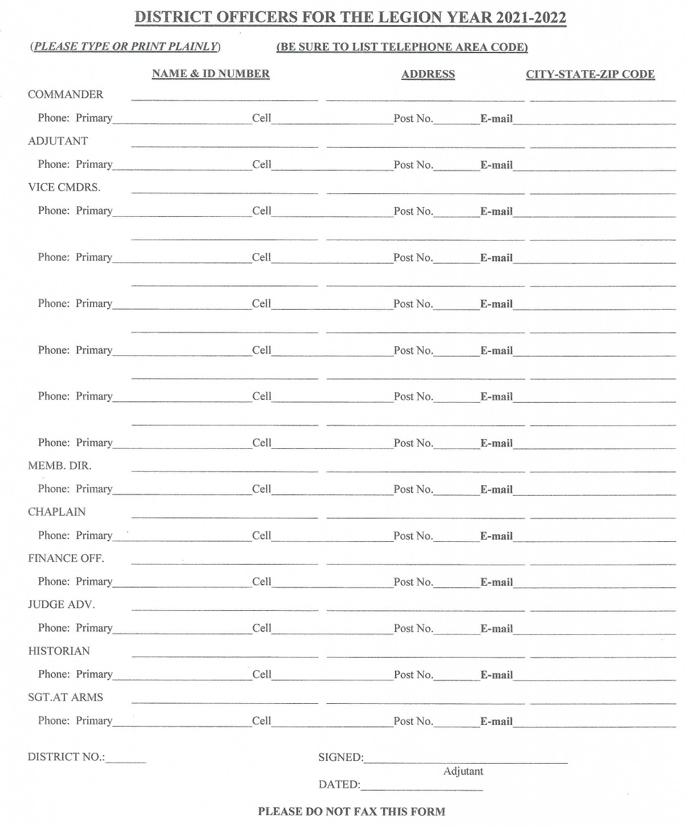
Mail to: The American Legion , 20 12th St W, Room 300A St Paul, MN 55155

DISTRICT COMMITTEE CHAIRMAN FORM

District No: Date Elected: Date Installed:

TITLE | NAME | ADDRESS | PHONE | EMAIL
Americanism
Baseball
Blood Program
Boy Scouts
Boys State
Children & Youth
Employment
Jr Shooting Sports
Law & Order
Legion Riders
Legionville
Legislative
National Security
Oratorical
Public Relations
VA&R
Sons of the American Legion

SONS OF THE AMERICAN LEGION

Thank you for making the commitment to charter a Sons of The American Legion (S.A.L.) Squadron at your post.

The S.A.L. is an important program which was created to support the aims and purposes of the parent organization, The American Legion. It is important to understand the relationship of the S.A.L. at all levels – from Post through the National level; the S.A.L. is a program of The American Legion and not an independent organization.

Like all programs and associated bodies, the S.A.L. must conform with five basic rules as outlined by the National American Legion Judge Advocate. These basic rules are:
- All officers of your S.A.L. squadron must be confirmed by the Post.
- Should any vacancies of the squadron offices occur, the new officers must also be confirmed by the Post.
- The Squadron must provide a monthly report, which includes financial information, to the Post.
- The Post Adjutant and/or Finance Officer must be signatory on all financial accounts.
- The Constitution and Bylaws of the S.A.L. Squadron, and all amendments thereto, must be approved by the Post.

Department Headquarters is always ready to assist with any questions or concerns that may arise regarding your S.A.L. Squadron or any other of the Americanism and Children & Youth programs. You can contact Department Headquarters at (651)-291-1800, Email: info@mnsal.org or the Detachment Web Site www.mnsal.org

Origin The Sons of The American Legion was born during the 1930’s in the midst of the Great Depression. The establishment of the Sons of The American Legion as a program was authorized by action of The American Legion’s 14th National Convention held in Portland, Oregon on September 12-15, 1932. The 1933 National Convention officially changed the name of the program to “Sons of The American Legion”, authorized use of the abbreviation “S.A.L.” and levied annual membership dues of 25 cents.

American Legion Program The Sons of The American Legion has been defined as a legal, self- sustaining program of The American Legion, authorized by resolution. The National Constitution of the Sons of The American Legion provides for finances and revenues derived from annual membership dues. The Squadron must provide a monthly report, which includes financial information, to the Post. Squadrons fall under the Post EIN and their financial activity is reported on the Post’s Annual IRS Form 990.

Recognition The American Legion, Department of Minnesota officially recognizes the Sons of The American Legion, in its Constitution and Bylaws.

Sons of The American Legion, Detachment of Minnesota The Sons of The American Legion, Detachment of Minnesota is duly organized and located at The American Legion, Department of Minnesota Headquarters in St Paul, Minnesota. A detailed History of the Sons of The American Legion, along with literature pertaining to S.A.L. activities, membership and programs can be obtained at Headquarters or at www.mnsal.org.

Squadron Organization The Sons of The American Legion Squadrons shall be organized under the jurisdiction of the Local Post of The American Legion, and shall bear the name and number of the Post. There shall be no more than one Squadron sponsored by each American Legion Post. Those who desire to form a Squadron shall make application for a charter to the local Post of The American Legion in the area in which they reside. The minimum membership for the formation of a Squadron shall be ten (10). Squadrons may be organized into sections based upon age.

Eligibility All male descendants, adopted sons and stepsons of members of The American Legion, and such male descendants of veterans who died in service during World War I or since December 7, 1941, during the delimiting periods set forth in Article IV, Section 1, of the National Constitution of The American Legion or who died subsequent to their honorable discharge from such service, shall be eligible for membership in the Sons of The American Legion. There shall be no form or class of membership except an active membership.

Administrative Program Manual Issued by the Detachment of Minnesota, this manual provides all of the administrative procedures and reporting forms necessary to properly administer the day-to-day activities of a chartered Sons of The American Legion squadron.

The American Legion Post-Sons of The American Legion Squadron Advisor The Department Constitution and Bylaws requires the Post Commander of an American Legion Post sponsoring a Sons of The American Legion Squadron, to appoint a committee of three or more members, to supervise the activities of their Squadron. Note: One of these committee members shall be designated “Squadron Advisor” and be listed on the S.A.L. Squadron Officers Report.

The American Legion, Department of Minnesota S.A.L. Program Chairman The Department Commander shall annually appoint a Program Chairman for the Sons of The American Legion, Detachment of Minnesota from the ranks of The American Legion, Department of Minnesota. The Program Chairman for the Sons of The American Legion, Detachment of Minnesota shall serve as a member of the Department Americanism Committee.

The American Legion, Department of Minnesota District Affiliation District Commanders are strongly urged to appoint a coordinator for the purpose of overseeing Sons of The American Legion activities. It is recommended that coordinators give reports of their activities at the District Conferences. It is further recommended that the Sons of The American Legion Squadrons be invited to attend meetings at all levels of The American Legion. Attendance at these meetings would greatly enhance the relationship between the S.A.L. and the Legion and improve the visibility of the Sons of The American Legion amongst the Legionnaires.

Starting a New Squadron For information on how to charter a Sons of The American Legion Squadron, contact The American Legion, Department of Minnesota for a squadron start up packet.

Squadron Officers Report Form Is to be used to report the Squadron Officers, Advisors, and District Chairmen. This information is used for Detachment Mailings and Membership contacts

How to Charter a Sons of The American Legion Squadron The Post Commander, with the approval of the members, should appoint a committee of not less than three (3) members to investigate the possibility of organizing an S.A.L. Squadron within the Post. The committee should obtain all available information on the Sons of The American Legion from Department Headquarters, 20 West 12th St Room 300A, St Paul, MN 55155-2000 or call (651) 291-1800. The Post should call a meeting to discuss the possibility of forming a squadron. Invite someone from the Sons of The American Legion, Detachment of Minnesota as a guest speaker to provide information about the organization and its activities.

The committee should survey the Post Membership to ascertain the number of sons, stepsons, adopted sons, grandsons, great grandsons, etc. eligible for membership in the Sons of The American Legion. Remember there is no age limit for membership in the Sons of The American Legion.

The committee should develop a program covering at least six months and establish a regular meeting day and time for the squadron at the Post home. All meetings must be conducted by the guidelines in the Squadron Handbook. At the first meeting of the Squadron, the Charter Application should be completed and sent to Department Headquarters. Be sure all four copies of the application are properly completed and signed. The committee should select temporary officers that will serve for a three-month period, after which a regular election can be scheduled. The Charter Application should be submitted to Department Headquarters for submission to National Headquarters for preparation of the Charter. This process can take up to four weeks.
Once the charter is received at Department Headquarters, membership cards will be prepared and sent to the Post Commander. Membership dues are then collected from eligible members and sent to Department Headquarters. Once membership is processed, the Charter will be sent to the Squadron. A ceremony should be planned for the purpose of presenting the Squadron Charter, initiating the new members and installing the Squadron Officers.

The Squadron Officers should prepare a report for each Post meeting outlining the accomplishments and goals of the Squadron.

The Post should notify the Squadron of all upcoming events, such as parades, Memorial Services and other functions of the Post in which the Squadron could take part. The Squadron should make itself useful in performing tasks that will assist the Post.

All efforts should be made to encourage Squadron Members to actively participate in all County, District and Detachment functions.


LEGION RIDERS

In Garden City, Mich., in 1993, Chuck "Tramp" Dare and Bill "Polka" Kaledas, commander of American Legion Post 396, shared an idea to start a motorcycle enthusiasts association within the organization. The two longtime riders wanted an environment where Legion family members could come together to share a common love for motorcycles.
Dare and Kaledas wrote a letter to Michigan Department Adjutant Hubert Hess, sharing their idea. Hess replied that he liked the concept and wanted to pursue it. Later, he gave Kaledas and Dare instructions for managing the program at the post level. He also explained how they could be approved to use The American Legion emblem, and how to gain Membership's support and recognition. At a regular meeting, Post 396 members passed a resolution for a new program to be known as the "American Legion Riders."
Joined by 19 other founding members from their post, Dare and Kaledas were flooded with requests for information about their organization. They agreed to establish a central source for the Riders to ensure that chapters formed not as motorcycle clubs or gangs, but as Legionnaires and Auxiliary and SAL members joining to ride as Legion family.
Currently, over 110,000 American Legion Riders meet in over 2,000 chapters in every domestic department and in at least three foreign countries. Riders in Iowa have formed an honor guard called The Five Star Freedom Riders, and Riders in Mulvane, Kan., founded the Patriot Guard to protect the sanctity of military funerals from protesters. Riders in all states have escorted military units returning home from combat tours overseas, conducted massive cross-country fundraising events for wounded warriors from all services, and have raised millions of dollars for countless local, state and national charities. Many Riders, supported by their departments, conduct annual statewide Legacy Runs in direct support of American Legion scholarship programs of Operation Comfort Warriors (OCW), supporting our wounded servicemembers across the nation.
American Legion Riders chapters are well known for their charitable work, which has raised hundreds of thousands of dollars for local children's hospitals, schools, veterans homes, severely wounded servicemembers and scholarships. Since 2006, Riders nationwide have participated in The American Legion Legacy Run to annually raise money for the Legacy Scholarship Fund, established to provide scholarships to children of U.S. military personnel killed since Sept. 11, 2001.
True to the Legion's grassroots tradition, each chapter manages its programs at the post level, where the best ideas are born. The Riders are part of many projects and events, including:
- Rolling Thunder, the annual POW/MIA rally in Washington on Memorial Day weekend.
- Annual regional rides such as Operation Wounded Warrior, sponsored by Riders in Nevada, Texas, New Mexico, Utah, Arizona, California and other Western states.
- Local charity events in support of The American Legion and local communities.
- Raising money for VA hospitals, women and children centers, children and youth centers, schools and other facilities.
- Sponsoring or participating in motorcycle runs to benefit numerous charities.
- Local memorial ceremonies and community parades.
- The American Legion Legacy Run, an annual cross-country fundraising ride from National Headquarters in Indianapolis to the national convention city.
- Riding to honor fallen military men and women, and to protect the sanctity of their funerals from those who would dishonor their memory.
- Escorting military units to departure airfields and airports for combat tours overseas and welcoming them home upon their return.
Eligibility
Eligibility for full membership in The American Legion Riders shall be as prescribed by the national constitutions of The American Legion, the American Legion Auxiliary, and the Sons of The American Legion.
All members of The American Legion Riders must further demonstrate current individual membership in The American Legion, The American Legion Auxiliary, or the Sons of The American Legion.
Each ALR member shall establish and maintain membership owning individually or through family, a motorcycle/trike licensed and insured as required under local laws. Additionally including the amendments of National Resolution 32 (Amendment to 35) which provides: “ALR programs may allow for continued membership for those who have given up motorcycle ownership because of age, illness, injury, or other reasons outside of the member’s control.”
There shall be no form or class of membership except an active membership in The American Legion Family.

Starting an American Legion Riders Chapter

The first step in starting an American Legion Riders Chapter is to get the local post to vote and approve a Legion Riders Chapter. Once that is done an organizational meeting needs to be held to elect officers. For more information please email:

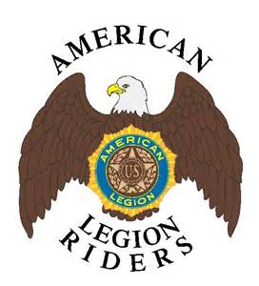

CODE OF CONDUCT

Minnesota Non-Profit Corporation law provides a standard for officers and for directors. The standard is substantially the same. A person has to use common sense and good judgement. He or she cannot just decide something to get it resolved and to move on. Care must be taken.

The law on standards of conduct for officers and/or directors of non-profit corporations is stated in the next two paragraphs. Each is taken directly from the applicable statute.

An officer shall discharge the duties of an office in good faith, in a manner the officer reasonably believes to be in the best interests of the corporation, and with the care an ordinarily prudent person in a like position would exercise under similar circumstances.
A director shall discharge the duties of the position of director in good faith, in a manner the director reasonably believes to be in the best interests of the corporation, and with the care an ordinarily prudent person in a like position would exercise under similar circumstances. A person who so performs those duties is not liable by reason of being or having been a director of the corporation.
Whether a person is an officer of a post or a district, that person must exercise their duties of office in good faith, in a manner that person reasonably believes to be in the best interests of the post or district and with the care an ordinarily prudent person in a like position would exercise under similar circumstances.

LEGIONVILLE

The Legionville School Safety Patrol Training Center in Brainerd MN, is a program of The American Legion Department of Minnesota. The patrol school’s primary function is to teach boys and girls, ages 10 to 13, the procedures of school-safety patrol work at intersections and in bus patrol work, is one aspect of Camp. Also safety subjects taught are; Swimming, Canoe, First Aid, CPR, Bulling, Social Media and Internet.
The idea of a school patrol program originated with Sister Carmela of the Cathedral School in Saint Paul in 1921 when the first patrolmen were stationed at the intersection of Kellogg Boulevard and Summit Avenue. St. Paul police adopted the program in 1922, and in 1935 the Minnesota highway patrol adopted it. Earl Brown, the first chief of the Minnesota highway patrol, felt that a uniform program for school safety patrols was needed and came to The American Legion for assistance. In 1936, The American Legion started a statewide training program held at the Crow Wing County Fairgrounds in Brainerd, MN, with two years at Camp Ripley.
In 1948, the Minnesota American Legion Department set up a committee to raise funds to construct a permanent training center for the school patrol and, with the funds raised, the original 560-acre site on North Long Lake was built. The site was donated by the Parker Family.
The school’s safety patrol training is conducted by the Minnesota highway patrol public information officers. There are also teachers for first aide, swimming and water safety, and canoeing. Between 500 to 600 campers attend Legionville each summer and more than 92,000 campers have graduated from the program. Many are third generation campers as parents and grandparents still talk about their experiences at camp.

Our top priorities at Legionville are Safety, Education and Fun. Campers stay at Legionville from Sunday through Friday during our summer sessions and take part in four education classes. Campers also enjoy activities such as swimming, canoeing, Tug-O-War, hiking and a Talent Show.

Legionville campers take part in many fun activities during their stay. As an example this may include the following:

Sunday: Movie Night
Monday: Kickball, Relay Races, Bonfire (with s'mores!)
Tuesday: Soccer, CPR Training, Movie Night
Wednesday: Volleyball, Tug-O-War, Talent Show
Thursday: Track Meet, Norwegian Kickball
*Each day includes one hour of recreational swim time.

LEGIONVILLE CAMPER RESERVATIONS
The summer months are quickly approaching, and Legionville is getting ready for another fantastic season of camp! There have been some significant changes to include an updated online registration and a fun new logo, but the personalized and exciting time the kids experience at camp will remain the same. While school safety patrol training and other safety classes are still at the center of the camp, it is not a requirement for kids to be school patrol members in order to attend camp. It is open to any child who will be between 10 and 13 years of age by September 1st, 2022. Exceptions to the age requirements are allowed but should be cleared ahead of time through our St. Paul office.

CAMP REGISTRATION - The fee is $400.00 per camper and can be received either by check (sponsors and parents) or by credit card online (parents only). For organizational sponsors such as an American Legion Post, School, or other entity, a coupon code will be issued to that organization once payment is secured. The coupon code will then be provided to the parent/guardian of each sponsored camper to use during the checkout process of the online registration. This will subtract the $400 fee from their balance due. These coupon codes must ONLY go to those campers being sponsored by a specific organization. Please remind your families that these are not shareable and are only available for those campers being sponsored. You can find the registration link on the website at https://legionville.weebly.com/ or Facebook page – Legionville Educational Center.

SPONSOR RESERVATIONS - Reservations are on a first come first served basis. As a sponsor, please return the enclosed camper reservation form along with payment to the St. Paul office at the address below. The form itself can be sent through email to rhill@mnlegion.org or as a package with the check by mail. Please do not hold this reservation application until you have the names of the sponsored campers. We do not need the names initially and you may lose your first choice of sessions if you wait. The purpose of the application is to ensure that a place will be reserved for your student(s) in the session(s) you select. The names will be added to your reservation once the parent has registered online. This is when the two will be connected.

PARENT RESERVATIONS – If a parent wishes to send a child to camp on his/her own, all communication and information will be done directly through the online registration tool. The parent/guardian will create an account, complete registration, and will be required to pay the fee at checkout. Please share this information with your schools so that we can get as many kids to camp as possible. The registration link can be found on our website at https://legionville.weebly.com/ or Facebook page – Legionville Educational Center.

Please read the enclosed brochure and letters carefully, then post the flier to hopefully gain more interest in Legionville’s Safety Summer Camp. Our goal is to get more kids learning about safety and enjoying the great MN outdoors..

Address all communications relating to reservations to:
MAIL: LEGIONVILLE TELEPHONE: (651) 291-1800
20 W 12th St., Room 300A EMAIL: registration@legionville.org
St. Paul, MN 55155

Check out our Legionville Facebook page – LEGIONVILLE EDUCATIONAL CENTER

NATIONAL LEGION COLLEGE
The American Legion National College enhances knowledge and appreciation of The American Legion and teaches the core values and contributions of the organization, its Auxiliary, Sons of The American Legion and many subordinate programs. The National Legion College prepares Legionnaires for leadership positions in posts, districts, counties, and departments through education, development, and motivation. The curriculum challenges student leaders to think critically and creatively about issues confronting the Legion.
The curriculum centers on self-taught, small-group sessions supervised by graduate facilitators, staff members, contracted professional speakers and national officers. Students review The American Legion’s core values, develop new ideas and consider the future. An emphasis is placed on programs, management techniques and leadership skills necessary to increase visibility of programs, growth in membership, and public awareness of the Legion and its corresponding organizations.
National leaders launch the week with sessions and lectures focusing on mentoring, recognizing and building leadership traits, and putting good leadership practices to use. These skills and techniques are practiced and reinforced throughout the week in a small-group environment and in student-led meetings and presentations. Small-group workshops provide students basic leadership training in a volunteer environment. Core subjects include mentoring, leadership styles and opportunities, time management, conflict resolution and legal issues.
Throughout the week, students learn the basics of developing communication strategies to promote American Legion programs, combined with the workshops and hands-on exercises. Topics include public outreach, media relations, “Reconnect” with today’s active-duty and reserve personnel, schools and community relations.
Salesmanship and Marketing Developed skills make students more valuable to their posts and departments. Students’ employers also directly benefit from students’ increased effectiveness and productivity. Teachings include community networking strategies, public-relations techniques, marketing and salesmanship programs, and image-building techniques.
Applications are available on the National American Legion website at Legion.org/college and must be completed and submitted to the Department Office. Each Department is allowed 1 candidate and if space permits additional candidates are allowed.
Prerequisites for attending National Legion College: all candidates must be a member in good standing, be a member for a minimum of three continuous years, have completed Basic Training online with a certificate dated after August 2016 and must be vetted and endorsed by their department leadership.

MINNESOTA LEGION COLLEGE
The Minnesota American Legion College enhances knowledge and appreciation of The American Legion and teaches the core values and contributions of the organization and many subordinate programs. The Minnesota Legion College prepares Legionnaires for leadership positions in posts, districts, counties, and departments through education, development, and motivation. The curriculum is meant to inspire future leaders to think critically and outside-the-box about issues confronting the Legion.
The curriculum is comprised of subjects recommended through surveys and in-person contact with members of posts throughout the Department of Minnesota. Sessions are facilitated by the Training Committee members and Subject Matter Experts on topic. An emphasis is placed on programs and leadership skills necessary to increase visibility of programs, growth in membership, and public awareness of the Legion.
The College session uses material from known best and current practices. Students are divided up into small groups throughout the training long weekend to work on various scenarios. Core subjects include the importance of continuity in post and district leadership, conflict resolution, resolution writing, legal issues and a complete how-to concerning membership (including recruitment, retention and reinstatement).
The purpose of the Minnesota American Legion College is to increase the knowledge of each of the attendees through a deeper understanding of the programs and goals of The American Legion. Additionally, we attempt to emphasize the importance of sharing what they’ve learned in their posts and districts. As such, many of the students have gone on to become leaders in their post and district and some have returned to teach at Minnesota American Legion College.
Applications are available on the Department American Legion website at mnlegion.org/legion-college. The class size is a minimum of 18 and a maximum of 24.
Prerequisites for attending Minnesota Legion College: all candidates must be a member in good standing and have completed Basic Training online with a certificate dated after August 2016.

WEBSITE INFORMATION
There are three (3) Websites to be aware of:
- The Department Website - mnlegion.org
- The National Website - www.legion.org
- The Membership Website www.mylegion.org

mnlegion.org:

This is the main website for The American Legion, Department of Minnesota. You can navigate to the other two websites from here.
This website is maintained to be up to date. Post and District members will find the the Membership Tab, under Forms and Resources needed documents.
Please take time to review the enter site as there are many resources for administrative, recruiting and fundraising purposes. Many resources are printable. Headquarters can be contacted for additional question not answered in the website.

legion.org:
This is the National website.

mylegion.org

This is the National membership site. All Posts and Districts should register for this free site where you can manage your membership and submit information and forms electronically. You can upload your Post image, newsletter, messages and calendar. Go to the site, click on the Register on the right hand above DONATE and REGISTER and follow the instructions.

THE AMERICAN LEGION, DEPARTMENT OF MINNESOTA
Veterans Affairs and Rehabilitation Contact Sheet
The following contact information relates to Veterans Affairs and Rehabilitation issues within The American Legion Department of Minnesota.

DEPARTMENT SERVICE OFFICER
Ray Kane
dso@mnlegion.org
Office: 612-467-3849
Cell: 651-377-0547

ASSISTANT DEPARTMENT SERVICE OFFICER
Janet Lorenzo
adso@mnlegion.org
Office: 612-467-3849
Cell: 612-468-6279

CLAIMS OFFICE SUPERVISOR
Rolando Sotolongo
Claims Office Supervisor
VA Regional Office St. Paul, MN
(612) 970-5662 main office
(612) 970-5768

Department Programs Contact Sheet

Administration Mike Maxa MMaxa@mnlegion.org
Americanism Jennifer Kelley JKelley@mnlegion.org
American Legion Baseball Tim Engstrom TEngstrom@mnlegion.org
American Legion Membership Misty Padilla MPadilla@mnlegion.org
Boy Scouts Jennifer Kelley
Boy’s State Jennifer Kelley
Children and Youth Jennifer Kelley
Donations Jennifer Kelley/Rachael Hill
Employment Jennifer Kelley
Finance Rachael Hill RHill@mnlegion.org
Law & Order Jennifer Kelley
Legionnaire Advertisements/Articles Tim Engstrom
Legionville Rachael Hill
National Security Jennifer Kelley
Oratorical Jennifer Kelley
Post Data and Officer Reporting Misty Padilla
PUFLs Misty Padilla
SAL Membership
Scholarships Jennifer Kelley
Trophies and Awards, Yearbook, Misty Padilla
Gold/Silver Brigade, Recruiter of the Yr. Misty Padilla
Website/Facebook Tim Engstrom

Other helpful contact information:
American Legion Customer Service 1-800-433-3318
Crisis Line 1-800-273-TALK “press 1 for Veterans”
Flag & Emblem Sales 1-888-453-4466
Gambling Control Board 651-639-4039
Legionnaire Insurance Trust 1-800-235-6943
Veterans Benefits Information 1-800-827-1000
Veterans Linkage Line 1-888-LINKVET (546-5838)

GET INVOLVED

Build a team
❖ Delegate authority and responsibility for programs to chairmen
❖ Involve new people in programs of interest to them
❖ Promote effective Post Community Service Programs
❖ Continue and expand Leadership-Training Programs

Communicate
Establish a communication system that works both up and down so that your programs will succeed! Timing is essential to the success of any program! Make your plans known so that others can be involved to get the work done in time and make it a success.

JULY

Consolidated Post Report (CPR) Monthly Worksheet 36

Renew & Rejoin Report 37

Goose Egg 38

CONSOLIDATED POST REPORT MONTHLY WORKSHEET
JULY
PROGRAMS | ACTIVITIES | EXPENSES | MAN HOURS | # OF PARTICIPANTS
VA&R: Cases Handled, Funds Disbursed, Volunteer at VA Hospital
National Security: # of Blood Donors & Pints,
ROTC Medals, Funeral Honors, Cost of Uniforms
Media & Communications: Community Events, Mention in Radio, TV, Cable, Newspaper
Uniformed Groups:
Economics: Referred to LVER or DVOP, placed in Employment, Job Training
Americanism – Children & Youth
Boys State, Baseball, Oratorical Contest, Shooting Sports
Scouting
Scholarships
School Awards
Other Education Programs
Flag Education/School Flags
Other Children & Youth Programs
Community Service: Donated Hall usage, Flag presentation at community events, Main Street Flag program, etc.
Administrative Costs: Paper, Equipment, Postage, etc., List Program
Contributions: Hall rental for Red Cross, other civic activities
Other:
This report will help you keep a monthly record of the work your Post does in the programs of The American Legion, and makes the Annual Consolidated Post Report, due June 1st each year, easier to fill out.

RENEW & REJOIN REPORT – JULY

REPORT OF POST OUTREACH TO UNRENEWED, EXPIRED AND 1982 MEMBERS
Post No: District: Year:

Date of Event | # of Legionnaires Participating | # of Persons Contacted

GOOSE EGG



The Consolidated Post Report (CPR) and Newly Elected Officer Report must be turned in to Department Headquarters.

AUGUST

Consolidated Post Report (CPR) Monthly Worksheet 40

Renew & Rejoin Report 41

Employment Award- Employer of Veterans 43

Employment Award- Employment Service 47

Employment Award- Employer of Older Workers 52

Employment Award- Enhance the Lives of Disabled Persons 55

Employment Award-Michael Guty Homeless Veteran Outreach 58

CONSOLIDATED POST REPORT MONTHLY WORKSHEET
AUGUST
PROGRAMS | ACTIVITIES | EXPENSES | MAN HOURS | # OF PARTICIPANTS
VA&R: Cases Handled, Funds Disbursed, Volunteer at VA Hospital
National Security: # of Blood Donors & Pints,
ROTC Medals, Funeral Honors, Cost of Uniforms
Media & Communications: Community Events, Mention in Radio, TV, Cable, Newspaper
Uniformed Groups:
Economic: Referred to LVER or DVOP, placed in Employment, Job Training
Americanism – Children & Youth
Boys State, Baseball, Oratorical Contest, Shooting Sports
Scouting
Scholarships
School Awards
Other Education Programs
Flag Education/School Flags
Other Children & Youth Programs
Community Service: Donated Hall usage, Flag presentation at community events, Main Street Flag program, etc.
Administrative Costs: Paper, Equipment, Postage, etc., List Program
Contributions: Hall rental for Red Cross, other civic activities
Other:
This report will help you keep a monthly record of the work your Post does in the programs of The American Legion, and makes the Annual Consolidated Post Report, due June 1st each year, easier to fill out.

RENEW & REJOIN REPORT – AUGUST

REPORT OF POST OUTREACH TO UNRENEWED, EXPIRED AND 1982 MEMBERS
Post No: District: Year:

Date of Event | # of Legionnaires Participating | # of Persons Contacted


THE NATIONAL VETERANS’ EMPLOYMENT & EDUCATION COMMISSION AWARDS
The first American Legion Veterans Employment and Education Commission Award was established in 1947, and recognized individuals across the country who had established outstanding records in the employment and retention of workers with disabilities. Since that time, categories were added to the current nine award programs.
The Veterans Employment and Education Commission is striving to award all possible pending awards that are available to The American Legion. We implore all departments to continue to submit award nominations for the awards with the hope that we receive all 400 + possible nominations. We are striving to reach 100% participation in this program.

- EMPLOYER OF VETERANS AWARD - (SMALL)
- EMPLOYER OF VETERANS AWARD - (MEDIUM)
- EMPLOYER OF VETERANS AWARD - (LARGE)
- EMPLOYMENT SERVICE AWARD - (DVOP)
- EMPLOYMENT SERVICE AWARD - (LVER)
- EMPLOYMENT SERVICE AWARD - (LOCAL OFFICE)
- EMPLOYER OF OLDER WORKERS AWARD
- ENHANCE THE LIVES OF DISABLED PERSON AWARD
- MICHAEL GUTY HOMELESS VETERANS OUTREACH AWARD

To be considered for the National Award, the deadline for submittals to the Veterans Employment and Education Commission in Washington, DC is January 15, of the following year. Example: To be nominated for the 2018 awards the nomination must be in by January 15, 2019.
It is important that the department winners are submitted by this time to ensure that they are considered for the national award to be delivered at the annual National Convention. Each of the national winners receives a stipend to help defray the cost of their representative’s travel to the convention city to accept the award.
We ask that you submit written correspondence or send an electronic scanned copy in the form of an e-mail to our national headquarters office. Please title your letter ‘[Title] Awards- [Department name]’.

All entries must be accompanied by an official nomination form (see the following pages) and must not be longer than two pages of narrative. Supporting documents, which may also be submitted with the nomination, must not exceed ten pages.

Posts will submit their nominee to their District Chairman who will in turn send the winning nominee to National.

DEPARTMENTS MAY REPRODUCE ALL FORMS FOR WIDER DISTRIBUTION

THE EMPLOYER OF VETERANS AWARD

Information Sheet

History: The Veterans Employment and Education Commission expanded its Employer Awards Program in 1969 when it created an award category for employers of veterans. Originally, departments were permitted to submit one nomination each for a large and a small employer of veterans. In 1992, the number of awards for employers of veterans was increased. Today, departments may submit a total of 3 nominations for this category for national consideration. Posts will submit their nominee to their District Chairman who will in turn send the winning nominee to National.

  - One nomination for a small company with 50 or fewer employees
  - One nomination for a medium sized company with workforces of 51 to 200
  - One nomination for a large company with 201 or more employees

National Awards: These awards, one in each of the three employers of veterans size categories, are presented at the National Convention. In order to be eligible for the Employer of Veterans Awards, nominees must meet the following criteria:

- At least 10 percent of the nominee’s workforce must be veterans.
- The nominee must have been in business for at least five years.
- The nominee cannot restrict employment to veterans only.
- The nominee must be a private sector employer. In other words, the nominee cannot be a city, state, or federal employer.

A department that submits a nomination for an employer of veterans that does not meet the above criteria will receive a plaque for presentation. However, that nominee will not be eligible for a national award.

Selections of the Employer of Veterans Awards are made by the Veterans Employment & Education Commission Award Subcommittee, which meets during the annual Washington Conference.

The purpose of Award: To confer recognition on one small, one medium and one large employer in each state for outstanding records in the hiring and retention of veterans.

Deadline: The deadline for submission of nominations of employers of veterans is no later than January 15th. Nominations received after that date will not be eligible for consideration for the national award.

Procedure: Nominations from posts, or sources outside the Legion, must be sent to department headquarters. The department then selects one nominee each in the small, medium and large employer categories and sends the nomination forms and supporting information for the winning employers to the National Employment and Education Commission. Those nomination forms must be signed by either the department adjutant or department employment chairman. Nominations that arrive without supporting information will not be eligible for the national awards.

Nomination Form: A copy of the official nomination form, which is the same for all three employer size categories, follows. Additional copies may also be obtained by writing or calling the Veterans Employment and Education Commission, The American Legion, 1608 K Street NW, Washington, DC 20006; phone 202-861-2700; email VE&E@legion.org. A copy of the nomination form can be found below and online at mnlegion.org, select ‘Programs’ at the top of the page and then ‘Program Downloads’ then ‘Employment’

Award: The commission provides free plaques to each department that submits nominations. It is recommended, however, that posts and departments recognize their other nominees with plaques or awards that can be purchased for a nominal cost through Emblem Sales. The National Winner will receive a large plaque to be presented by the National Commander at the Annual National convention and will receive a stipend to help defray the cost of their representative’s travel to the convention city to accept the award.

DEPARTMENTS MAY REPRODUCE ALL FORMS FOR WIDER DISTRIBUTION

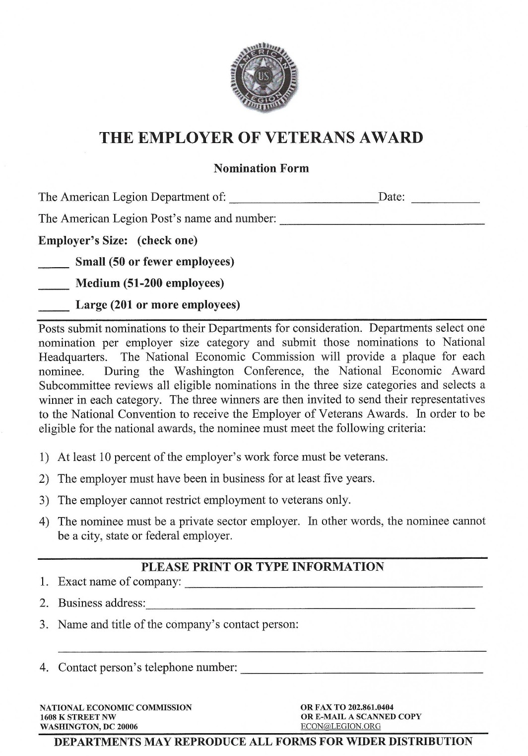

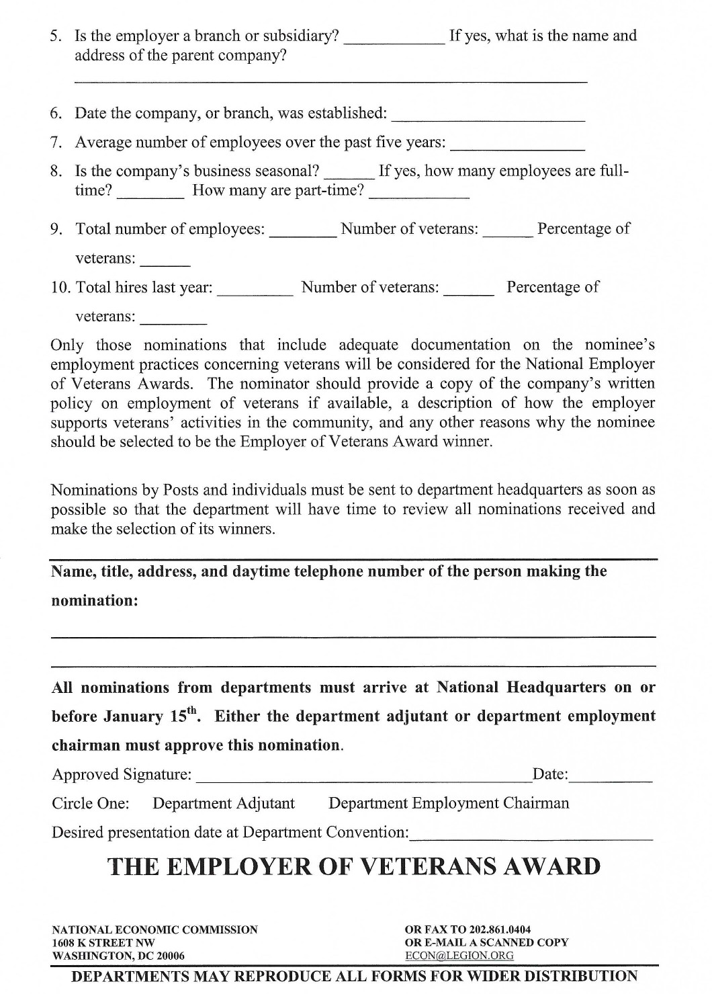

EMPLOYMENT SERVICE AWARDS
Information Sheet

History: In 1990, a resolution established a national awards program to recognize outstanding Employment Service (ES) offices and employees.
Both the National Veterans Employment & Education Commission and the Internal Affairs Commission’s Trophies and Awards Subcommittee conducted extensive studies and both recommended approval and referred the resolution to the National Executive Committee for final approval. The NEC unanimously approved the resolution at its spring 1992 meeting.

Purpose: The purpose of the ES awards program is to confer national recognition annually on one outstanding Local Veterans Employment Representative (LVER) and one Disabled Veterans Outreach Program specialist (DVOP). LVERs, DVOPs, and the ES office provide job counseling, testing and placement assistance to unemployed and underemployed veterans.

Deadline: The deadline for submission of nominations of the ES office is no later than January 15th. Nominations received after that date will not be eligible for consideration for the national award.

Procedure: Nominations from posts, ES employees or other sources must be sent to department headquarters. The department then selects one nominee each in the LVER, DVOP, and ES Office categories, and sends the winning nominations with their supporting information to the National Veterans Employment & Education Commission. Either the department adjutant or department employment chairman must sign those nominations. Nominations that arrive without supporting information will not be eligible for the national awards.

Nomination Form: A copy of the official nomination form, which is the same for all the ES office categories, follows. Additional copies may also be obtained by writing, calling, or emailing the National Veterans Employment & Education Commission, The American Legion, 1608 K Street NW, Washington, DC 20006; phone 202-8612700; email VE&E@legion.org. A copy of the nomination form can be found in the Forms Appendix at the back of this manual and online at mnlegion.org, select ‘Programs’ at the top of the page and then ‘Program Downloads’ then ‘Employment’

Award: The commission provides free plaques to each department that submits nominations. It is recommended, however, that posts and departments recognize their other nominees with plaques or awards that can be purchased for a nominal cost through Emblem Sales. The National Winner will receive a large plaque to be presented by the National Commander at the annual National Convention and will receive a stipend to help defray the cost of their representative’s travel to the convention city to accept the award.

DEPARTMENTS MAY REPRODUCE ALL FORMS FOR WIDER DISTRIBUTION
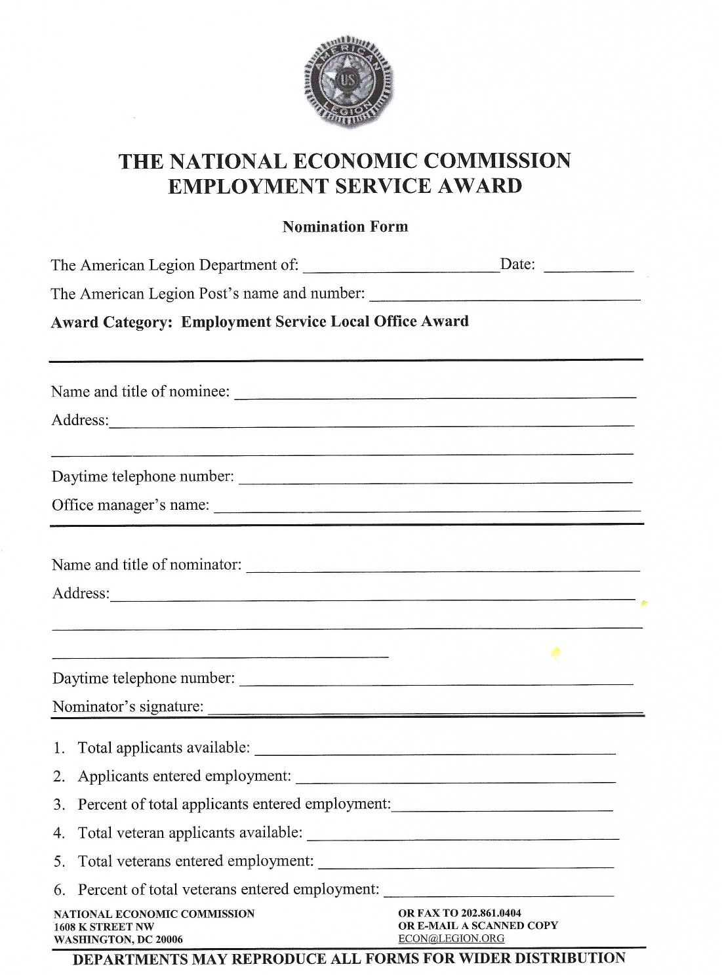
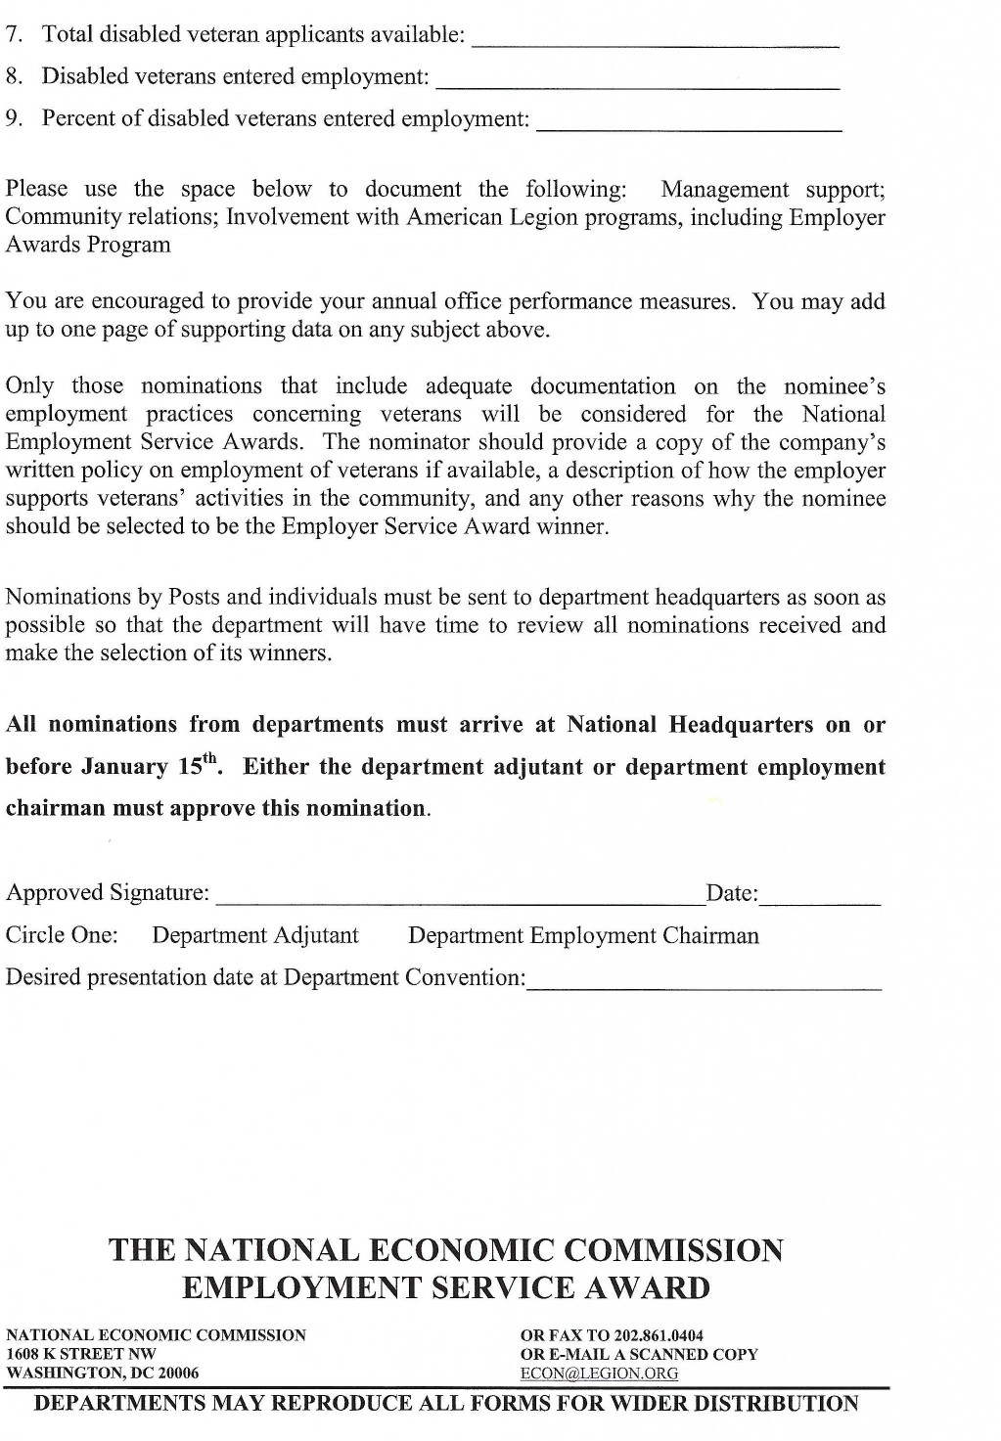
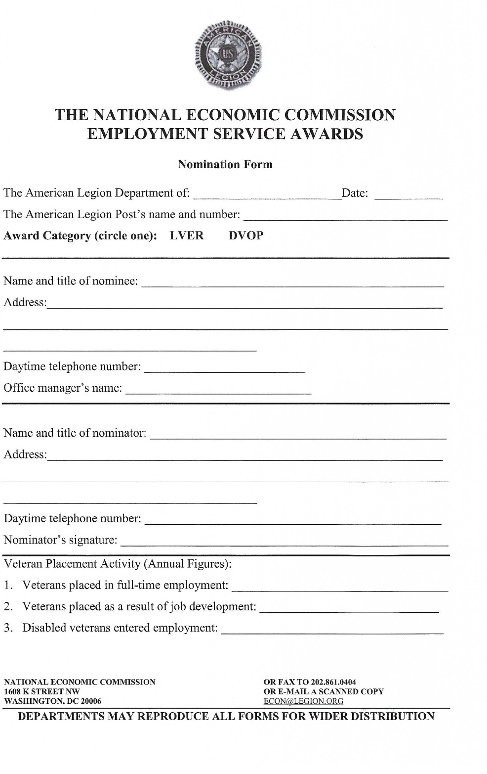
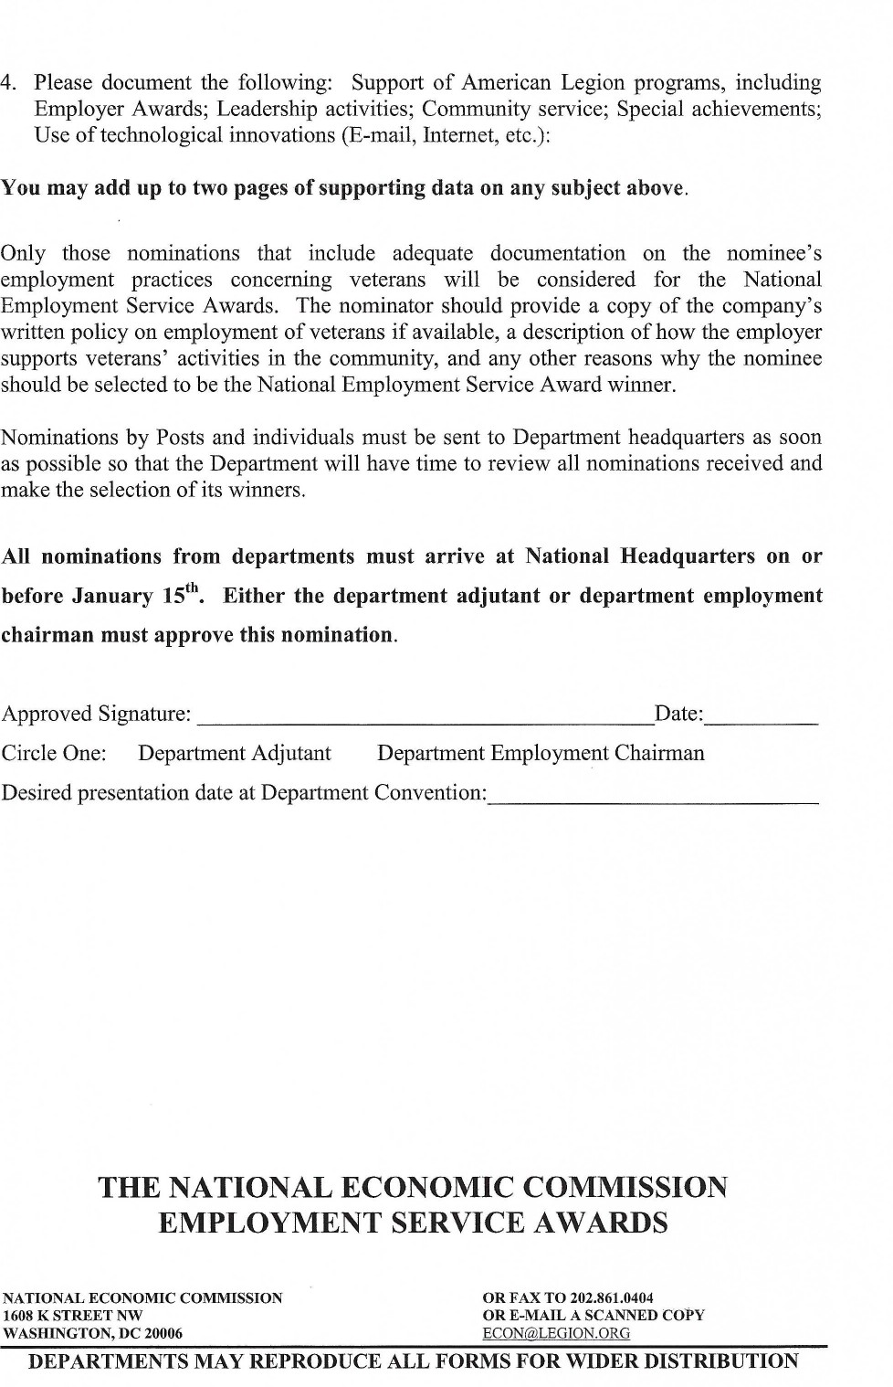

EMPLOYER OF OLDER WORKERS AWARD

Information Sheet

History: In 1958, the National Veterans Employment & Education Commission expanded its Employer Awards Program by creating an award for employers of older workers. Because the commission saw older workers as a valuable economic resource of proven skills, stability and experience, it wanted to encourage employers to hire and retain older workers in the work force. National “Employ the Older Worker Week” was established by The American Legion and is observed during the last full week of each September.
The National Veterans Employment & Education Commission believes that this particular award category will become increasingly important over the next few years. Several major studies have concluded that as we move through the twenty-first century there will be fewer young people entering the labor market. As a result, it will be necessary for employers to encourage older workers to stay in the labor force.

Purpose of Award: To confer recognition on one employer in each state for an outstanding record in the hiring and retention of older workers.

Deadline: The deadline for submission of nominations of Employer of Older Workers is no later than January 15th. Nominations received after that date will not be eligible for consideration for the national award.

Procedure: Nominations from posts, or other sources must be sent to department headquarters. The department then selects one nominee and sends the winning nominations with their supporting information to the National Veterans Employment & Education Commission. Either the department adjutant or department employment chairman must sign the nomination. Nominations that arrive without supporting information will not be eligible for the national awards.

Nomination Form: A copy of the official nomination form will follow. Additional copies may also be obtained by writing, calling, or emailing the National Veterans Employment & Education Commission, The American Legion, 1608 K Street NW, Washington, DC 20006; phone 202-861-2700; email VE&E@legion.org. A copy of the nomination form can be found in the Forms Appendix at the back of this manual and online at mnlegion.org, select ‘Programs’ at the top of the page and then ‘Program Downloads’ then ‘Employment’

Award: The commission provides free plaques to each department that submits nominations. It is recommended, however, that posts and departments recognize their other nominees with plaques or awards that can be purchased for a nominal cost through Emblem Sales. The National Winner will receive a large plaque to be presented by the National Commander at the annual National Convention and will receive a stipend to help defray the cost of their representative’s travel to the convention city to accept the award.

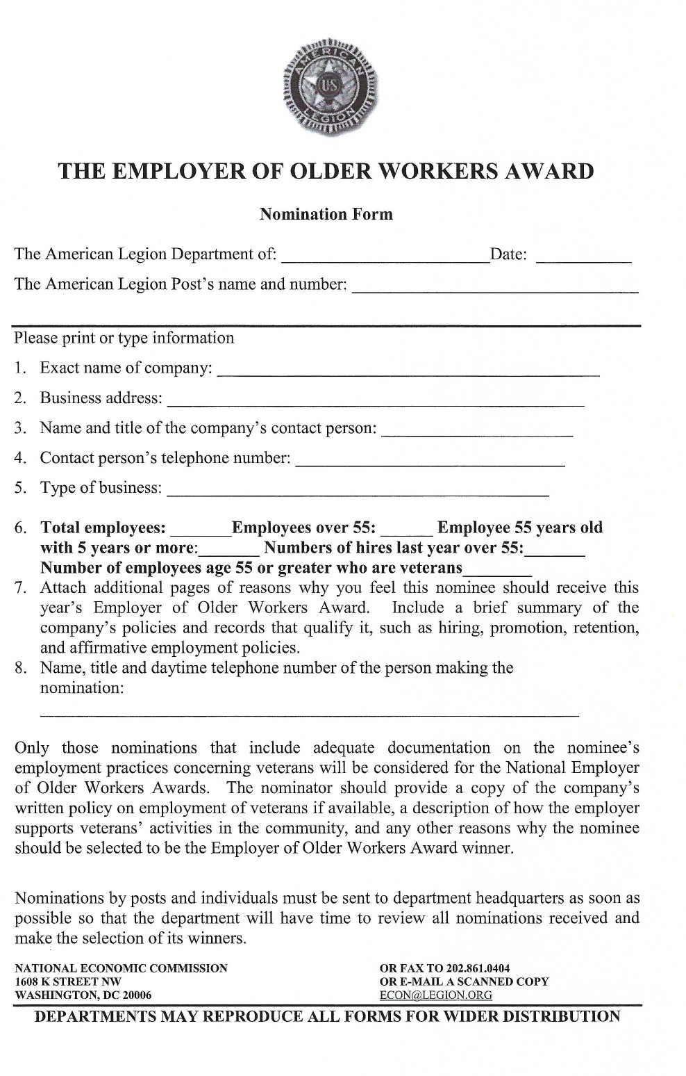
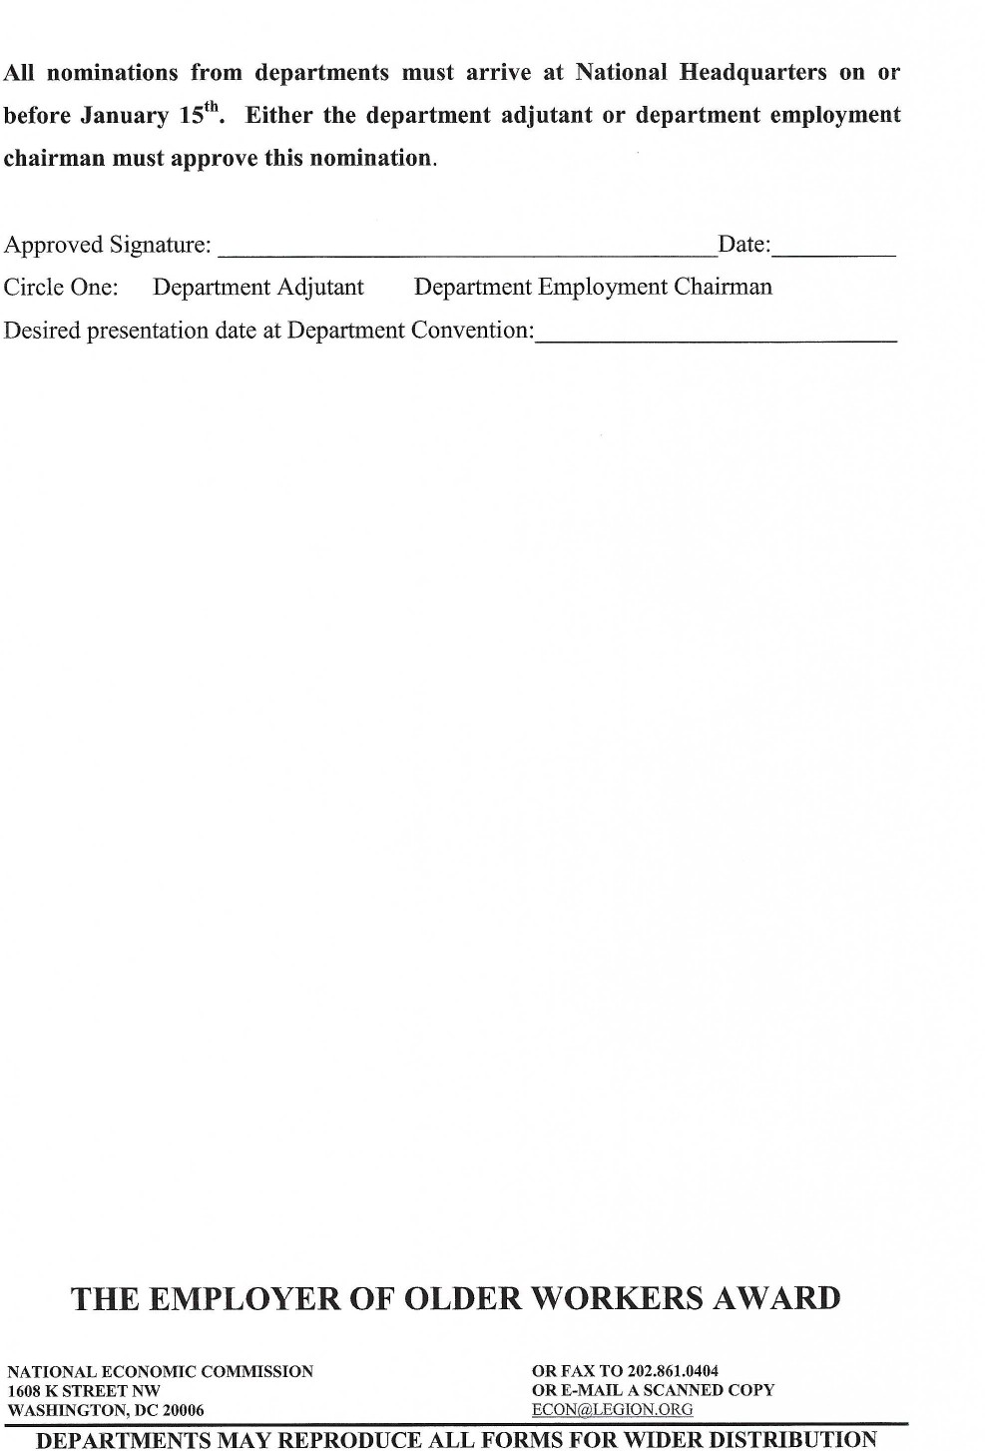

AWARD TO ENHANCE THE LIVES OF DISABLED PERSONS
Information Sheet

Purpose: The purpose of the National Organization on Disability (NOD) Awards competition is to confer national recognition on organizations, such as The American Legion, for their involvement in enhancing the lives of disabled persons by providing opportunities for their participation in community activities. Any Legion project or program that improves the quality of life for disabled persons will be considered.

History: Since 1987, American Legion posts have competed for prizes through the Awards Program. NOD will continue to award certificates to the winners, and all nominees and their departments will receive American Legion citations of appreciation.

Criteria: All entries must be accompanied by an official nomination form (see the following page) and must not be longer than two pages of narrative. Supporting documents, which may also be submitted with the nomination, must not exceed ten pages.

Deadline: The deadline for submission of nominations of the Award to Enhance the Lives of Disabled Persons is no later than January 15th. Nominations received after that date will not be eligible for consideration for the national award.

Procedure: Nominations from posts, or other sources must be sent to department headquarters. The department then selects one nominee and sends the winning nominations with their supporting information to the National Veterans Employment & Education Commission. Either the department adjutant or department employment chairman must sign the nomination. Nominations that arrive without supporting information will not be eligible for the national awards.

Nomination Form: A copy of the official nomination form will follow. Additional copies may also be obtained by writing or calling the National Veterans Employment & Education Commission, The American Legion, 1608 K Street NW, Washington, DC 20006; phone 202-861-2700, or online at VE&E@legion.org

Award: The commission provides free plaques to each department that submits nominations. It is recommended, however, that posts and departments recognize their other nominees with plaques or awards that can be purchased for a nominal cost through Emblem Sales. The National Winner will receive a large plaque to be presented by the National Commander at the annual National Convention and will receive a stipend to help defray the cost of their representative’s travel to the convention city to accept the award.

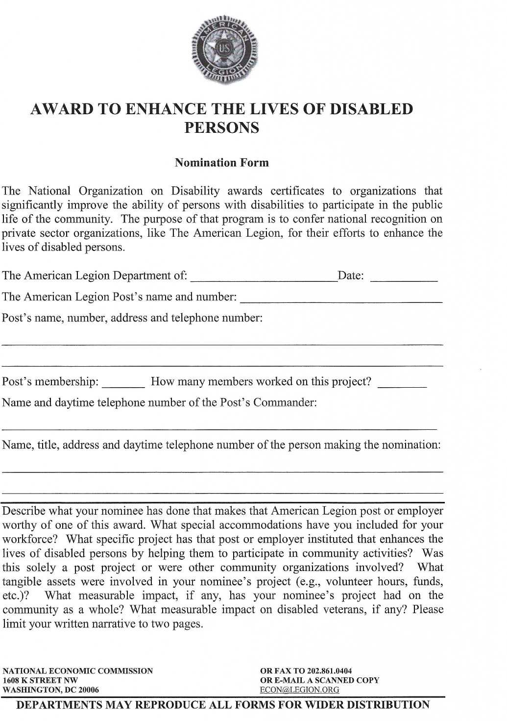
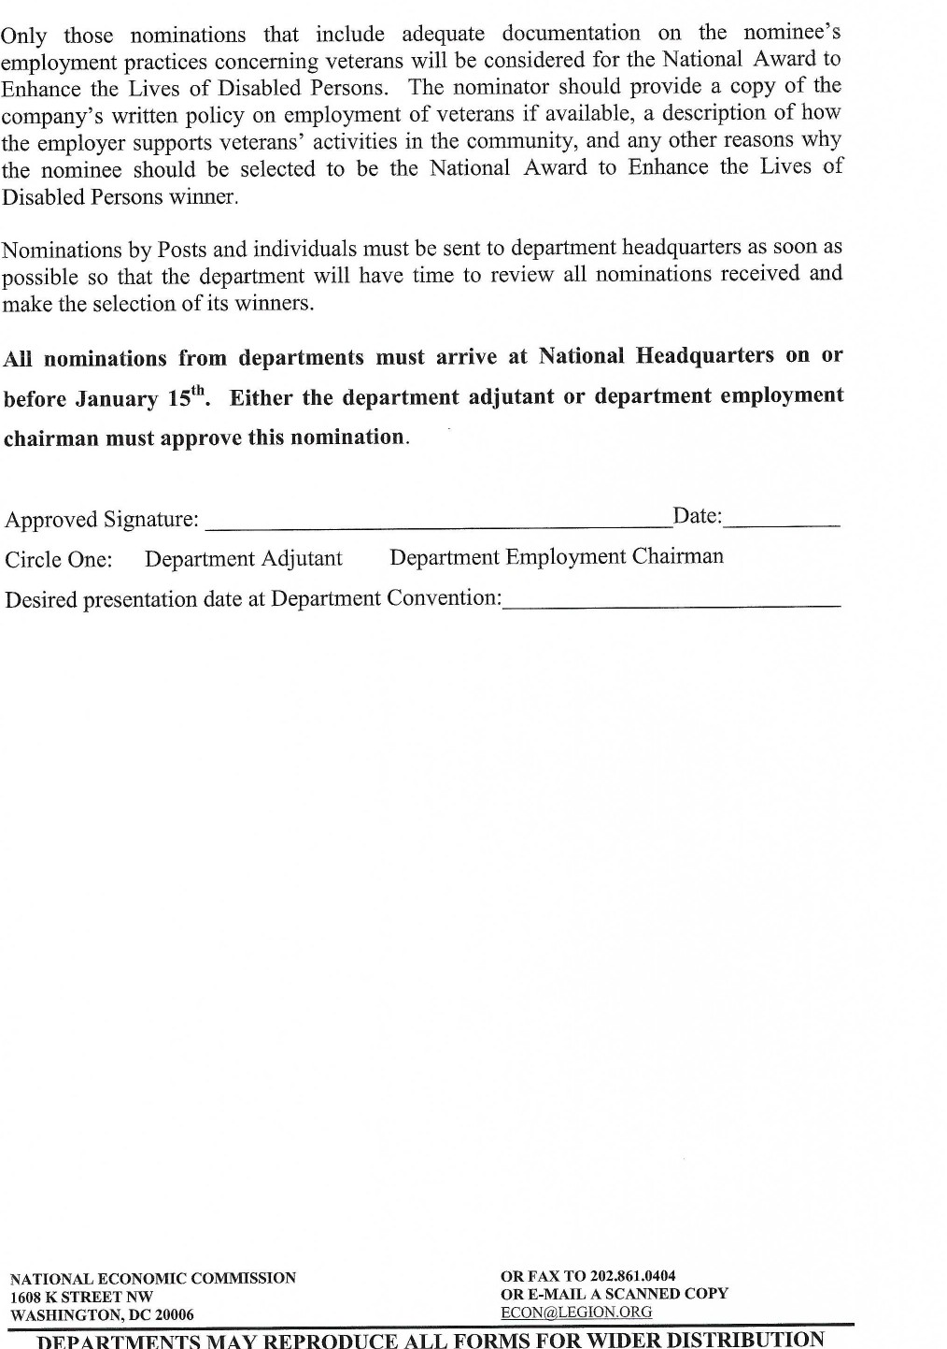

MICHAEL GUTY HOMELESS VETERANS OUTREACH AWARD
Information Sheet

In January of 2003, the Veterans Employment & Education Commission requested that each department appoint a Homeless Veterans Task Force chairman, who should coordinate the department’s activities and report on them to the department adjutant and to the Veterans Employment & Education Division at least once a year.
The Homeless Veterans Outreach Award, instituted in 2005, recognizes departments for their activities toward eliminating homelessness among veterans and prevention of future homeless veterans.
Deadline: The deadline for submission of nominations for this outreach award is no later than January 15th. Nominations received after that date will not be eligible for consideration for the national award.
Criteria: This award will be given to The American Legion department that demonstrates American Legion family involvement in homeless veteran initiatives that show outstanding support for activity in any or all of these areas: volunteerism, prevention, supportive housing, advocacy and fundraising.
Have you appointed a Homeless Veterans Task Force chairman? Does he/she have a committee? How often do they meet? Are your members working with the Sons of The American Legion? The American Legion Auxiliary? Are they working with agencies within the Departments of Defense, Labor, and Veterans Affairs?
Are they working with local and county agencies, shelters, and faith-based and community-based organizations?
Tell us how many of your members are involved in your programs. Do programs operate year round or once a year? How are your activities organized?

Please tell us in narrative form what you are doing toward the goal of ending homelessness among veterans.
The Homeless Veterans Task Force executive committee will review the reports during Washington Conference, and the winner chosen by the National Veterans Employment & Education Commission Awards Subcommittee.
Procedure: Nominations that arrive without supporting information will not be eligible for the national awards.

Nomination Form: A copy of the official nomination form will follow. Additional copies may also be obtained by writing, calling, or emailing the National Veterans Employment & Education Commission, The American Legion, 1608 K Street NW, Washington, DC 20006; phone 202-861-2700; email VE&E@legion.org. A copy of the nomination form can be found in the Forms Appendix at the back of this manual and online at mnlegion.org, select ‘Programs’ at the top of the page and then ‘Program Downloads’ then ‘Employment’
Award: The commission provides free plaques to each department that submits nominations. It is recommended, however, that posts and departments recognize their other nominees with plaques or awards that can be purchased for a nominal cost through Emblem Sales. The National Winner will receive a large plaque to be presented by the National Commander at the annual National Convention and will receive a stipend to help defray the cost of their representative’s travel to the convention city to accept the award.

DEPARTMENTS MAY REPRODUCE ALL FORMS FOR WIDER DISTRIBUTION

SEPTEMBER

Consolidated Post Report (CPR) Monthly Worksheet 61

Membership Goal (Early Bird/NEF Kickoff) 62

Renew & Rejoin Report 63

Eagle Scout of the Year 64

Oratorical. 69

Shooting Sports. 70

CONSOLIDATED POST REPORT MONTHLY WORKSHEET
SEPTEMBER
PROGRAMS | ACTIVITIES | EXPENSES | MAN HOURS | # OF PARTICIPANTS
VA&R: Cases Handled, Funds Disbursed, Volunteer at VA Hospital
National Security: # of Blood Donors & Pints,
ROTC Medals, Funeral Honors, Cost of Uniforms
Media & Communications: Community Events, Mention in Radio, TV, Cable, Newspaper
Uniformed Groups:
Economics: Referred to LVER or DVOP, placed in Employment, Job Training
Americanism – Children & Youth
Boys State, Baseball, Oratorical Contest, Shooting Sports
Scouting
Scholarships
School Awards
Other Education Programs
Flag Education/School Flags
Other Children & Youth Programs
Community Service: Donated Hall usage, Flag presentation at community events, Main Street Flag program, etc.
Administrative Costs: Paper, Equipment, Postage, etc., List Program
Contributions: Hall rental for Red Cross, other civic activities
Other:
This report will help you keep a monthly record of the work your Post does in the programs of The American Legion, and makes the Annual Consolidated Post Report, due June 1st each year, easier to fill out.

MEMBERSHIP GOAL - SEPTEMBER

Early Bird/Harvest Rally

50% GOAL

Traditionally the second Wednesday of September.

Membership cards received at the Department Headquarters on or before the cutoff date, will receive credit toward the Premier Race.

RENEW & REJOIN REPORT – SEPTEMBER

REPORT OF POST OUTREACH TO UNRENEWED, EXPIRED AND 1982 MEMBERS
Post No: District: Year:

Date of Event | # of Legionnaires Participating | # of Persons Contacted

THE AMERICAN LEGION EAGLE SCOUT OF THE YEAR
Eligibility Requirements: The nominee must be a registered, active member of a Boy Scout Troop, Varsity Scout Team, or Venturing Crew chartered to an American Legion Post, American Legion Auxiliary Unit or Sons of The American Legion Squadron.

OR

Be a registered, active member of a chartered Boy Scout Troop, Varsity Scout Team, or Venturing Crew and the son or grandson of a Legionnaire or Auxiliary member.

AND
- Received the Eagle Scout Award.
- Be an active member of his religious institution and must have received the appropriate Boy Scout religious emblem.
- Have demonstrated practical citizenship in church, school, scouting and community.
- Have reached his 15th birthday and be enrolled in high school at the time of selection. Eagle Scouts still in high school who reached their 18th birthday during the nomination year remain eligible if otherwise qualified.
- Reside in the Department (state) to which he applies.

Scholarships

Department: The Department chooses one Eagle Scout of the Year as the Department winner. This winner receives a $1,000.00 scholarship and is forwarded on to the National competition for consideration.

National: The American Legion Eagle Scout of the Year winner will receive a $10,000.00 scholarship. Three runner-up scholarship awards will be granted in the amount of $2,500.00 each. The Eagle Scout of the Year will join the youth champion delegation, and participate in, the Annual National Convention.

The scholarship recipients will be eligible to receive their scholarship immediately upon graduation from high school (public, parochial, military, private or home school) and must utilize the total award within four years of their graduation date, excluding active military duty or religious mission.

The scholarship may be used to attend a school selected by the student provided it is state accredited, above the high school level and within the continental limits of the United States, except in the case where the student may be from a possession of the United States, in which case he can select a school in that possession or in the continental United States.

Disbursement from the scholarship fund will be made jointly to the student and the school at the beginning of each semester or quarter. Only one request will be honored per semester or quarter.

For the Eagle Scout of the Year application go to https://www.legion.org/scholarships/eaglescout

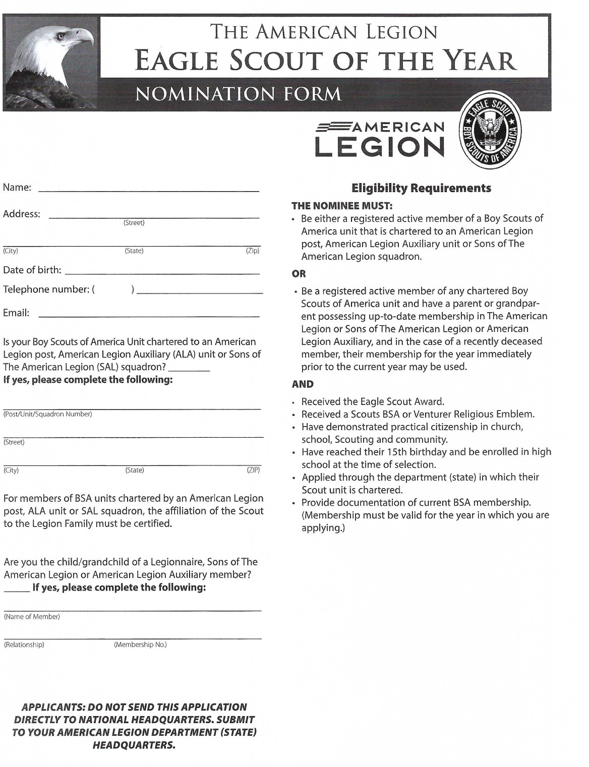

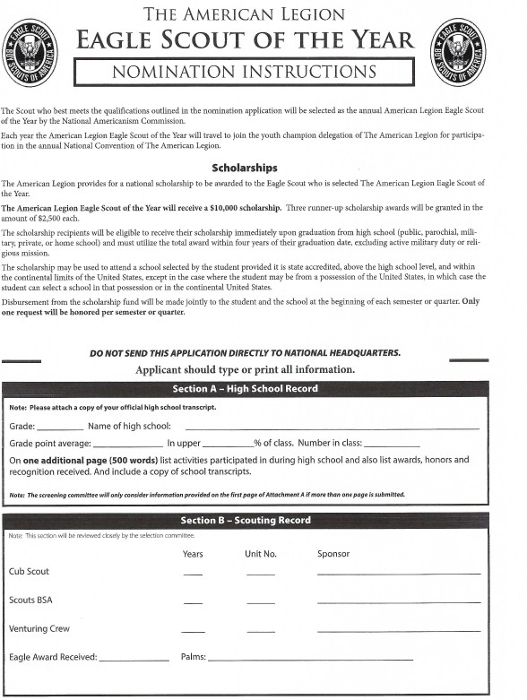

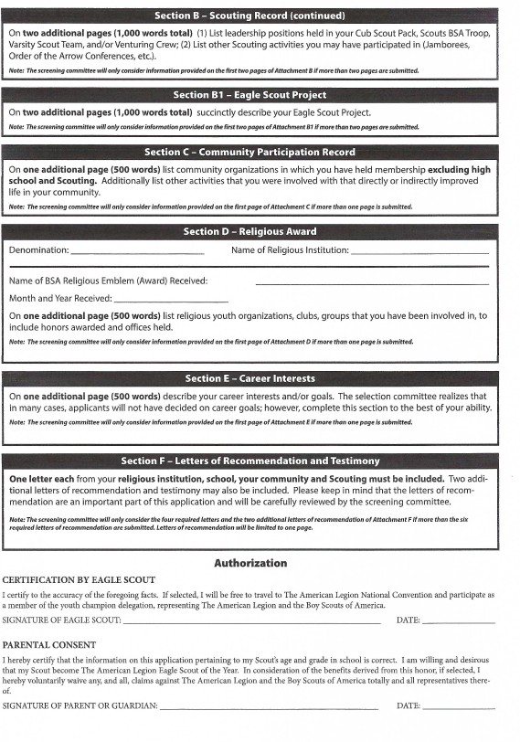

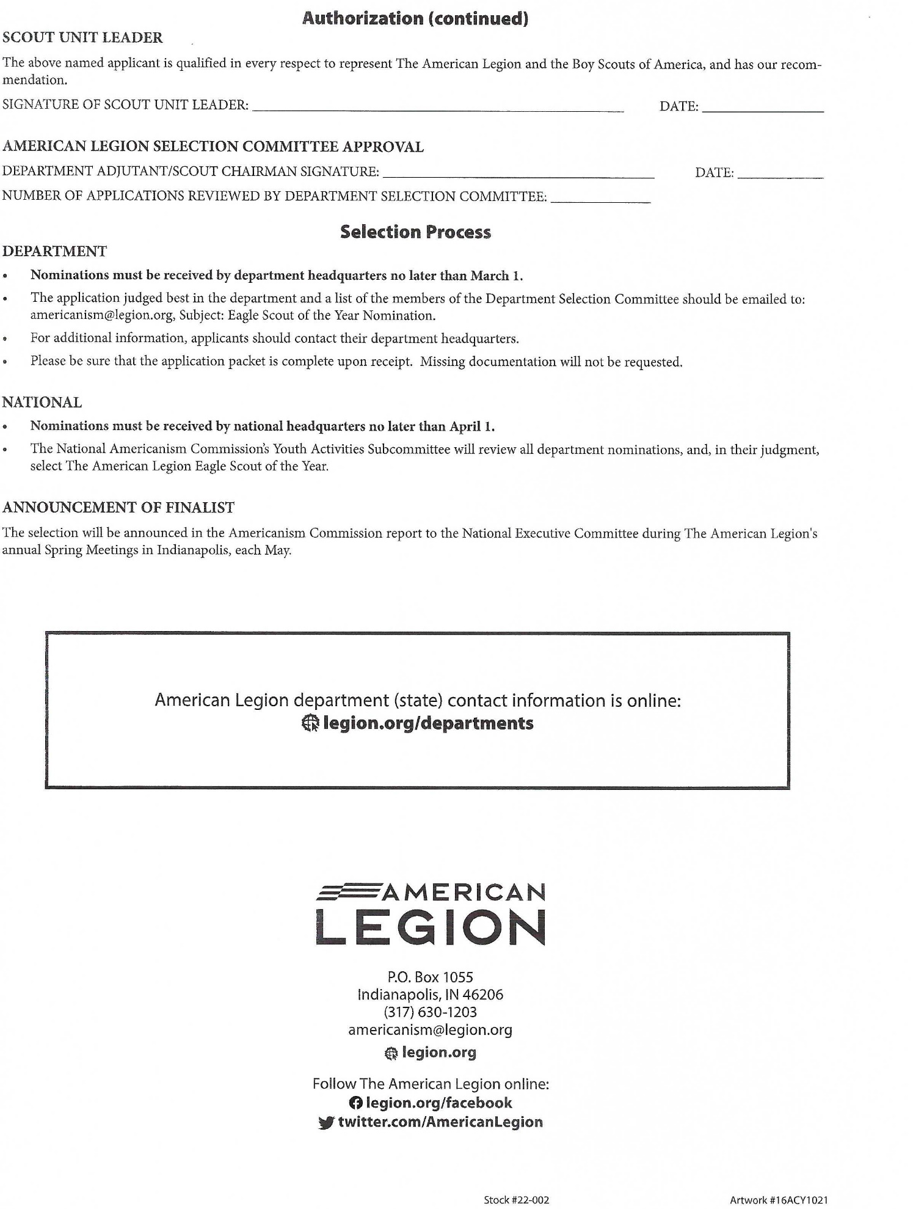

ORATORICAL SCHOLARSHIP PROGRAM
The American Legion Oratorical Contest exists to develop deeper knowledge and appreciation for the U.S. Constitution among high school students. Since 1938, the program has presented participants with an academic speaking challenge that teaches important leadership qualities, the history of our nation’s laws, the ability to think and speak clearly, and an understanding of the duties, responsibilities, rights and privileges of American citizenship.

Participants are required to give an 8-to-10-minute speech related to the United States Constitution, as well as a 3 to 5 minute presentation on an “Assigned Topic”. The following scholarships are awarded:
- District Awards are decided within each District
  - The Department finalists will receive $1,500.00 for 1st and moves on to the National competition, $1,000.00 for 2nd and $700.00 for 3rd and $500.00 for 4th
  - National finalists receive $25,000.00 for 1st, $22,500.00 for 2nd and $20,000.00 for 3rd
Contestants in the Post contest may be selected from one or more high schools, including home school, within the Post area. This contest will be under the direction and supervision of the Post Commander or representative. Each Post may certify one (1) contestant to the District Level of competition.

The District Contest shall be limited to one (1) contestant from each Post. This contest will be under the direction and supervision of the District Chairman or representative. Each District may certify one (1) contestant into the State level of competition.

The Department Oratorical Chairman will announce the date and time (traditionally the last week of February) of the State Contest. The State Final contests will be conducted on the same day and at the same location. The 10 Districts will be divided into two (2) Semi Final contests. The first-place winners from each Semi Final contest will advance to the State Finals.

Oratorical Chairman

An Oratorical Chairman should be appointed at the District and Post level. Appointment of the Oratorical Chairman should be based on interest, availability and qualifications. It is crucial that the Oratorical Chairman have contact with the local school to promote the program, communicate a description of the program, and the scholarships available to their students who participate. Every Post is encouraged to sponsor one contestant in the Oratorical contest.

The Oratorical Rules, Guidebook and assigned topics can be found at https://mnlegion.org/department-annual-oratorical-contest or contact Department Headquarters.

SHOOTING SPORTS

The American Legion,

Department of Minnesota

Junior Shooting Sports

What is The American Legion Junior Shooting Sports Program? The American Legion Junior Shooting Sports Program is a gun safety education and marksmanship program that encompasses the basic elements of safety, education, enjoyment and competition.

What is Shooting? Shooting is a skilled sport. Skills learned in shooting are valuable in other aspects of life. Learning to be a safe shooter teaches responsibility. Learning to hit a difficult target teaches self-discipline and self-control. Learning to hold a firearm steady and hit the target teaches concentration. Knowing that the shooter alone is ultimately responsible for his or her performance teaches self-reliance and enhances individual esteem.

Who is Eligible? Boys and girls compete equally in shooting. Any students between 8 to 18 years of age are eligible to participate.

Create a Successful Program: There are two options to become involved with the program. The first option is to start your own program at the Post. Things to consider are: space to shoot, insurance, qualified shooting leaders, rifles and equipment. An alternative to starting a program at your Post is to affiliate with an existing shooting program such as a 4-H club, ROTC, the Boy Scouts or a Youth Sports club. To become a sponsor of an existing program is as simple as filling out the Junior Shooting Sports affiliation form found at www.mnlegion.org and click ‘Programs’ then ‘Junior Shooting Sports’.

Three (3) Scholarships awarded annually: To qualify for the scholarships, students must have participated in the Department Postal Match (Sporter Class). A $1,000, $750 and $250 scholarship are awarded to the three (3) highest individual match scores in the Age Group I, See awards on the following page.

The future of The American Legion Junior Shooting Sports Program: Depends on our ability to engage our youth and provide them with the fundamentals that lead to a feeling of success by:
- Promoting the safe and ethical use of firearms
- Providing a positive experience and positive message about shooting
- Keeping the program safe, interesting and fun!

3-Position Air Rifle (Sporter Class) Postal Match

Purpose: A postal match offers junior air rifle shooters a competition designed to encourage and reward individual marksmanship skills. The match can be shot at a club range without a lot of expense or travel. NOTE: This Department match is separate from the National competition.

Date of Competition: Targets can be ordered beginning in October. Set target order requests will not be accepted after February 14th. All “official target sets” (both fired and unfired) must be returned to the CMP, in accordance with the instructions and schedule provided by the CMP and included in target sets.
Order forms can be found at https://www.legion.org/shooting/postal-match

Who May Compete: Entry in either the Individual or Team Postal match is limited to competitors who are active members of a Jr. Shooting club sponsored by or affiliated with an American Legion Post. A representative from a sponsoring post MUST be present when the match is fired.

Any students between 8 to 18 years of age are eligible to participate. This postal match is for the Sporter Class only.

Individual Age Categories: USE the same age groups as defined by the rulebook page 6.
3P Sporter – Beginner – 8-11 years old
3P Sporter – Junior – 12-14 years old
3P Sporter – Senior – 15-18 years old

Rules-Course of Fire: The current National Standard Three-Position Air Rifle rules will apply. This is a 3X10 event. Ten shots in each position: prone, standing and kneeling. Rule books may be ordered, viewed or downloaded from the CMP website
https://www.thecmp.org/wp-content/uploads/2021/04/3PARRules.pdf

Equipment: The Sporter Air rifle is intended to be a low cost, entry-level rifle without specialized modifications. Sporter air rifles must be .177 caliber (4.5 mm) pneumatic, spring air, or compressed air of CO2 rifles with a muzzle velocity of 600 fps or less that comply with these requirements. See the National Standard Three-Position Air Rifle rule book for a complete list of approved rifles.

Entry Fee: $5.00 per individual shooter, additional $10 to enter four (4) shooters as a team. Only targets ordered from Headquarters will be accepted.

Match Conduct: All phases of the individual and Team postal match will be conducted in accordance with the National Standard Three-Position air rifle rules.

Results: Tournament results can be monitored at http://www.legion.org/shooting/postal_match.
a. Results will be updated daily.
b. A final results bulletin will be posted on The American Legion website, http://www.legion.org/shooting at the conclusion of the first and second rounds (Individual and Team Tournament).
c. A final tournament results bulletin will be posted after completion of the National Championship (Individual Tournament shoulder-to-shoulder match).

Awards: Trophies will be awarded for 1st place, 2nd place and 3rd place in each age Group. A trophy will be awarded to the highest team score (total of top four scores from one club). Scholarships will be awarded to the 3 highest individual match scores in the Age Group I as follows: 1st place- $1,000; 2nd place- $750; 3rd place- $250.
Integrity: Postal tournaments are conducted with the expectation that each competitor will have the integrity to fire the match according to the rules. Any individual or team discovered taking advantage of tournament rules will be disqualified.

For more information on the program or the Postal Match, contact the Department of Minnesota at 651-291-1800 or email inquiries to department@mnlegion.org. You can also visit the Department website at mnlegion.org under ‘Programs’, then ‘Jr Shooting Sports’ or the National website at www.legion.org under ‘Programs’, then ‘Jr Shooting Sports’.

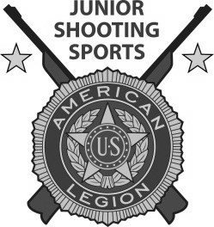

.

OCTOBER

Consolidated Post Report (CPR) Monthly Worksheet 74

Membership Goal (Fall Meetings). 75

Kaisersatt. 76

Renew & Rejoin Report 77

Minnesota American Legion Memorial Scholarship 78

Minnesota American Legion Foundation Scholarship 80

Minnesota American Legion Nurses Training Scholarship 82

Fire Fighter of the Year 84

Law Enforcement Officer of the Year 87

Fund for Hospitalized Veterans 90

CONSOLIDATED POST REPORT MONTHLY WORKSHEET
OCTOBER
PROGRAMS | ACTIVITIES | EXPENSES | MAN HOURS | # OF PARTICIPANTS
VA&R: Cases Handled, Funds Disbursed, Volunteer at VA Hospital
National Security: # of Blood Donors & Pints,
ROTC Medals, Funeral Honors, Cost of Uniforms
Media & Communications: Community Events, Mention in Radio, TV, Cable, Newspaper
Uniformed Groups:
Economics: Referred to LVER or DVOP, placed in Employment, Job Training
Americanism – Children & Youth
Boys State, Baseball, Oratorical Contest, Shooting Sports
Scouting
Scholarships
School Awards
Other Education Programs
Flag Education/School Flags
Other Children & Youth Programs
Community Service: Donated Hall usage, Flag presentation at community events, Main Street Flag program, etc.
Administrative Costs: Paper, Equipment, Postage, etc., List Program
Contributions: Hall rental for Red Cross, other civic activities
Other:
This report will help you keep a monthly record of the work your Post does in the programs of The American Legion, and makes the Annual Consolidated Post Report, due June 1st each year, easier to fill out.

MEMBERSHIP GOAL - OCTOBER

FALL MEETINGS

55% GOAL

Traditionally the second Wednesday of October.

Membership cards received at the Department Headquarters on or before the cutoff date, will receive credit toward the Premier Race.

MEMBERSHIP GOAL – OCTOBER

Kaisersatt

Contest ends at Fall Department Conference in October.

Weekly points are based on a percent of the previous year’s Department Convention total turned in each week by the District – to the District which garners the highest number of points in 12 weeks. The Contest is divided into four equal sections of four weeks duration and points credited each week. Each week the top five Districts are credited with points.

First Section Second Section Third Section
Place Points Points Points
1 20 18 16
2 18 16 14
3 16 14 12
4 14 12 10
5 12 10 8

RENEW & REJOIN REPORT – OCTOBER

REPORT OF POST OUTREACH TO UNRENEWED, EXPIRED AND 1982 MEMBERS
Post No: District: Year:

Date of Event | # of Legionnaires Participating | # of Persons Contacted

MINNESOTA AMERICAN LEGION MEMORIAL SCHOLARSHIP
The purpose of this scholarship, sponsored by The Minnesota American Legion Foundation, is to provide financial assistance to students to further their education in any Minnesota University, College, Vocational School, or other accredited institutions of higher education, or in states with a Minnesota reciprocity agreement.
QUALIFICATIONS
- Applicant must be a legal resident of the State of Minnesota, and a citizen of the United States.
- Applicant shall be a legal descendent of a Veteran member of The American Legion; and/or a legal descendent of an American Legion Auxiliary member.
- Applicant shall be a High School graduate upon receipt of the scholarship and must meet the academic standards of the school they will be attending.
- Applicant must have a good record of school and community citizenship, indicate their loyalty to their country, and show the qualities of initiative and desire to pursue an education beyond High School.
- Applicant shall establish a financial need.
BASIS OF SELECTION
Awards will be made on the basis of personal need with consideration given to the desire to continue education, ability to succeed, career to be pursued, and purpose for which scholarship is to be used. The decisions of the committee, composed of the members of the Education and Americanism Committee, or its duly appointed agents, will be final. Scholarship winners will be determined in the month of April. You will not be notified if you do not receive this scholarship. All applications will be destroyed after selection.
EXTENT OF AWARD
The maximum scholarship award is for $500.00 and is for one year only, but application may be made for aid in succeeding years, should no applications be received for the first-year studies. The $500.00 will be sent to the institution of the student’s choice before the Fall Quarter/Semester.
REQUIREMENTS
1. High School/College transcript must be included.
2. Applicant should include a personal letter.
3. Applicant should include at least two (2) letters of recommendation.
4. An American Legion Post Official must sign the application.
APPLICATION AND DEADLINE
Application forms for the scholarship may be obtained from the Education Committee, The American Legion, Department of Minnesota, 20 West 12th Street, Room 300A, St. Paul, MN 55155-2000.
APPLICATION DEADLINE IS APRIL 1
Please send completed Scholarship Application to The American Legion, Department of Minnesota, 20 West 12th Street, Room 300A, St. Paul, MN 55155. If you have any questions, please call (651) 291-1800 or e-mail to department@mnlegion.org

APPLICATION
MINNESOTA AMERICAN LEGION MEMORIAL SCHOLARSHIP

APPLICANT’S NAME ______________________________________________________________________
ADDRESS ________________________________________________________________________________
CITY ___________________________ STATE _______ ZIP ___________ PHONE (_____) ______________
EMAIL ___________________________________________________________________________________
LEGAL DESCENDENT OF A QUALIFIED MEMBER OF AMERICAN LEGION POST:
NAME _____________________________ MEMBERSHIP NUMBER __________________
MILITARY BRANCH _____________ SERVICE DATES______________

Or
LEGAL DESCENDENT OF A QUALIFIED MEMBER OF AMERICAN LEGION AUXILIARY UNIT:
NAME _______________________________ MEMBERSHIP NUMBER _________________

FATHER’S OCCUPATION _______________________ MOTHER’S OCCUPATION___________________________
NUMBER OF DEPENDENTS IN THE FAMILY _________________________________________________________
FAMILY ADJUSTED GROSS INCOME FOR THE LAST TAX YEAR (TAKEN FROM THE FEDERAL INCOME TAX RETURN) __________________________________________________________________________
SCHOOL YOU WILL ATTEND ___________________________________________________________________
ADDRESS ____________________________________ CITY _____________________ STATE ____ ZIP __________
HAVE YOU RECEIVED ANY OTHER SCHOLARSHIPS OR FINANCIAL ASSISTANCE? IF SO, PLEASE LIST __________________________________________________________________________________________________
__________________________________________________________________________________________________

THE FOLLOWING SHOULD BE COMPLETED BY AN APPROPRIATE ADULT:
- Student’s scholastic average for the last three years __________. Include high school transcript.
(If applicant is a Veteran, no transcript is needed).
- Adult recommendation and remarks. (At least two or more recommendations should be included.)
- Applicant should include a personal essay – essay can include why applicant should receive scholarship or what education the student is pursuing. The essay can be as long or short as the applicant deems necessary.

APPLICATION APPROVED AND RECOMMENDED BY AMERICAN LEGION POST # _________________________________
POST LOCATION ____________ POST OFFICIAL’S SIGNATURE ________________________________ DATE ____________

ANY APPLICATION TO BE CONSIDERED MUST BE IN DEPARTMENT HEADQUARTERS BY APRIL 1. APPLICANT SHOULD COMPLETE THE APPLICATION IN EVERY DETAIL, IN ORDER TO QUALIFY. ALL APPLICATIONS WILL BE DESTROYED AFTER SELECTION. ONLY THE WINNERS WILL BE NOTIFIED.

MINNESOTA AMERICAN LEGION FOUNDATION SCHOLARSHIP
The purpose of this scholarship, sponsored by The Minnesota American Legion Foundation, is to provide financial assistance to students to further their education in any Minnesota University, College, Vocational School, or other accredited institutions of higher education, or in states with a Minnesota reciprocity agreement.
QUALIFICATIONS
1. Applicant must be a legal resident of the State of Minnesota, and a citizen of the United States.
2. Applicant shall be a legal descendent of a Veteran member of The American Legion; and/or a legal descendent of an American Legion Auxiliary member.
3. Applicant shall be a High School graduate upon receipt of the scholarship and must meet the academic standards of the school they will be attending.
4. Applicant must have a good record of school and community citizenship, indicate their loyalty to their country, and show the qualities of initiative and desire to pursue an education beyond High School.
5. Applicant shall establish a financial need.
BASIS OF SELECTION
Awards will be made on the basis of personal need with consideration given to the desire to continue education, ability to succeed, career to be pursued, and purpose for which scholarship is to be used. The decisions of the committee, composed of the members of the Education and Americanism Committee, or its duly appointed agents, will be final. Scholarship winners will be determined in the month of April. You will not be notified if you do not receive this scholarship. All applications will be destroyed after selection.
EXTENT OF AWARD
The maximum scholarship award is for $500.00 and is for one year only, but application may be made for aid in succeeding years, should no applications be received for the first-year studies. The $500.00 will be sent to the institution of the student’s choice before the Fall Quarter/Semester.
REQUIREMENTS
1. High School/College transcript must be included.
2. Applicant should include a personal letter.
3. Applicant should include at least two (2) letters of recommendation.
4. An American Legion Post Official must sign the application.
APPLICATION AND DEADLINE
Application forms for the scholarship may be obtained from the Education Committee, The American Legion, Department of Minnesota, 20 West 12th Street, Room 300A, St. Paul, MN 55155-2000.
APPLICATION DEADLINE IS APRIL 1
Please send completed Scholarship Application to The American Legion, Department of Minnesota, 20 West 12th Street, Room 300A, St. Paul, MN 55155. If you have any questions, please call (651) 291-1800 or e-mail to

department@mnlegion.org

APPLICATION
MINNESOTA AMERICAN LEGION FOUNDATION SCHOLARSHIP

APPLICANT’S NAME ______________________________________________________________________
ADDRESS ________________________________________________________________________________
CITY ___________________________ STATE _______ ZIP ___________ PHONE (_____) ______________
EMAIL ___________________________________________________________________________________
LEGAL DESCENDENT OF A QUALIFIED MEMBER OF AMERICAN LEGION POST:
NAME _____________________________ MEMBERSHIP NUMBER __________________
MILITARY BRANCH _____________ SERVICE DATES______________
Or
LEGAL DESCENDENT OF A QUALIFIED MEMBER OF AMERICAN LEGION AUXILIARY UNIT:
NAME _____________________________ MEMBERSHIP NUMBER _________________

FATHER’S OCCUPATION _______________________ MOTHER’S OCCUPATION___________________________
NUMBER OF DEPENDENTS IN THE FAMILY _________________________________________________________
FAMILY ADJUSTED GROSS INCOME FOR THE LAST TAX YEAR (TAKEN FROM THE FEDERAL INCOME TAX RETURN) __________________________________________________________________________
SCHOOL YOU WILL ATTEND ___________________________________________________________________
ADDRESS ____________________________________ CITY _____________________ STATE ____ ZIP __________
HAVE YOU RECEIVED ANY OTHER SCHOLARSHIPS OR FINANCIAL ASSISTANCE? IF SO, PLEASE LIST __________________________________________________________________________________________________
__________________________________________________________________________________________________
THE FOLLOWING SHOULD BE COMPLETED BY AN APPROPRIATE ADULT:
- Student’s scholastic average for the last three years __________. Include high school transcript.
(If applicant is a Veteran, no transcript is needed).
- Adult recommendation and remarks. (At least two or more recommendations should be included.)
- Applicant should include a personal essay – essay can include why applicant should receive scholarship or what education the student is pursuing. The essay can be as long or short as the applicant deems necessary.

APPLICATION APPROVED AND RECOMMENDED BY AMERICAN LEGION POST # _________________________________
POST LOCATION ____________ POST OFFICIAL’S SIGNATURE ________________________________ DATE ____________
ANY APPLICATION TO BE CONSIDERED MUST BE IN DEPARTMENT HEADQUARTERS BY APRIL 1. APPLICANT SHOULD COMPLETE THE APPLICATION IN EVERY DETAIL, IN ORDER TO QUALIFY. ALL APPLICATIONS WILL BE DESTROYED AFTER SELECTION. ONLY THE WINNERS WILL BE NOTIFIED.

MINNESOTA AMERICAN LEGION NURSE’S TRAINING SCHOLARSHIP
The purpose of this scholarship, sponsored by The Minnesota American Legion Nurse’s Training Scholarship Fund, is to provide financial assistance to students to further their Nursing education in any Minnesota University, College, or other accredited institutions of higher education that provide Nursing Programs.
QUALIFICATIONS
1. Applicant must be a legal resident of the State of Minnesota, and a citizen of the United States.
2. Applicant shall be a registered student in a Nursing Program in any Minnesota University, College, or other accredited institutions of higher education, and must meet the academic standards of the school they will be attending.
3. Applicant shall include a letter of recommendation from the Department Head of the Nursing Program in which they are enrolled.
4. Applicant must have a good record of school and community citizenship, indicate their loyalty to their country, and show the qualities of initiative and desire to pursue an education in the nursing field of their endeavor.
5. Applicant shall establish a financial need.
BASIS OF SELECTION
Awards will be made on the basis of personal need with consideration given to the desire to continue their nursing education, ability to succeed, and Nursing career to be pursued. The decisions of the committee, composed of the members of the Education and Americanism Committee, or its duly appointed agents, will be final. Scholarship winners will be determined in the month of April and will be awarded during the month of May on that day designated as Nurses Day. You will not be notified if you do not receive this scholarship. All applications will be destroyed after selection.
EXTENT OF AWARD
The maximum scholarship award is for $1,000.00 and is for one year only, but application may be made for aid in succeeding years. The $1,000.00 will be sent to the institution of the student’s choice before the Fall Quarter/Semester.
REQUIREMENTS
1. College transcript must be included.
2. Applicant should include a personal letter.
3. Applicant should include at least two (2) letters of recommendation.
APPLICATION AND DEADLINE
Application forms for the scholarship may be obtained from the Education Committee, The American Legion, Department of Minnesota, 20 West 12th Street, Room 300A, St. Paul, MN 55155-2000.
APPLICATION DEADLINE IS APRIL 1
Please send completed Scholarship Application to The American Legion, Department of Minnesota, 20 West 12th Street, Room 300A, St. Paul, MN 55155. If you have any questions, please call (651) 291-1800 or e-mail to department@mnlegion.org
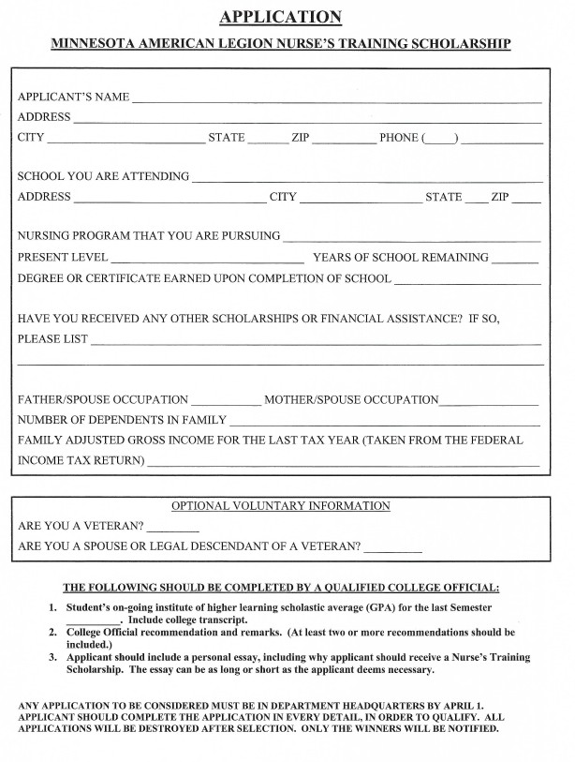

AMERICAN LEGION FIRE FIGHTER OF THE YEAR

Starting in 2010, The American Legion has given a National Firefighter of the Year Award to a firefighter who has exceeded the requirements expected of his or her position and has shown a distinct pattern of community service and professional achievement. The award, which takes into account heroic acts, will be given annually at the Legion's national convention.
Fire departments are encouraged to submit nominations to the American Legion Post in their community. Posts must then submit them to the District Law and Order Chairman. After selection of the District candidate the application is then forwarded to American Legion Department Office. Applications must be received in the Department Officer by April 1. The Department Law and Order Committee then makes the selection of the Department Fire Fighter of the Year, and that application is forwarded to the National Headquarters. Departments may only submit one nomination per year. Only department winners are eligible for the award, which will be accepted at the national convention.
Nominees must be active firefighters and U.S. citizens. Emergency medical technicians (EMTs) are eligible only if they are certified firefighters. Posthumous awards will be acceptable only if the nominee's death occurs after the department's selection.
Nominees must also reside and be assigned within their nominating department's state.
EACH ENTRY SHOULD BE THOROUGHLY DOCUMENTED IN BOOK FORM AND NOT TO EXCEED EIGHTEEN (18) PAGES. This is in accordance with National rules. The application should be supported with additional materials, to include: (1) a completed application form, (2) a 5”x7” photograph of the nominee and (3) a maximum of 18 one-sided pages 8 ½ x 11 bond paper of service documentation. The first six or seven pages should contain the individual’s service narrative. The additional pages may include supporting citations and other documentation to include press articles.
The American Legion will provide the award winner and spouse with travel, hotel and other reasonable expenses for a round trip to the national convention city.

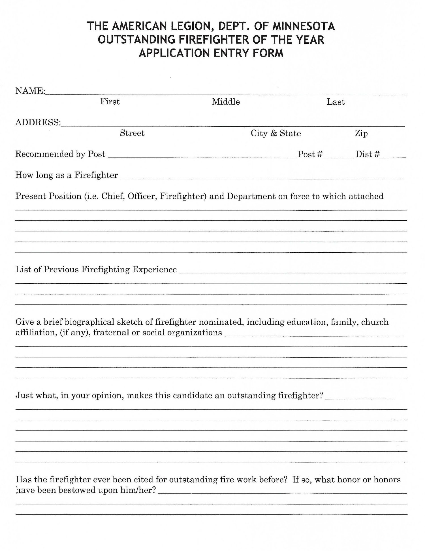

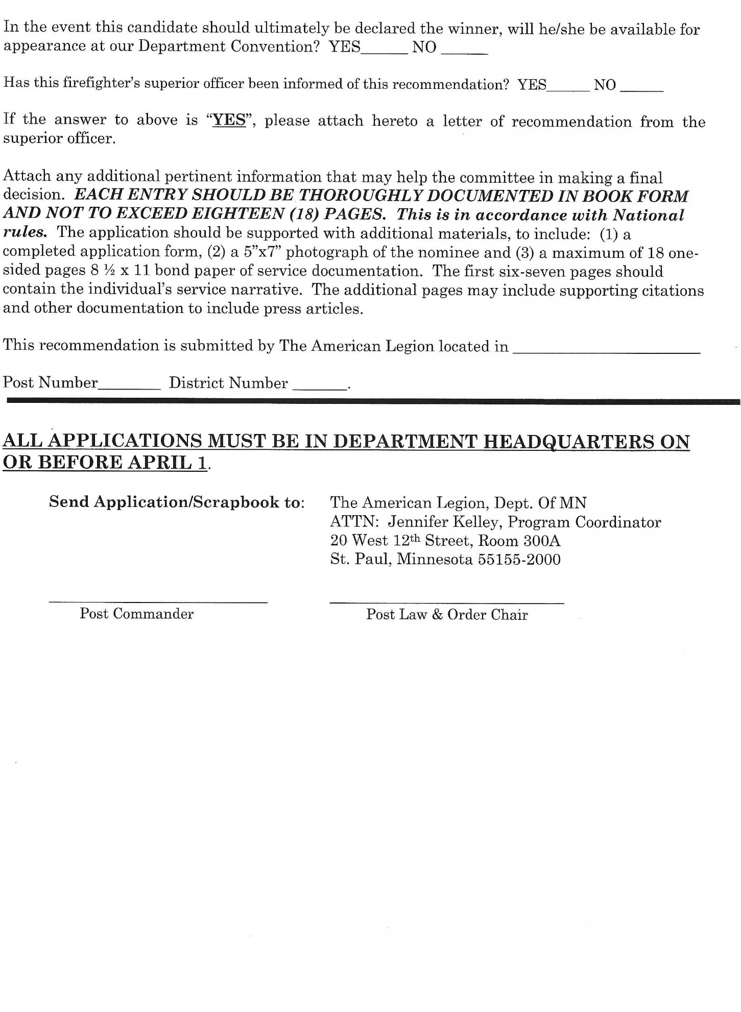

AMERICAN LEGION LAW ENFORCEMENT OFFICER OF THE YEAR
Each year, The American Legion gives its National Law Enforcement Officer of the Year Award to a well-rounded law enforcement officer who has exceeded the duty requirements expected of his or her position and has demonstrated a distinct pattern of community service coupled with professional achievement. The award, which especially takes into account heroic acts, is presented annually at the Legion's national convention.
Posts should submit their nominee to the District Law and Order Chairman. The District Law and Order Chairman, along with their committee, will select the District candidate and submit the application to the Department office no later than April 1. EACH ENTRY SHOULD BE THOROUGHLY DOCUMENTED IN BOOK FORM AND NOT TO EXCEED EIGHTEEN (18) PAGES. This is in accordance with National rules. The application should be supported with additional materials, to include: (1) a completed application form, (2) a 5”x7” photograph of the nominee and (3) a maximum of 18 one-sided pages 8 ½ x 11 bond paper of service documentation. The first six-seven pages should contain the individual’s service narrative. The additional pages may include supporting citations and other documentation to include press articles.
Department Law and Order Committees are encouraged to select and honor a Law Enforcement Officer of the Year at their conventions. Departments nominate their winners for the national award by submitting an application to The American Legion, Attn: National Security-Foreign Relations Division, 1608 K Street, NW, Washington, DC 20006. Departments may only submit one nomination per year. Only department winners are eligible for the national award, which should be accepted at the national convention.
Nominees must be U.S. citizens and living, active, full-time and paid, sworn law enforcement officers entrusted with full authority and the powers of arrest. Posthumous awards will be acceptable only if the nominee's death has occurred after the department's selection.
Nominees must be assigned to or fully recognized by municipal, county, district or state police; highway patrol; sheriff's office or as a sworn federal law enforcement officer (FBI, Secret Service agent,
U.S. Marshal, National Park Police, U.S. Capitol Police, etc.) Military police officers or investigators are eligible if they are state law enforcement certified.
Nominees must also reside and be assigned or attached for duty in the nominating department. Federal agents serving overseas should be nominated by the overseas department.
The American Legion will provide round-trip coach airfare or vehicle mileage, in accordance with its employee mileage reimbursement rates, staff per diem for two days, two tickets to National Commander’s Banquet, and lodging for one night in accordance with travel policies of The American Legion for an individual recipient or a single representative of a group or organization to receive the award at National Convention. The American Legion will not provide for any incidental expenses or any expenses incurred by guests accompanying the award recipient.
The National Law Enforcement Officer of the Year Award recognizes officers who go above the call of duty. A major secondary purpose of this award is to encourage further development of department and post Law and Order Committees through continued recognition of law enforcement officers. It is firmly believed this award serves to promote public trust and support of our law enforcement agency.

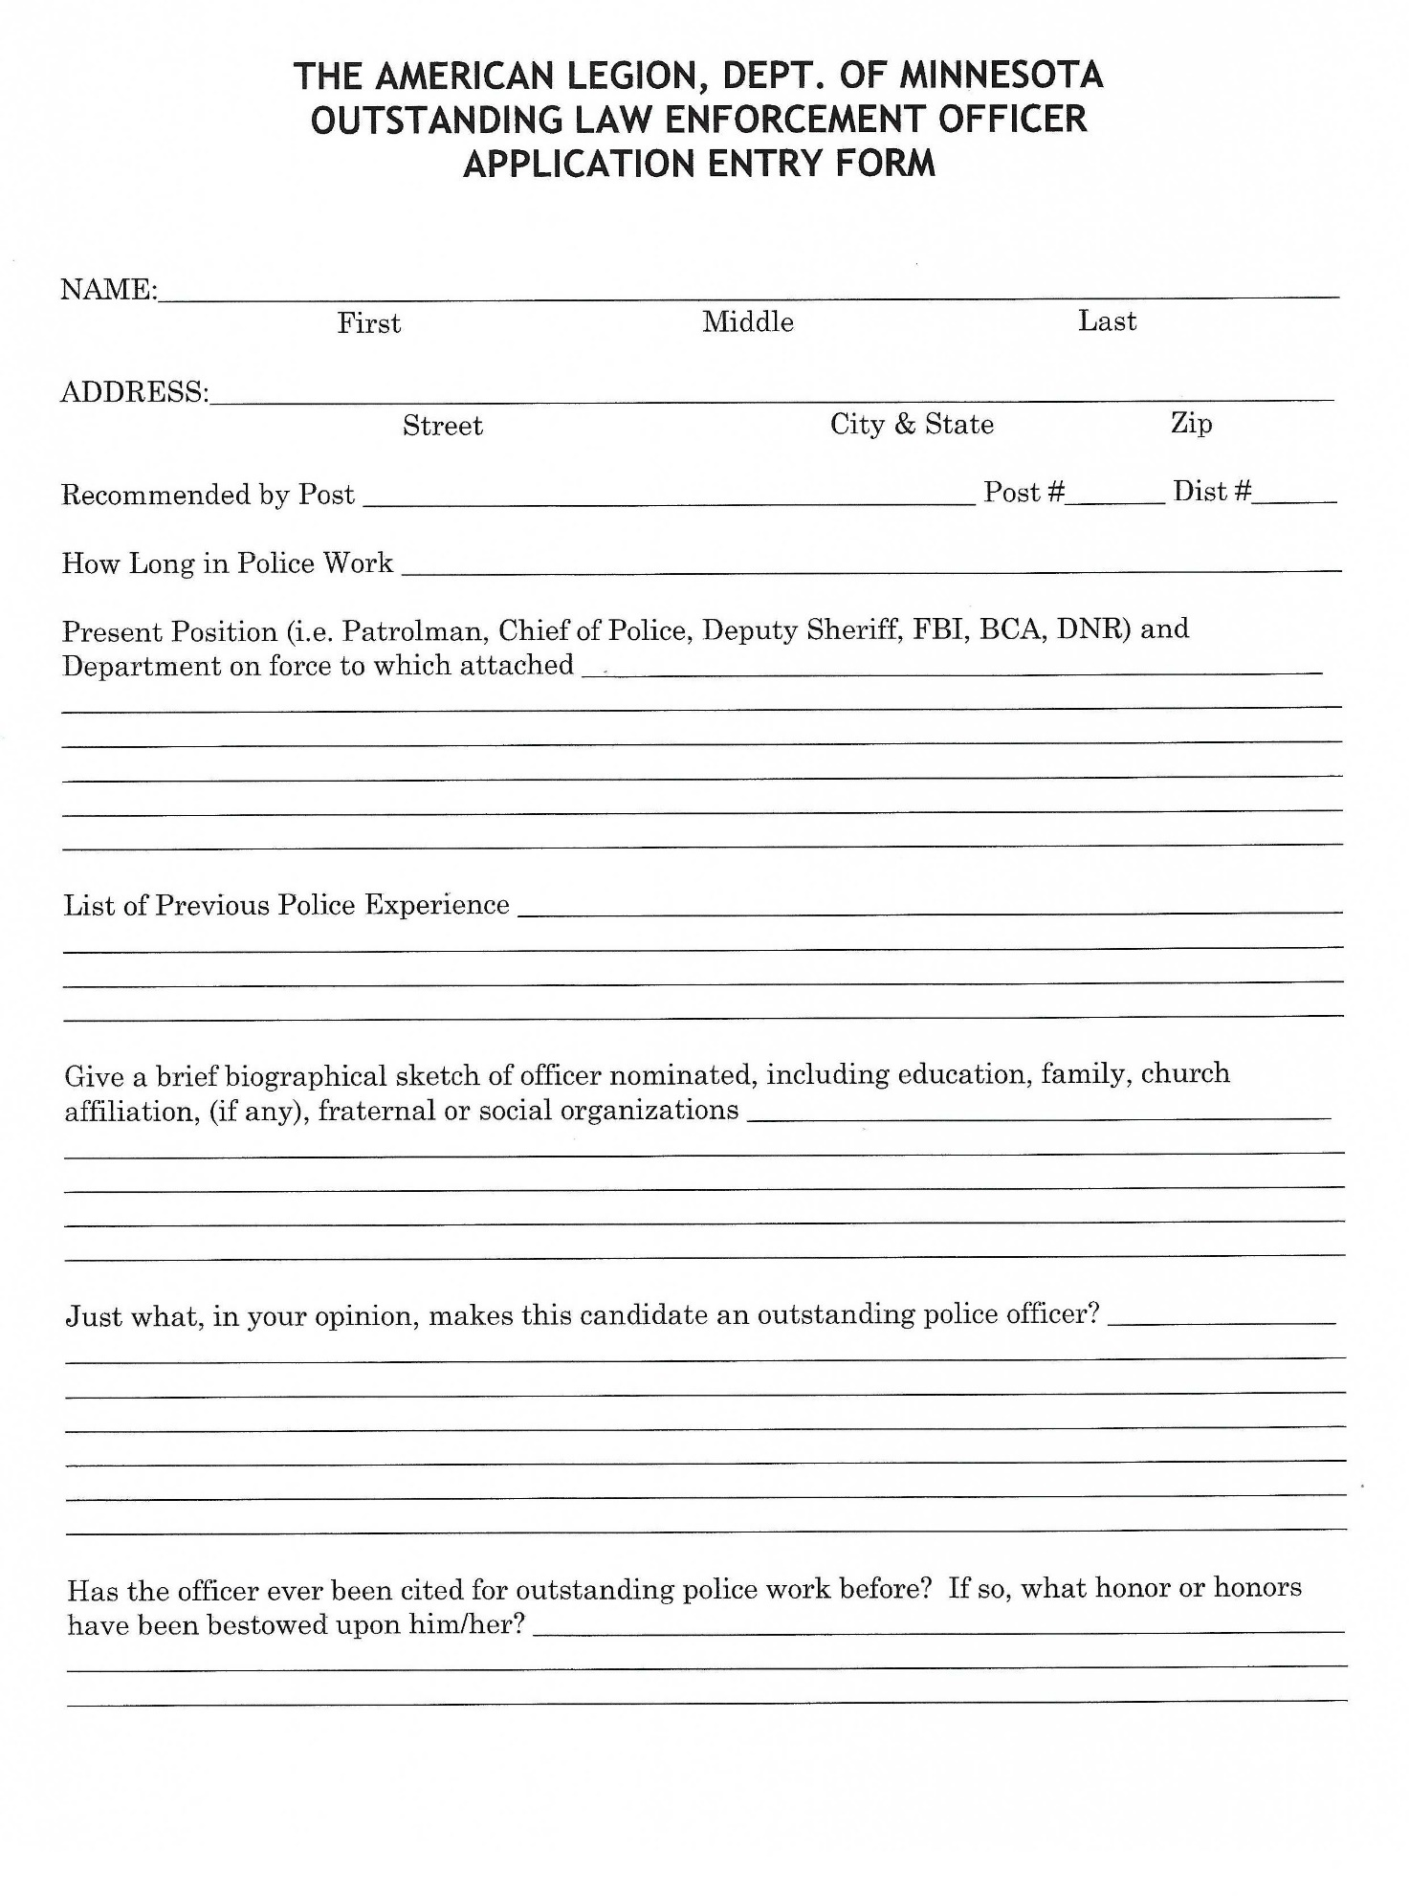

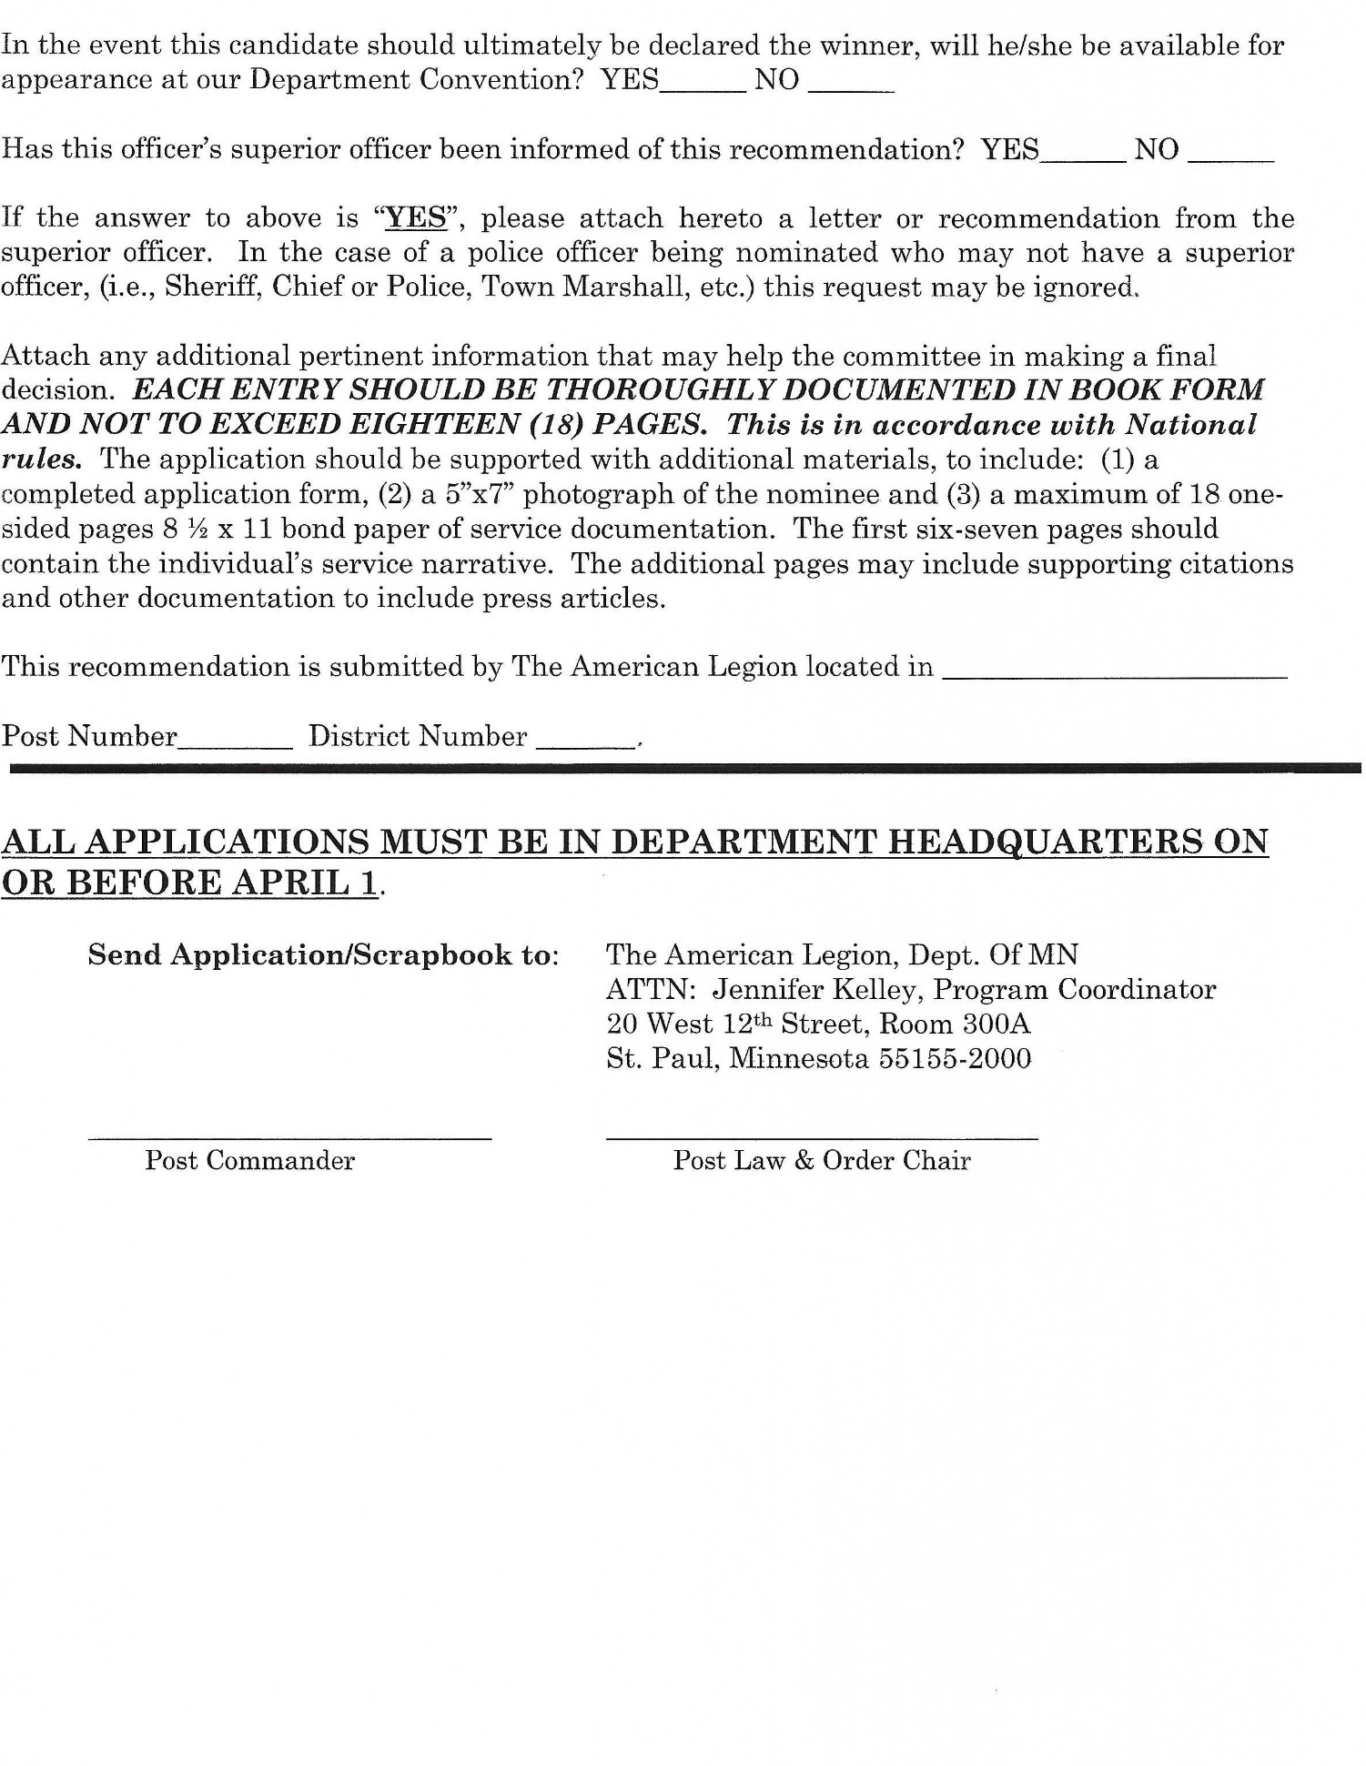

Fund for Hospitalized Veterans

The Fund for Hospitalized Veterans provides funding to certain programs within the four (4) VA Healthcare Systems (Minneapolis, St Cloud, Sioux Falls and Fargo) that care for Minnesota Veterans. Programs include, but not limited to: Veteran Emergency Assistance, Hospice, Newspapers, and Transportation Programs.
The 4th & 5th District Funding helps with purchasing canteen books for hospitalized veterans. These books can be used to purchase canteen items in the cafeteria or shopette.
The VHA Enrolled Veterans Emergency Assistance Fund can assist with financial hardships for food, gas, or homeless short-term hotel stays, etc.

NOVEMBER

Consolidated Post Report (CPR) Monthly Worksheet 92

Membership Goal (Veterans Day). 93

Renew & Rejoint Report 94

ROTC Scholarship Program 95

CONSOLIDATED POST REPORT MONTHLY WORKSHEET
NOVEMBER
PROGRAMS | ACTIVITIES | EXPENSES | MAN HOURS | # OF PARTICIPANTS
VA&R: Cases Handled, Funds Disbursed, Volunteer at VA Hospital
National Security: # of Blood Donors & Pints,
ROTC Medals, Funeral Honors, Cost of Uniforms
Media & Communications: Community Events, Mention in Radio, TV, Cable, Newspaper
Uniformed Groups:
Economics: Referred to LVER or DVOP, placed in Employment, Job Training
Americanism – Children & Youth
Boys State, Baseball, Oratorical Contest, Shooting Sports
Scouting
Scholarships
School Awards
Other Education Programs
Flag Education/School Flags
Other Children & Youth Programs
Community Service: Donated Hall usage, Flag presentation at community events, Main Street Flag program, etc.
Administrative Costs: Paper, Equipment, Postage, etc., List Program
Contributions: Hall rental for Red Cross, other civic activities
Other:
This report will help you keep a monthly record of the work your Post does in the programs of The American Legion, and makes the Annual Consolidated Post Report, due June 1st each year, easier to fill out.

MEMBERSHIP GOAL - NOVEMBER

VETERAN’S DAY

65% GOAL

Traditionally the second Wednesday of November.

Membership cards received at the Department Headquarters on or before the cutoff date, will receive credit toward the Premier Race.

RENEW & REJOIN REPORT – NOVEMBER

REPORT OF POST OUTREACH TO UNRENEWED, EXPIRED AND 1982 MEMBERS
Post No: District: Year:

Date of Event | # of Legionnaires Participating | # of Persons Contacted

ROTC Scholarship Program

By Department Convention Resolution, the National Security/Foreign Relations Committee has the responsibility to raise money for the ROTC Scholarship Fund. This fund gives a $750 scholarship to current students in ROTC Units in Minnesota:

3 – University of Minnesota – Air Force, Army & Navy/Marines
1 – University of Minnesota Duluth – Air Force
1 – St John’s University/St Cloud State – Army
1 – Minnesota State University, Mankato – Army
1 – St Thomas College – Air Force

The success of this American Legion Program depends on the donations receive from Posts around the State of Minnesota. This program is part of the Minnesota American Legion Foundation and is Fund 63 within the Foundation.

DECEMBER

Consolidated Post Report (CPR) Monthly Worksheet 97

Membership Goal (Pearl Harbor Day) 98

Renew & Rejoin Report 99

Military Achievement Award 100

Children & Youth Report 105

CONSOLIDATED POST REPORT MONTHLY WORKSHEET
DECEMBER
PROGRAMS | ACTIVITIES | EXPENSES | MAN HOURS | # OF PARTICIPANTS
VA&R: Cases Handled, Funds Disbursed, Volunteer at VA Hospital
National Security: # of Blood Donors & Pints,
ROTC Medals, Funeral Honors, Cost of Uniforms
Media & Communications: Community Events, Mention in Radio, TV, Cable, Newspaper
Uniformed Groups:
Economics: Referred to LVER or DVOP, placed in Employment, Job Training
Americanism – Children & Youth
Boys State, Baseball, Oratorical Contest, Shooting Sports
Scouting
Scholarships
School Awards
Other Education Programs
Flag Education/School Flags
Other Children & Youth Programs
Community Service: Donated Hall usage, Flag presentation at community events, Main Street Flag program, etc.
Administrative Costs: Paper, Equipment, Postage, etc., List Program
Contributions: Hall rental for Red Cross, other civic activities
Other:
This report will help you keep a monthly record of the work your Post does in the programs of The American Legion, and makes the Annual Consolidated Post Report, due June 1st each year, easier to fill out.

MEMBERSHIP GOAL - DECEMBER

PEARL HARBOR DAY

75% GOAL

Traditionally the second Wednesday of December.

Membership cards received at the Department Headquarters on or before the cutoff date, will receive credit toward the Premier Race.

RENEW & REJOIN REPORT – DECEMBER
REPORT OF POST OUTREACH TO UNRENEWED, EXPIRED AND 1982 MEMBERS
Post No: District: Year:

Date of Event | # of Legionnaires Participating | # of Persons Contacted

Military Achievement Award

The Military Achievement Award (or Enlisted Person of the Year) is an award to honor our outstanding Minnesota Military members. The award is given to individuals in the Minnesota Army National Guard (2 Awards), Minnesota Air National Guard (1 Award), Air Force Reserve (1 Award), Army Reserve (1 Award), Navy Reserve (1 Award), Marine Reserve (1 Award) and Coast Guard Reserve (1 Award)
Each individual selected will be recognized at the Department Fall Conference and be given a plaque and a monetary award to help with expenses of getting to the conference.
Nominations must be submitted through the District National Security Chairman, who will, along with his/her committee, make the district selection and submit it to the Department National Security Committee.
The Department National Security Committee looks at not only the individual’s military career but their community involvement as well.

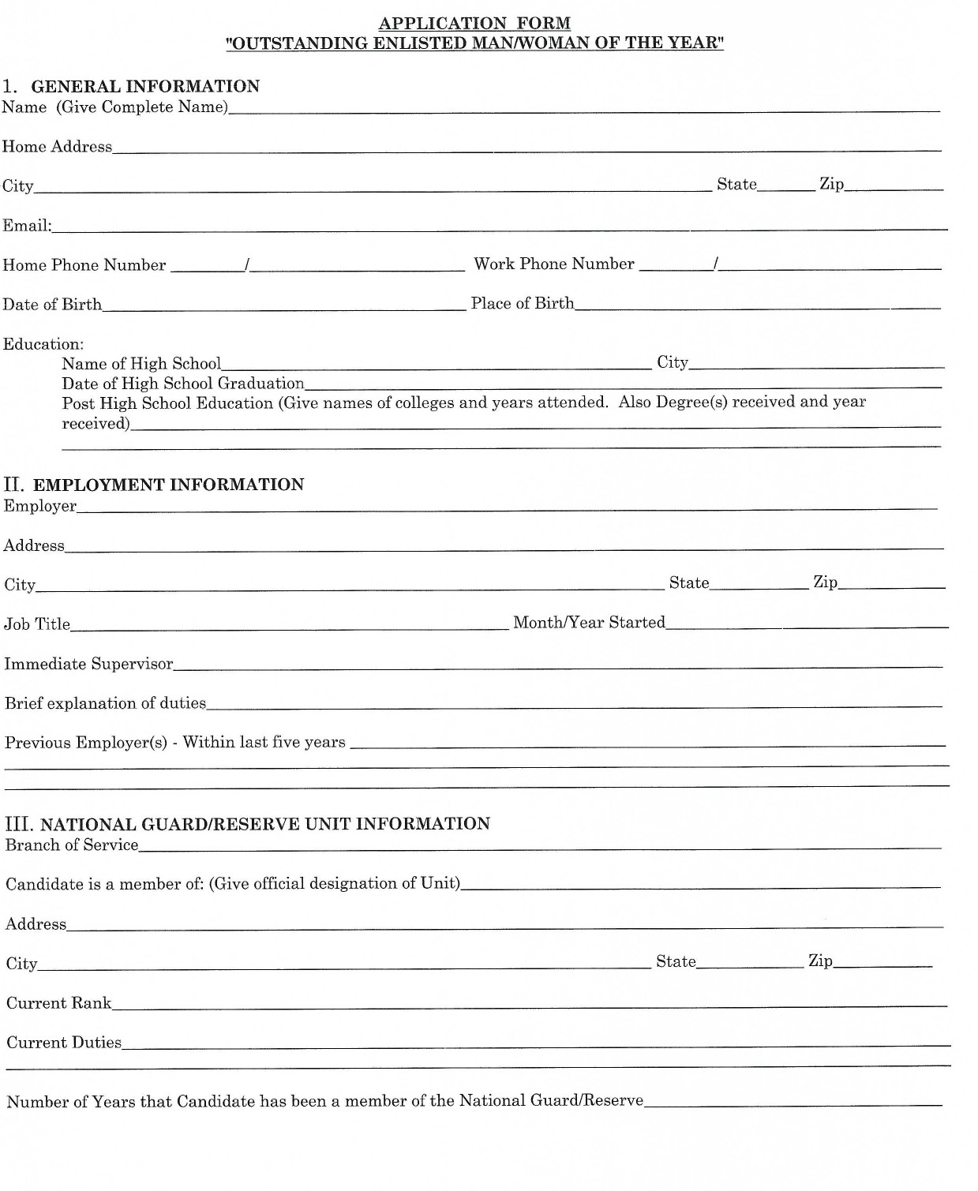
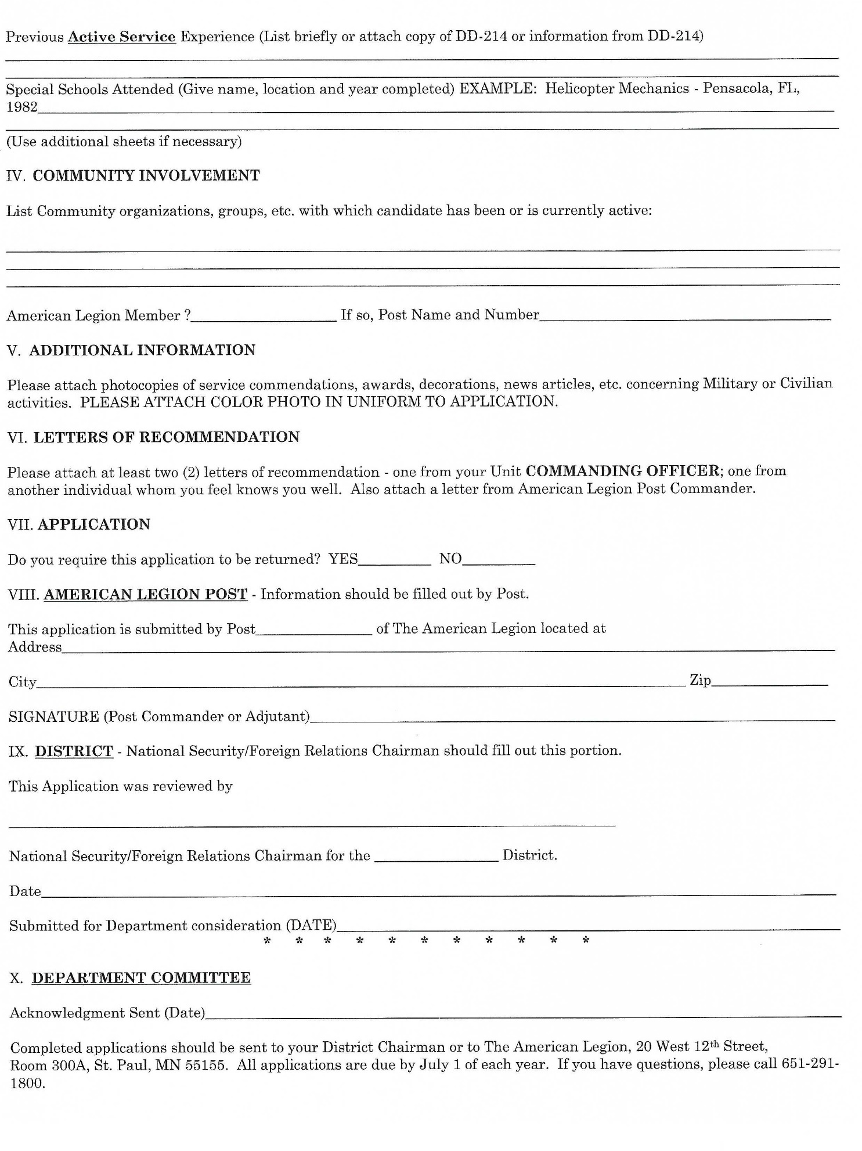

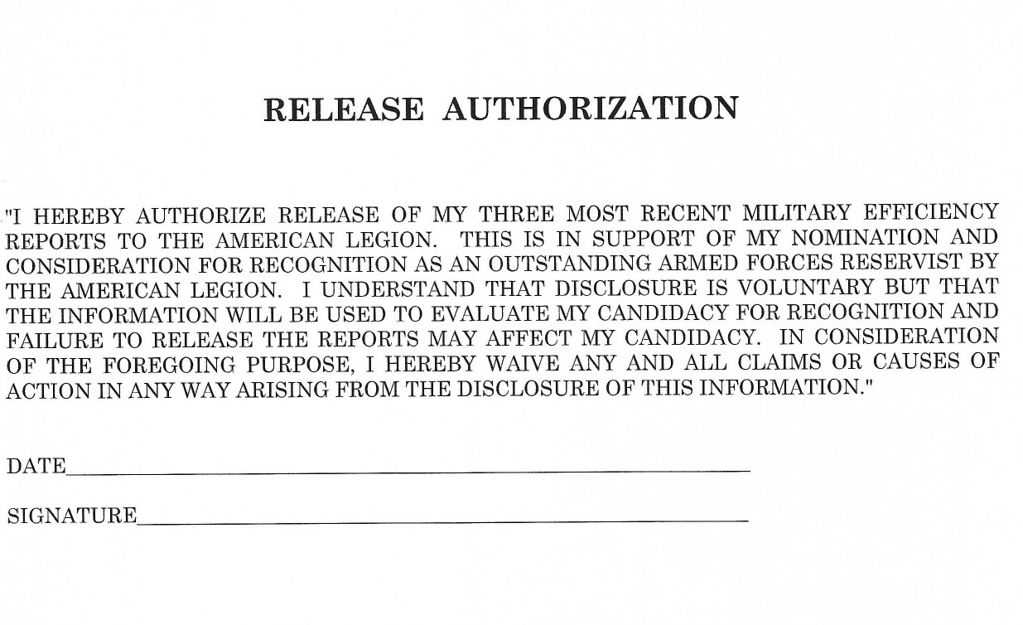

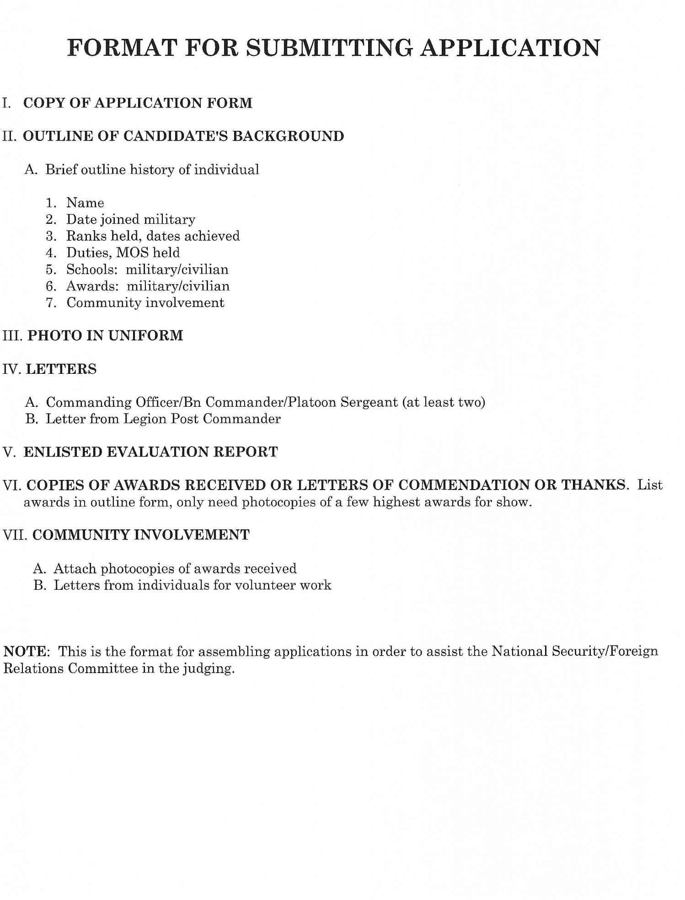

CHILDREN & YOUTH REPORTING

Each year Posts carry on many and varied programs dealing with Children & Youth. This program year encompasses the period of March 1 through February 28. The following offers information for the reporting of your Children & Youth activities during the past year and details awards available for reporting by Posts. We hope it will be helpful to you.

In addition to completing the Annual Children & Youth Report and sending it to Department Headquarters by March 31st, it is imperative that the Consolidated Post Report form be sent to Department Headquarters. The Consolidated Post Report is forwarded to National Headquarters. This information is compiled and used for testimony before congress to show the work of The American Legion and ensure the continuation of our non-profit status.

Any Post to be considered for the Annual Children & Youth Awards must have completed the Consolidated Post Report Form and have submitted it to Department Headquarters no later than JUNE 1st.
Post awards
The Committee on Children & Youth offers three post-level Children & Youth program awards. After determining which posts deserve the following awards, forward the appropriate form as indicated on the specific award order form.
Annual Children & Youth Citation
Upon certification by the department children & youth chairman, this award is available to any post that has reported an outstanding Children & Youth program for the year. The Americanism Division will send a supply of citations to the department adjutant or the C&Y chairman, who will assume responsibility for having individual citations completed and awarded.
Special Children & Youth Citation
This award recognizes posts within a district that have conducted outstanding C&Y programs during the reporting year. One post is selected from each of the four membership categories:
Category 1 15 to 99 members
Category 2 100 to 299 members
Category 3 300 to 499 members
Category 4 500+ members
Certificate of Meritorious Service
The Committee on Children & Youth issues this award for meritorious work performed by a post. It is available to only one post in each of the four membership categories within a department. These posts must have distinguished themselves as having the best Children & Youth program in their respective category. Once you have determined the top four standards for judging, posts’ reports are left entirely to the discretion of the departments. Departments are the final and sole authority in the selection of posts to receive these awards. Give citations only in cases where a post has actually reported creditable Children & Youth work. A report form with the notation “no report” is just that.
The Committee on Children & Youth believes you are the best judge of who deserves these awards; therefore, supportive material is not required for justification.

District award
The National Executive Committee has authorized one district reporting award. The National Achievement Award is given to districts achieving 100% Children & Youth reporting by posts in the district. Percentages of reporting are to be based solely on the CPR form. Children and Youth Report can be found on the Department Website mnlegion.org under Programs, then Program Downloads and Children & Youth
Department awards
The Committee on Children & Youth has authorized department C&Y reporting awards:
100% Consolidated Post Reporting Award
This award recognizes departments achieving 100% post reporting on the CPR form, as verified by National Headquarters. Qualifying departments receive their citations in the fall.
100% Children & Youth Post Narrative Reporting Award
For a department to qualify for this award, the department chairman must have received a copy of a narrative report from each of his or her posts. These in turn are compiled by the chairman into a single department narrative report, which is mailed to the Americanism Division, separate from the CPR. When you have determined that your department has achieved 100% C&Y narrative reporting, fill out the appropriate form, attach a copy of each report and forward it to the Americanism Division. Only those departments having 100% Children & Youth post reporting should submit this report for verification.

THE AMERICAN LEGION, DEPARTMENT OF MINNESOTA
POST CHILDREN AND YOUTH REPORTING FORM (for March 1 through February 28)

********** ********** ********** ********** ********** # of Children Man/Hours $ Cash (Rounded)
SECTION A. NATIONAL MAIN POINTS OF EMPHASIS
1) APRIL IS C & Y MONTH YES___ NO___ ___________ __________ $_______________
2) DRUG AND ALCHOL ABUSE YES___ NO___ ___________ __________ $_______________
3) CHILDREN’S MIRACLE NETWORK YES___ NO___ ___________ __________ $_______________
4) NATIONAL FAMILY WEEK YES___ NO___ ___________ __________ $_______________
5) CHILD SAFETY YES___ NO___ ___________ __________ $_______________
6) YOUTH SUICIDE PREVENTION YES___ NO___ ___________ __________ $_______________
7) HALLOWEEN SAFETY YES___ NO___ ___________ __________ $_______________
8) FAMILY SUPPORT NETWORK YES___ NO___ ___________ __________ $_______________ 9) OPERATION MILITARY KIDS YES___ NO___ ___________ __________ $_______________

********** SECTION A TOTAL - ITEMS 1 through 9 ********** ___________ __________ $_______________

SECTION B. DIRECT AID TO CHILDREN
- Money your Post gave to needy families with children for food,
clothing, fuel, medical assistance, food, shelter, etc. ___________ __________ $_______________
2) Value of goods or services (if by donation), for food, clothing, etc. ___________ __________ $_______________

********** SECTION B TOTAL - ITEMS 1 through 2 ********** ___________ __________ $_______________

SECTION C. PARTIES, GIFTS, CAMPS, CONTESTS, ETC
- Holiday Parties, School Patrol Parties, Teen Dances, Fre
Movies and Free Videos, Senior Graduation Party ___________ __________ $_______________
2) Red Wing & Sauk Centre School gift / Boys and Girls County ___________ __________ $_______________
3) Legionville - Contributions (NOT Registration Camper Fees) ___________ __________ $_______________ 4) Special C&Y Projects (Specify with special report.
Use back &/or extra sheets as necessary) ___________ __________ $_______________

********** SECTION C TOTAL - ITEMS 1 through 4 ********** ___________ __________ $_______________

SECTION D. ACTIVITIES
1) Sports OTHER THAN AMERICAN LEGION BASEBALL ___________ __________ $_______________
2) 4-H Club, FFA, FHA, Special Olympics ___________ __________ $______________
3) Other (Specify Use back &/or extra sheets as necessary) ___________ __________ $_______________

********** SECTION D TOTAL - ITEMS 1 through 3 ********** ___________ __________ $_______________

SECTION E. CONTRIBUTIONS to Charitable Organizations (Indirect Aid for Children only)
1) Community Fund (Youth Activities Only) ********** ********** $_______________ 2) Mental Health, Handicapped Children ********** ********** $_______________
3) American Red Cross / United Way ********** ********** $_______________
4) Child Welfare Fund ********** ********** $_______________
5) Other (Specify Use back &/or extra sheets as necessary) ********** ********** $_______________

********** SECTION E TOTAL - ITEMS 1 through 5 ********** ********** ********** $_______________

SECTION F. MISCELLANEOUS ($ dollar - value in kind)
- $ Value of Man-hour labor donated by Post members for C&Y projects
(include all hours worked in Sections A through D) @ $10.00 per TOTAL HOURS $_______________
2) $ Value of Rental of Post Building or property for C&Y projects @ $200.00 per OCCASION $_______________
3) Amount of money spent for administrative expenses for C & Y
overhead (postage, printing, conferences, etc) $ Value ESTIMATED $_______________

********* SECTION F TOTAL - ITEMS 1 through 3 ********** ********** ********** $_______________

GRAND TOTALS (SECTIONS A – F) ___________ __________ $_______________ CHILDREN HOURS CASH (rounded)

DISTRICT # _____ POST # ______

POST NAME _______________________________________________ LOCATED AT ____________________________, MN

POST MEMBERSHIP AS OF MARCH 1, (previous year) ________ DATE_______________________________
Person making report _______________________________________ Signed _______________________________________

PLEASE COMPLETE THIS FORM IN DUPLICATE (typed or legibly hand printed)

With attachments & an optional narrative elaborating on your posts children & youth activities

*************** SUBMIT – BEFORE MARCH 31 – NO LATER ***************

WHITE COPY TO YOUR DISTRICT CHILDREN & YOUTH CHAIRMAN – YELLOW COPY FOR POST FILE

JANUARY

Consolidated Post Report (CPR) Monthly Worksheet 109

Membership Goal (Midwinter) 110

Renew & Rejoin Report 111

Boys State 112

Blood Report 113

CONSOLIDATED POST REPORT MONTHLY WORKSHEET
JANUARY
PROGRAMS | ACTIVITIES | EXPENSES | MAN HOURS | # OF PARTICIPANTS
VA&R: Cases Handled, Funds Disbursed, Volunteer at VA Hospital
National Security: # of Blood Donors & Pints,
ROTC Medals, Funeral Honors, Cost of Uniforms
Media & Communications: Community Events, Mention in Radio, TV, Cable, Newspaper
Uniformed Groups:
Economics: Referred to LVER or DVOP, placed in Employment, Job Training
Americanism – Children & Youth
Boys State, Baseball, Oratorical Contest, Shooting Sports
Scouting
Scholarships
School Awards
Other Education Programs
Flag Education/School Flags
Other Children & Youth Programs
Community Service: Donated Hall usage, Flag presentation at community events, Main Street Flag program, etc.
Administrative Costs: Paper, Equipment, Postage, etc., List Program
Contributions: Hall rental for Red Cross, other civic activities
Other:
This report will help you keep a monthly record of the work your Post does in the programs of The American Legion, and makes the Annual Consolidated Post Report, due June 1st each year, easier to fill out.

MEMBERSHIP GOAL - JANUARY

MIDWINTER

80% GOAL

Traditionally the third Wednesday of January.

Membership cards received at the Department Headquarters on or before the cutoff date, will receive credit toward the Premier Race.

RENEW & REJOIN REPORT – JANUARY
REPORT OF POST OUTREACH TO UNRENEWED, EXPIRED AND 1982 MEMBERS
Post No: District: Year:

Date of Event | # of Legionnaires Participating | # of Persons Contacted

BOYS STATE

Minnesota American Legion Boys State is a week-long experience of learning about Minnesota government at the local, county and state levels by “doing”. It is a week of intensive study and involvement. The participants will actually organize and participate in the various levels and branches of government in addition to participating in athletics, writing for the newspaper or holding leadership positions across all levels of the program. Every boy will participate in the process of city, county and state government. Minnesota Boys State is a program for young men who have just completed their junior year of high school. Highlights of the week include political speakers, mock trials, campaigning, elections, and announcement of the Boys State Governor and State Constitutional Officers.
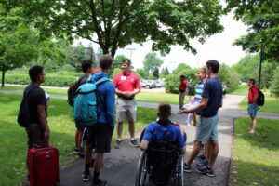
Unlike a summer or recreational camp, Minnesota Boys State is a week of studying and learning by involvement. However, they do have fun times, too. The citizens also have the opportunity for group living. For many, it will be their first exposure to dormitory living and sharing a room. Meals are served cafeteria style. This is quite different from their home environment. This week will be a good preview of college dorm life. The citizens have both an opportunity and a responsibility. The opportunity is one of participating in a program of government with hundreds of other young men from throughout Minnesota. The responsibility is not only spending the week learning as much as he can, but also taking this knowledge and experience back into his school and his community, using it and sharing it with others. If you have any questions concerning Minnesota American Legion Boys State, please contact State Headquarters or your local American Legion Post.
Our staff is an all-volunteer organization comprised of Legionnaires, former Boys Staters, teachers, and civic minded citizens from various professions. Combined, the staff has decades of experience in instructing the delegates at Boys State and works hard to fulfill the objectives and goals put forth by the American Legion.
Go to our website and find out more about Minnesota Boys State www.mnboysstate.org or contact The American Legion Department of Minnesota at (651) 291-1800.

BLOOD DRIVE INFORMATION

Convenience, for many people, turns out to be the deciding factor whether they give blood or not. The American Red Cross works closely with companies, community groups, military bases, churches and synagogues, colleges, universities and high schools to organize blood drives at places most convenient for donors; the places where they live, work, worship and play. In fact, 80% of blood donations made through the Red Cross are made at blood drives rather than fixed donor centers.

Blood drives need sponsors and organizations that can provide the appropriate physical space and a coordinator from the organization to educate, motivate and recruit donors and work with the local Red Cross.

Why do organizations sponsor drives? It is both a simple and powerful way to serve your community and allow employees/colleagues or members to get involved. Whether your organization is large or small, you can make a difference!

If you or your organization is interested in becoming a blood drive sponsor, please call 1-800- GIVE LIFE (1-800-448-3543) for details or contact your local blood center for more information.

What you can expect as a blood drive sponsor:

The Sponsor: Offers a suitable location ~ Helps recruit donors within the organization and publicizes the drive ~ Schedules donors for their appointments (Now also online).

The Red Cross/Blood Center does the rest: Works with you every step of the way to plan and organize the Blood Drive ~ Helps you determine how many donors to expect and how to recruit them ~ Brings equipment and supplies to you, sets everything up and takes it down at the end. ~ Confidentially screens donors and collects the donations, safely and professionally ~ Schedules or helps you schedule volunteers to greet donors and serve refreshments.

Resources for Sponsors:

When you host a blood drive, your Red Cross representatives will provide you with a variety of resources and recruitment tools.

Many resources are available online at http://www.redcrossblood.org. This site offers tools for hosting a Blood Drive, promoting your blood drive and allows for donors to pre-register for your drive. Regular donors have a Red Cross app on their electronic devices that shows them the nearest registered Blood Drive.

And last, but not lease, please see the difference you are making in so many lives and accept a big THANK YOU – we couldn’t do it without you!

AMERICAN LEGION POST BLOOD DONATION REQUEST
TO: Post Adjutants or Post Blood Chairman

This report is for dates January 1 through December 31. Please answer the following questions and return by May 1 to your District Blood Chairman.

- Number of Legionnaires, Auxiliary and SAL members donating blood during this time period
.
- Total number units of blood donated by Legionnaires, Auxiliary and SAL members during this time period .

- Did your Post sponsor a Bloodmobile/Blood drive? YES NO . If yes, total of units donated through your efforts .

- Are these totals estimated? YES NO .

- Total Units of Blood Donations

Please take the time to fill this out and get credit for what your Post is doing. Also, please fill in the Blood Donor Program section on the yearly Consolidated Post Report. Last year it was item 14 & 15 under National Security.

POST NUMBER DISTRICT

POST NAME

ADDRESS

CITY ZIP

YOUR NAME

SIGNATURE TITLE

YOUR ADDRESS

CITY ZIP

PLEASE RETURN TO DISTRICT BLOOD CHAIRMAN BY MAY 1.

OPTIONAL PAGE
This is an optional second page of the blood program report. Please fill out this page if the number of units of blood has, or could in the future, increase.

Does your Post participate in a blood program? YES NO _

If so, do your think an additional drive
per year (or more) would be possible? YES

NO______

If not, would you be interested in
starting a new location? YES NO________

If not, would you be interested in helping with a drive in your community? (Such as providing space for the drive or helping
with the refreshments) YES NO_________

A suggestion for any Post/Unit/SAL that is interested in some expansion of their activity would be to contact the County Health Nurse. Also let your District Blood Program Chairman know of your interest.

FEBRUARY

Consolidated Post Report Monthly (CPR) Worksheet 117

Membership Goal (President’s Day) 118

Renew & Rejoint Report 119

Baseball 120

.

CONSOLIDATED POST REPORT MONTHLY WORKSHEET
FEBRUARY
PROGRAMS | ACTIVITIES | EXPENSES | MAN HOURS | # OF PARTICIPANTS
VA&R: Cases Handled, Funds Disbursed, Volunteer at VA Hospital
National Security: # of Blood Donors & Pints,
ROTC Medals, Funeral Honors, Cost of Uniforms
Media & Communications: Community Events, Mention in Radio, TV, Cable, Newspaper
Uniformed Groups:
Economics: Referred to LVER or DVOP, placed in Employment, Job Training
Americanism – Children & Youth
Boys State, Baseball, Oratorical Contest, Shooting Sports
Scouting
Scholarships
School Awards
Other Education Programs
Flag Education/School Flags
Other Children & Youth Programs
Community Service: Donated Hall usage, Flag presentation at community events, Main Street Flag program, etc.
Administrative Costs: Paper, Equipment, Postage, etc., List Program
Contributions: Hall rental for Red Cross, other civic activities
Other:
This report will help you keep a monthly record of the work your Post does in the programs of The American Legion, and makes the Annual Consolidated Post Report, due June 1st each year, easier to fill out.

MEMBERSHIP GOAL – FEBRUARY

PRESIDENT’S DAY

85% GOAL

Traditionally the second Wednesday of February.

Membership cards received at the Department Headquarters on or before the cutoff date, will receive credit toward the Premier Race

RENEW & REJOIN REPORT – FEBRUARY
REPORT OF POST OUTREACH TO UNRENEWED, EXPIRED AND 1982 MEMBERS
Post No: District: Year:

Date of Event | # of Legionnaires Participating | # of Persons Contacted

THE AMERICAN LEGION BASEBALL PROGRAM

American Legion Baseball enjoys a reputation as one of the most successful and tradition-rich amateur athletic leagues. American Legion Baseball is a summer program for boys 13-19 years old. Posts sponsor and financially support over 300 Minnesota American Legion Baseball teams. The purpose of American Legion Baseball is to:
- Instill in youth a better understanding of the American way of life and to promote the principles of Americanism.
- Instill in the nation’s youth a sincere desire to develop within themselves a feeling of citizenship, sportsmanship, loyalty and team spirit.
- Aid in the improvement and development of the physical fitness of our country’s youth.
- Build for the Nation’s future through our youth.

All games are played under the OFFICIAL BASEBALL RULES as published by The Sporting News of St. Louis, MO and is modified by the National American Legion Baseball Rule Book and the Minnesota American Legion Baseball handbook.
All teams have to play at least 10 games against Legion Baseball teams to compete in regional play. There are seven (7) Regional tournaments played in each class statewide. The State Baseball Commissioner and the Board of Directors assign each team to a Regional Tournament.
Scholarship Information: An annual scholarship is awarded by the Minnesota American Legion Baseball Association to a graduating senior who demonstrates outstanding leadership, scholarship, character and citizenship and who has a demonstrated need for funding to continue their education beyond high school. Players are nominated by their respective team managers in June, and the winner is selected by the Minnesota American Legion Baseball Association each July.
Important Dates to Remember:
- All teams must register, buy insurance and pay fees through National’s electronic registration system at www.legion.org/baseball prior to May 15th.
- A hardcopy of the Player Agreement (form 2) must be completed and signed prior to the team’s first scheduled game.
- On-line team roster (form 1) must be completed by Mid-June at www.legion.org/baseball.

Code of Sportsmanship
I will: Keep the rules; Keep faith with my teammates;
Keep my temper;
Keep myself fit;
Keep a stout heart in defeat; Keep my pride under in victory;
Keep a sound soul, a clean mind, and a healthy body.

For more information contact Department Headquarters at (651) 291-1800

MINNESOTA AMERICAN LEGION

Girls Fastpitch SOFTBALL
Purpose & Mission
- To instill to youth a better understanding of the American way of life and to promote the principles of 100 percent Americanism.
- To instill in Minnesota’s youth a sincere desire to develop within themselves a feeling of citizenship, sportsmanship, loyalty, and team spirit.
- To aid in the improvement and development of the physical fitness of our country’s youth.
- To strengthen and build the nation’s future through our youth.
- Build a sense of giving back. It is recommended that all players, coaches, or teams perform at least one veteran community service act as a team, group, or individual during the year. Examples:
  - Any way to show veterans that you are thankful for their service and the opportunity their service has provided you to represent them, your Community, Family, and Country.
  - Help your post with a project
  - Volunteering at or visiting a V.A. Hospital or veterans homes

FAQ'S
Our goal is to make softball accessible to softball players across the state.
Where/How do we register?
Register under the Registration tab on top of the home page.
Do we have to be sponsored by an American Legion Post?
No, you can be sponsored by a post or a business/organization as long as it is approved by the softball committee. We would prefer a post to sponsor each team and plan on creating an "Adopt a Team" for posts looking to sponsor teams as well.
What uniform requirements will there be?
The American Legion softball logo will be required for the left sleeve or left chest of the uniform. Currently, we are waiting approval of our logo. This requirement may be delayed awaiting approval.
What is the cost? What is included in that cost?
The cost is $500. That covers state fees and insurance. It also locks you into an opportunity for postseason play.

Can we combine towns/schools to make a team?
Teams are created based on school enrollment. Each player is tied directly to their high school. If two or more neighboring schools need to combine enrollment to create a team, that is acceptable as long as the enrollment does not surpass 3,600 students. If a team is created by a cooperative like this, all players in those schools would be tied to that team.
Who schedules games? When do we play?
Once we have a list, teams will need to contact teams in their area / district to put together schedules/conferences.
Who is in charge of league play? Playoffs?
League play will be done locally. Playoffs will be overseen by Directors. Some playoff Sub-States will be very similar to the leagues you play in. Others may not depending on the number of teams registered in your area.
What will playoffs look like?
Great question but very little clarity right now until we know the number of teams we will have our first year. We will have an 8-team state tournament meaning 7 qualifying teams and the host.
American Legion Softball is set up very similar to baseball to keep things familiar for posts that already sponsor a baseball team. The playoff format has the same setup in mind. However, logistics need to be ironed out when teams register.

For more information contact Department Headquarters at (651) 291-1800

MARCH

Consolidated Post Report (CPR) Monthly Worksheet..............122

Membership Goal (Legion Birthday) 123

Renew & Rejoin Report 124

Post Service Officer Report 125

Community Service Report 128

Consolidated Post Report 130

Consolidated Squadron Report 132
CONSOLIDATED POST REPORT MONTHLY WORKSHEET
MARCH
PROGRAMS | ACTIVITIES | EXPENSES | MAN HOURS | # OF PARTICIPANTS
VA&R: Cases Handled, Funds Disbursed, Volunteer at VA Hospital
National Security: # of Blood Donors & Pints,
ROTC Medals, Funeral Honors, Cost of Uniforms
Media & Communications: Community Events, Mention in Radio, TV, Cable, Newspaper
Uniformed Groups:
Economics: Referred to LVER or DVOP, placed in Employment, Job Training
Americanism – Children & Youth
Boys State, Baseball, Oratorical Contest, Shooting Sports
Scouting
Scholarships
School Awards
Other Education Programs
Flag Education/School Flags
Other Children & Youth Programs
Community Service: Donated Hall usage, Flag presentation at community events, Main Street Flag program, etc.
Administrative Costs: Paper, Equipment, Postage, etc., List Program
Contributions: Hall rental for Red Cross, other civic activities
Other:
This report will help you keep a monthly record of the work your Post does in the programs of The American Legion, and makes the Annual Consolidated Post Report, due June 1st each year, easier to fill out.
MEMBERSHIP GOAL – MARCH

LEGION BIRTHDAY

90% GOAL

Traditionally the second Wednesday of March.

Membership cards received at the Department Headquarters on or before the cutoff date, will receive credit toward the Premier Race

RENEW & REJOIN REPORT – MARCH
REPORT OF POST OUTREACH TO UNRENEWED, EXPIRED AND 1982 MEMBERS
Post No: District: Year:

Date of Event | # of Legionnaires Participating | # of Persons Contacted

POST SERVICE OFFICER REPORT

The American Legion- Department of Minnesota
Post Service Officer Report
Please report on your Post activities from April 1st - March 31st.
Please print LEGIBLY.
Once completed please return to your District Rehabilitation Chairman by May 22nd.
Post Name/ City |  | Post Commander
Post # |  | District #

1- Does your Post have a Post Service Officer (PSO)? |  | Yes | No
2- Number of veterans assisted by your Post Service Officer. |  | #
3- Does your Post have medical equipment to loan veterans & dependents? |  | Yes | No
4- Does your Post have activities or programs that help homeless veterans? |  | Yes | No
5- Number of veterans your Post has assisted in finding employment. |  | #
6- Number of veterans your Post has assisted in finding training opportunities. |  | #
7- Does your Post provide military funeral honors? |  | Yes |  | No
8- To date, the number of regularly scheduled (RS) volunteers and RS hours to VA Voluntary Service (VAVS) programs within your Post.

 | # RS Volunteers
 | # RS Hours
9- To date, the number of occasional volunteers and occasional hours contributed to VA Voluntary Service (VAVS) programs within your Post.

 | # Occasional Volunteers
 | # Occasional Hours
10- Number of new VAVS volunteers & assignments within the last year. | #
11- How many American Legion awards for voluntary service in the VAVS program were presented this year? | # of awards for each
 | 100 hours
 | 300 hours
 | 1,000 hours
 | 2,000 + hours
12- Does your Post contribute to local VA Medical Center?  VA Medical Center: __________________ Amount contributed: $______________ |  | Yes |  | No
13- What does your Post do to encourage and support Youth volunteers? | Please give examples:
14- Does your Post have any special rehabilitation projects that regularly aid veterans and their dependents? | Please give examples:
15- Did your Post make any referrals to Department Headquarters or Department Service Officer for assistance to the Department for Temporary Financial Assistance (TFA)?  How many? ________________ |  | Yes |  | No
16- Did your Post make any referrals to Department Headquarters or Department Service Officer for assistance for Family Support Network?  How many? ________________ |  | Yes |  | No
17- Please list Post funds expended in rehabilitation related activities: | List:
18- Is your Post a member of your community’s ‘Beyond the Yellow Ribbon’ program? |  | Yes |  | No
19- Who is your Count Veteran Service Officer (CVSO)? | Name & County:
20- Who is the Post Service Officer at your Post? | Name

Additional Comments:

Person Completing Form:

Name |  | Phone #
Title |  | Email:

COMMUNITY SERVICE REPORT

Service to our Country and Community is what created The American Legion. Continuing to serve is what the Legion Family has always done to help our immediate communities improve our lives and get through bad times. Your membership interacts and helps the community in may ways.
The Community Service Report and Competition allow you to recognize the effotst of your Post, they deserve it.
Simple Rules for filling out the report:
- You can use every hour of your membership’s volunteered time!
- You will total up All Donations that your Post has made in each category. If you cannot find a fitting category, use the last one.
- $10.00 for Each Volunteer hour is then added to the actual donation total.
  - Example: (5 hours of time and $100 actual cash would give you a credit of $150) in the dollars column
- All reports have to be in the Department office by June 1st to be accepted.
- Every Post gets 1 hour and the $10 credit for just filling out the report. Put it in the last category under community.

Competition Categories
At the Department Convention the following certificates and plaques will be awarded.
- Four certificates will be awarded in each Post membership category within each District. One in each of the following four membership categories:
  - Category I – Posts with membership of 10 to 100
  - Category II – Posts of 101-250
  - Category III – Posts of 251-700
  - Category IV – Posts of 701 and above
- A plaque will be awarded to the Post with the Highest Volunteer Hours per Member in each of the four (4) categories.
- A plaque will be awarded to the Post with the Highest Financial Contribution in each of the four (4) categories.

Remember volunteer hours can and have often overtake gambling contributions.

8 Plaques – Win One!

COMMUNITY SERVICE CONTEST REPORT
The American Legion, Department of Minnesota
Fill out this report to the best of your knowledge. This information is for the Community Service competition plaques and awards. Any Post can win an award. Every hour and every dollar counts. Dollars are calculated by actual donation dollars plus an additional $10.00 per hour for every hour of volunteered time since May 1. You will be surprised at how many you have when you start adding them up.

Children and Youth Activities and Contributions
Special Education, United Fund Drive, Red Cross, Cancer,
Children in Distress, Special Olympics, Plus other Post Activities related:
Hours______ Total $_________

Veterans Affairs, Hospitals and Rehabilitation
Post Service Officer, Aid from Post Funds, VA Hospital Programs & Vol. Hrs.
Vets Home Vol. Hrs., Post Vets in Distress, Pheasant Dinners:
Hours or Expenses incurred directly for veterans Hours______ Total $_________

Americanism Programs
Boys State, A.L. Baseball, Boy Scouts, Shooting Sports, Oratorical Contest,
Aid to School Sports, Music & the Arts, Energy Conservation, Memorial Day,
Veterans Day in the Schools, Education Week, Drill Teams, Color Guard, etc.
Include any Program you feel falls under Americanism. Hours______ Total $_________

Military Funerals for Comrades
Number of Funerals and/or Memorial Services since last Department Convention ______
(For Volunteer Funeral Hours always use a (minimum of 21 hrs) or 3 hrs per
funeral detail member per funeral): Hours______ Total $_________

Donations for Service done for your Community
This total is for anything your Post does for your community
that is not listed above. Parks, Swimming pools, Vets Parks,
Flags, Ball Parks, City Donations, Senior Citizens Groups, etc: Hours_______ Total $________

Add up Two Columns for the Grand Totals __________ $__________

Dist #______ Post Name ___________________________________Post Number ______ City___________________

Current Post Goal Membership _________

Person completing this report

Signature:__________________________________

Title:________________________________________________

Phone Number: _____ _____________________ (Phone needed if we have questions)

CONSOLIDATED POST REPORT ANNUAL REPORTING
Purpose: To obtain and tabulate quantitative reports form Posts on major National Programs.
Procedure: The Department Adjutant provides the Posts with a preprinted form to fill out. Instructions follow on how to prepare the form. This form is also available online through MyLegion.org
Deadline: Posts are to fill out the complete form in the areas that apply to the Post. Posts must return the first two copies to the Department Adjutant by JUNE 1st. This report should normally cover the 12-month period from June 1st to May 31st. The Post Commander and Adjutant should complete this report with assistance from the Post Officers and Committee Chairman. The Consolidated Post Report can be filed electronically through your mylegion.org account. Posts utilizing the Consolidated Post Report Monthly Worksheet will be able to easily complete the Annual Consolidated Post Report.
Instructions: The Consolidated Post Report is perhaps the most important document yout Post can submit. This information will be compiled with all other Posts that submit forms, put into a summary and presented to congress. This summary is used by the National Commander when testifying to congress to show what The American Legion does to ensure the continuation of The American Legion’s non-profit status.
You should not feel that everything has to be filled in. If your Post only has one program, then that is all you can report. Your Post needs to file other reports for the Department and your completion of the Consolidated Post Report will assist your Post in completion of those reports. For example, if your Post submits the Children & Youth Post Narrative Report Form, they are only eligible for the awards if their Post also submitted the Consolidated Post Report.
- There are three (3) copies of the form; the first two copies get sent to Department Headquarters by JUNE 1st. The Post keeps the third copy for their records. The Consolidated Post Report can be filed electronically through your mylegion.org account .
- Some questions can be answered by putting an “X” in the box; an “X” means “Yes” and leaving it blank means “No”.
- Many of the questions call for figures, such as the number of cases handled by the Post Service Officer.
- Some questions request dollars spent and are indicated with a dollar sign. These figures should be rounded to the nearest dollar and not include cents.
- Please type or print clearly using a dark colored ink.
- If your Post did not participate in a program listed on the report, or cannot get the information by the requested date, leave the section blank. It will be a very unusual Post that has something to report on every line.
Other Post Projects: If your Post has projects that cannot be adequately covered on the Consolidated Post Report Form, attach a narrative report to the National and Department copies. The narrative report will be reviewed by National Headquarters staff responsible for specific programs and may be passed on to the editor of The American Legion Magazine. Narrative reports are helpful to the Department Adjutant and the Department Program Committees in selecting Posts for various Department and National Program Awards. Be sure to identify the Post Number, District Number and Department.

CONSOLIDATED SQUADRON REPORT ANNUAL REPORTING
Purpose: To obtain and tabulate quantitative reports form Squadrons on major National Programs.
Procedure: The Detachment Adjutant provides the Squadrons with a preprinted form to fill out. Instructions follow on how to prepare the form. This form is also available online through MyLegion.org
Deadline: Squadrons are to fill out the complete form in the areas that apply to the Squadron. Squadrons must return the first two copies to the Detachment Adjutant by JUNE 1st. This report should normally cover the 12-month period from June 1st to May 31st. The Squadron Commander and Adjutant should complete this report with assistance from the Squadron Officers and Committee Chairman. The Consolidated Squadron Report can be filed electronically through your mylegion.org account. Squadrons utilizing the Consolidated Squadron Report Monthly Worksheet will be able to easily complete the Annual Consolidated Squadron Report.
Instructions: The Consolidated Squadron Report is perhaps the most important document your Squadron can submit. This information will be compiled with all other Squadrons that submit forms, put into a summary and presented to congress. This summary is used by the National Commander when testifying to congress to show what The American Legion does to ensure the continuation of The American Legion’s non-profit status.
You should not feel that everything has to be filled in. If your Squadron only has one program, then that is all you can report. Your Squadron needs to file other reports for the Detachment and your completion of the Consolidated Squadron Report will assist your Squadron in completion of those reports. For example, if your Squadron submits the Children & Youth Squadron Narrative Report Form, they are only eligible for the awards if their Squadron also submitted the Consolidated Squadron Report.
- There are three (3) copies of the form; the first two copies get sent to Detachment Headquarters by JUNE 1st. The Squadron keeps the third copy for their records. The Consolidated Squadron Report can be filed electronically through your mylegion.org account.
- Some questions can be answered by putting an “X” in the box; an “X” means “Yes” and leaving it blank means “No”.
- Many of the questions call for figures, such as the number of cases handled by the Squadron Service Officer.
- Some questions request dollars spent and are indicated with a dollar sign. These figures should be rounded to the nearest dollar and not include cents.
- Please type or print clearly using a dark colored ink.
- If your Squadron did not participate in a program listed on the report, or cannot get the information by the requested date, leave the section blank. It will be a very unusual Squadron that has something to report on every line.
Other Squadron Projects: If your Squadron has projects that cannot be adequately covered on the Consolidated Squadron Report Form, attach a narrative report to the National and Detachment copies. The narrative report will be reviewed by National Headquarters staff responsible for specific programs and may be passed on to the editor of The American Legion Magazine. Narrative reports are helpful to the Detachment Adjutant and the Detachment Program Committees in selecting Squadrons for various Detachment and National Program Awards. Be sure to identify the Squadron Number, District Number and Detachment.

APRIL

Consolidated Post Report (CPR) Monthly Worksheet 135

Membership Goal (Children & Youth) 136

Renew & Rejoin Report 137

Applications/Reports Due Dates 138

Post Excellence Award 139

CONSOLIDATED POST REPORT MONTHLY WORKSHEET
APRIL
PROGRAMS | ACTIVITIES | EXPENSES | MAN HOURS | # OF PARTICIPANTS
VA&R: Cases Handled, Funds Disbursed, Volunteer at VA Hospital
National Security: # of Blood Donors & Pints,
ROTC Medals, Funeral Honors, Cost of Uniforms
Media & Communications: Community Events, Mention in Radio, TV, Cable, Newspaper
Uniformed Groups:
Economics: Referred to LVER or DVOP, placed in Employment, Job Training
Americanism – Children & Youth
Boys State, Baseball, Oratorical Contest, Shooting Sports
Scouting
Scholarships
School Awards
Other Education Programs
Flag Education/School Flags
Other Children & Youth Programs
Community Service: Donated Hall usage, Flag presentation at community events, Main Street Flag program, etc.
Administrative Costs: Paper, Equipment, Postage, etc., List Program
Contributions: Hall rental for Red Cross, other civic activities
Other:
This report will help you keep a monthly record of the work your Post does in the programs of The American Legion, and makes the Annual Consolidated Post Report, due June 1st each year, easier to fill out.

MEMBERSHIP GOAL – APRIL

CHILDREN & YOUTH

95% GOAL

Traditionally the second Wednesday of April.

Membership cards received at the Department Headquarters on or before the cutoff date, will receive credit toward the Premier Race

RENEW & REJOIN REPORT – APRIL
REPORT OF POST OUTREACH TO UNRENEWED, EXPIRED AND 1982 MEMBERS
Post No: District: Year:

Date of Event | # of Legionnaires Participating | # of Persons Contacted

APPLICATIONS/REPORTS DUE DATES

April 1 – Scholarship Applications are due to Department
April 1 – Law & Order Applications are due to Department
April 1 – Children & Youth Reports are due
April 1 – Boys State Pre-Registration Applications are due
April 15 – Annual Post Data Reports are due to Department
April 30 – Boy’s State Registration is due online
April 30 – Blood Report is due to Department

POST EXCELLENCE AWARD

To qualify for the Post Excellence Award, a post is required to achieve excellence in four areas: membership, submission of the Consolidated Post Report (CPR), attaining a 90 percent renewal rate and community activity.
The purpose of this award is membership growth, exposure of American Legion values to the youth of the community, and increased visibility of the American Legion Family through service projects. A post achieving this qualification will have had numerous post members involved in planning and achieving these goals. Many posts are most likely already active in these areas and will qualify without extra effort. Others, however, will need to increase their efforts in one or more areas to qualify for the award.
The standard to be achieved in each area is as follows:
Membership: Post must attain at least 103 percent of their membership goal. At least one post officer attends district meetings.
Consolidated Post Report: CPRs must be submitted by July 1. The American Legion's federal charter requires the submission of an annual report to Congress on activities for the year. MyLegion.org has made it simple for a post to submit its CPR in a timely manner.
90% Renewal Rate: The post must renew at least 90 percent of their members that were on the previous years roster.
Community Activity: The post must conduct an event that connects the local community with The American Legion post. The objective is to open your doors, welcome the community in, and educate them on what The American Legion is all about and how the post is an asset to the community. Posts do not need to have a physical building to accomplish this. This activity can be held in a park, a community center, or anywhere the post can welcome and interact with the local community.
The district commander responsible for the post will certify a post as having achieved the four specified criteria. The district commander will submit a list of posts meeting the criteria to department headquarters. That list should include the post name, phone number, address and commander's name. If possible, accompany the last two criteria with copies of press releases submitted to the local media about the projects to show that the projects were not only accomplished but that an attempt was made to enhance the image of The American Legion through local media. The copy submitted should include a date and time stamp showing receipt by the media outlet.
The department adjutant will transmit information as posts qualify to the National Headquarters.

MAY

Consolidated Post Report (CPR) Monthly Worksheet.......................141
Membership Goal (Armed Forces Day) ............................................142
Renew & Rejoin Report...................................... ...............................143
Applications/Reports Due Date.........................................................144
Trophies & Awards...........................................................................145

CONSOLIDATED POST REPORT MONTHLY WORKSHEET
MAY
PROGRAMS | ACTIVITIES | EXPENSES | MAN HOURS | # OF PARTICIPANTS
VA&R: Cases Handled, Funds Disbursed, Volunteer at VA Hospital
National Security: # of Blood Donors & Pints,
ROTC Medals, Funeral Honors, Cost of Uniforms
Media & Communications: Community Events, Mention in Radio, TV, Cable, Newspaper
Uniformed Groups:
Economics: Referred to LVER or DVOP, placed in Employment, Job Training
Americanism – Children & Youth
Boys State, Baseball, Oratorical Contest, Shooting Sports
Scouting
Scholarships
School Awards
Other Education Programs
Flag Education/School Flags
Other Children & Youth Programs
Community Service: Donated Hall usage, Flag presentation at community events, Main Street Flag program, etc.
Administrative Costs: Paper, Equipment, Postage, etc., List Program
Contributions: Hall rental for Red Cross, other civic activities
Other:
This report will help you keep a monthly record of the work your Post does in the programs of The American Legion, and makes the Annual Consolidated Post Report, due June 1st each year, easier to fill out.

MEMBERSHIP GOAL – MAY

ARMED FORCES DAY

100% GOAL

Traditionally the second Wednesday of May.

Membership cards received at the Department Headquarters on or before the cutoff date, will receive credit toward the Premier.

RENEW & REJOIN REPORT – MAY
REPORT OF POST OUTREACH TO UNRENEWED, EXPIRED AND 1982 MEMBERS
Post No: District: Year:

Date of Event | # of Legionnaires Participating | # of Persons Contacted

APPLICATIONS/REPORTS DUE DATES

May 11 – Recruiter of the Year Applications are due to Department
May 11 – Gold and Silver Brigade Applications are due to Department
May 22 – Post Service Officer Reports are due
May 27 – Community Service Reports are due
All Resolutions for Department Convention are due 30 days prior to the start of the Department Convention

TROPHIES AND AWARDS

TO: Post Adjutants

FROM: Misty Padilla, Department of Minnesota

SUBJECT: Department Awards and Trophies

The Posts of The American Legion, Department of Minnesota have a rich history of supporting their communities through various volunteer and charity efforts. The Department would like to honor and recognize the work of these great Posts. We recognize 10 awardees each year at our Department Convention, these awards recognize at least one of the four pillars of The American Legion.

We have 10 different awards; Posts may apply to more than one award. On the following page there is a short description of what a Post needs to have accomplished in order to qualify for each award.

When entries are supported by newspaper articles, be sure that all of the newspaper clippings and/or copies thereof include the name of the paper and the date on which the article appeared. Names and dates of the newspapers should be clipped from the paper and should not be written on.

Winners will be notified in advance to ensure they have the opportunity to have a representative at Department Convention to accept the award. In the unforeseen circumstance the Post cannot attend please make arrangements with your District leadership to accept your award.

If you have any questions, please feel free to call. We are looking forward to every post in Minnesota having entries in competition for trophies and awards this year.

APPLICATIONS MUST BE RECEIVED AT DEPARTMENT BY JUNE 15. All reports submitted must be typed.

- All applications are judged on the basis of achievement and merit.

Application Cover Sheet

Post Name: _______________________________ Post No: _________ District: _____

Address: _________________________________

_________________________________

___ Father L.J. Fortin Trophy

___ Lindell Community Service Bell*

___ Frank J. Ring Boy Scout Trophy

___ Levi M. Hall School Patrol Trophy

___ Joseph W. Finley Trophy

___ Stafford King Conservation Trophy

___ Americanism Trophy

___ Nate V. Keller Civilian Defense Trophy

___ Lloyd Grossnickle Award

___ Hanson Education Trophy

Signature: ________________________________________
Post Commander or Adjutant

Please indicate which award is being applied for—an application cover sheet must accompany each award being applied for—please make copies as needed. Each application must contain sufficient information on the application to qualify for the award.

*The Community Service Award is based on a SINGLE event in your community. If you had more than one event, you will need to submit an entry for each event. Multiple entries on one application form will cause disqualification.

Mail to: The American Legion
Trophies and Awards
20 W. 12th St Room 300A
St Paul, MN 55155-2000

APPLICATION PROCESS
If at all possible, we ask that you please submit your application in typed form; your application for any one trophy does not need to be more than one page long. Your entry should summarize your project from inception to completion. Also, to further your application, it is helpful to attach any newspaper clippings, etc., to your application.

FATHER L.J. FORTIN TROPHY
The Father L.J Fortin trophy will be awarded to the post that has participated or has an active program emphasizing the Legion’s dedication to God.
Examples of activities are: the use of prayer in the opening and closing of official functions, urging prayer and attendance at church, special post ceremonies at such occasions such as the anniversary in February of the Four Chaplains of WWII. Please don’t forget celebrations of Veteran’s Day and Memorial Day are other examples that may be eligible for this award.

LINDELL COMMUNITY SERVICE BELL
This trophy is awarded to a post for initiating or completing a living war memorial or that has been solely or primarily responsible for civic fundraisers.

FRANK J. RING BOY SCOUTS TROPHY
This trophy is awarded to the post with the most outstanding Boy Scout program during the past year. If you promoted scouting where none existed before, or if your post did something special to honor and recognize local scouts or their leaders, you are eligible to apply.

HANSON EDUCATION TROPHY
The Hanson Education Trophy is awarded to the post contributing the most to the field of education. “The rightful education of the children of our country” is a cardinal purpose of The American Legion. The major promotion or creation of scholarships, honoring outstanding teachers or their work, taking a major part in an expanded school building program and such are types of qualifying activities.

LEVI M. HALL SCHOOL PATROL TROPHY
The Levi M Hall trophy is awarded for outstanding and exceptional School Patrol Activity.

JOSEPH W. FINLEY TROPHY
The Joseph W. Finley Trophy will be awarded to the post with best all-around program of post activities. This trophy is awarded to the post that has managed to keep active in the numerous programs of The American Legion. Programs such as: American Legion Baseball, School Patrol, Children and Youth, Americanism, Rehabilitation, National or Civil Defense, or any of the other many Legion programs.

STAFFORD KING CONSERVATIONIST OF THE YEAR TROPHY
Conservation of our natural resources is closely tied in with the principal purposes of The American Legion. Promoting or sponsoring a conservation program, such as a tree-planting or anti-pollution project successfully started or accomplished are a few examples of qualifying projects.

AMERICANISM TROPHY
A program which fosters, teaches or encourages love of country will qualify for this trophy. It will be awarded to the post with the best Americanism Program.

NATE V. KELLER TROPHY
This trophy will be awarded to the post contributing the best record in the Civil Defense program. If your post has participated in your local Civil Defense program, it is eligible for this trophy.

LLOYD GROSSNICKLE MEMORIAL AWARD
This trophy will be awarded to the Post with the most outstanding single Children and Youth project.

JUNE

Consolidated Post Report (CPR) Monthly Worksheet 149
Renew & Rejoin Report 150
Applications/Reports Due Dates 151

CONSOLIDATED POST REPORT MONTHLY WORKSHEET
JUNE
PROGRAMS | ACTIVITIES | EXPENSES | MAN HOURS | # OF PARTICIPANTS
VA&R: Cases Handled, Funds Disbursed, Volunteer at VA Hospital
National Security: # of Blood Donors & Pints,
ROTC Medals, Funeral Honors, Cost of Uniforms
Media & Communications: Community Events, Mention in Radio, TV, Cable, Newspaper
Uniformed Groups:
Economics: Referred to LVER or DVOP, placed in Employment, Job Training
Americanism – Children & Youth
Boys State, Baseball, Oratorical Contest, Shooting Sports
Scouting
Scholarships
School Awards
Other Education Programs
Flag Education/School Flags
Other Children & Youth Programs
Community Service: Donated Hall usage, Flag presentation at community events, Main Street Flag program, etc.
Administrative Costs: Paper, Equipment, Postage, etc., List Program
Contributions: Hall rental for Red Cross, other civic activities
Other:
This report will help you keep a monthly record of the work your Post does in the programs of The American Legion, and makes the Annual Consolidated Post Report, due June 1st each year, easier to fill out.

RENEW & REJOIN REPORT – JUNE
REPORT OF POST OUTREACH TO UNRENEWED, EXPIRED AND 1982 MEMBERS
Post No: District: Year:

Date of Event | # of Legionnaires Participating | # of Persons Contacted

APPLICATIONS/REPORTS DUE DATES

June 1 – Consolidated Reports are due
July 1 – District Officer Reports are due
July 1 – District Committee Chairman reports are due
July 1 – Annual Military Achievement Awards are due
All Resolutions for Department Convention are due 30 days prior to the start of the Department Convention

Membership Awards & Processing

Membership Awards 158

Membership Processing 164

Member Data Form 169

Online Renewal Processing 170

Online Post Transmittals 171

Paid Up For Life (PUFL)……………………………………..173

Post/Squadron Membership Transmittal 174

Signing Into MyLegion.org 176

MEMBERSHIP AWARDS

NATIONAL INDIVIDUAL MEMBERSHIP AWARDS

- Silver Brigade Award: Any Legionnaire who recruits 25-49 NEW MEMBERS (transfers do not count) in The American Legion by the May target date will qualify for enrollment in the Silver Brigade. Those who qualify will receive a silver pin and certificate.
- Gold Brigade Award: Any Legionnaire who recruits 50 or more NEW MEMBERS (transfers do not count) in The American Legion by the May target date will qualify for enrollment in the Gold Brigade. Those members who qualify will receive a specialty jacket, cap, pin, patch and certificate.
- National “Recruiter of The Year”: The individual certified with the highest number of new members from among all of the Departments will be declared National Membership Recruiter of The Year and will receive an expense paid trip for two to the National Convention. The second-place winner will receive a $1,000.00 Emblem Sales certificate. Then (10) third prize winners will receive $150.00 certificates and fifteen (15) fourth place winners receive $100.00 certificates.

NATIONAL POST AWARDS

- Post Honor Ribbon: Honor Ribbons will be awarded to all Posts whose membership as of December 31st equals or exceeds their final membership.
- Certificate of Meritorious Service: This certificate will be awarded to all Posts who have, by December 31st, enrolled an advance membership equaling or surpassing the Posts previous All-Time-High membership.
- Five or More Consecutive Years All-Time-High Post Award: This citation will be awarded to each Post who have recorded five or more consecutive years all-time high in membership. A Minimum of five consecutive years is necessary to qualify.
- 100% Post Commander Certificates: National will present a certificate to each Post Commander who achieved 100% of their Department goal. The National office will mail the award directly to the Post.

NATIONAL DISTRICT AWARDS

- District Commander Achievement Award and District Honor Ribbon: All District Commanders whose membership, by the May target date, exceeds the previous year’s membership by at least the number of Posts in the District will be awarded the District Commanders Achievement Framed Certificate Award. In addition, the District will receive Honor Ribbon for its District Colors.
- District Commander’s New Post Achievement Award: District Commanders who achieve the goal of creating new American Legion Posts in their respective Districts, and have the new Post Temporary Charter Application on file at National Headquarters by the May target date qualify.

- District Commander “Race to the Top”: Competition will be divided into five categories based on the membership of the district without regard to geographic locations. District Commanders will compete in each of the following categories based on the previous year’s final totals.

Category I 15-1499 members

Category II 1500-2999 members

Category III 3000-4999 members

Category IV 5000-7499 members

Category V 7500+ members

The Department Adjutant will certify that the District Commander has attained at least 100% of the District’s assigned membership objective by March 31, and has transmitted the information to National for receipt by the April Target date.

The National Convention trip will be presented to the District Commander and guest in each category whose District membership, transmitted to National no later than the April target date, represents the greatest percentage over the final membership of the previous year.

These awards are the annual awards at the National and Department levels. PLEASE NOTE: Additional awards may be added upon election of the National and Department Commanders. Most forms are generated after the elections and will be available at www.mnlegion.org, distributed in Post Mailings and available at Conventions, Conferences and meetings of the Department.

PREMIER RACE
The Premier Race is a series of challenges for the Districts, which result in one District being the annual winner of the PREMIER Award. Points are awarded for each challenge with 10 points being the highest award and 1 being the lowest award. To be awarded points the district must achieve or exceed the challenge.

Quick Calls to Generate Articles

Call a member - Ask three of your members to name three people they respect most for their Legion knowledge or success. Ask one of your members, to interview one of those individuals for your newsletter.
Call a program chairman – Ask the program chairman to write, or assign a committee member to write, an article on a timely topic affecting your members. Present your need for an article as the solution to the committee chairman’s need to communicate his/her position or to collect more information.
Call an up-and-coming district member – Ask the up-and-comer to provide a written overview of a major issue currently facing our organization. Position your need for an article as a way for the member to increase their visibility.
Call an officer – Ask the officer to tell about the big picture, about how your Post officers serve the membership. Focus on how the officer uses his or her membership effectively.
Call someone who has benefited from one of your Post programs – Ask one of your members to put you in contact with a Boys State Alumni, Oratorical Contest winner, TFA recipient, Law Officer/Firefighter of the Year, etc. Their testimony can confirm that membership in The American Legion matters. This is the best answer to the perennial question from members: “What Have You Done For Me Lately?”
Call a senior member – Ask a well-respected senior member to provide some history on the origin and growth of the Post, on leading members from the past or on a historical perspective on the future.
Call a vocal competitor of your members – Occasionally, a guest editorial statement from a nonmember exercises your members to recall and act on shared values and goals.

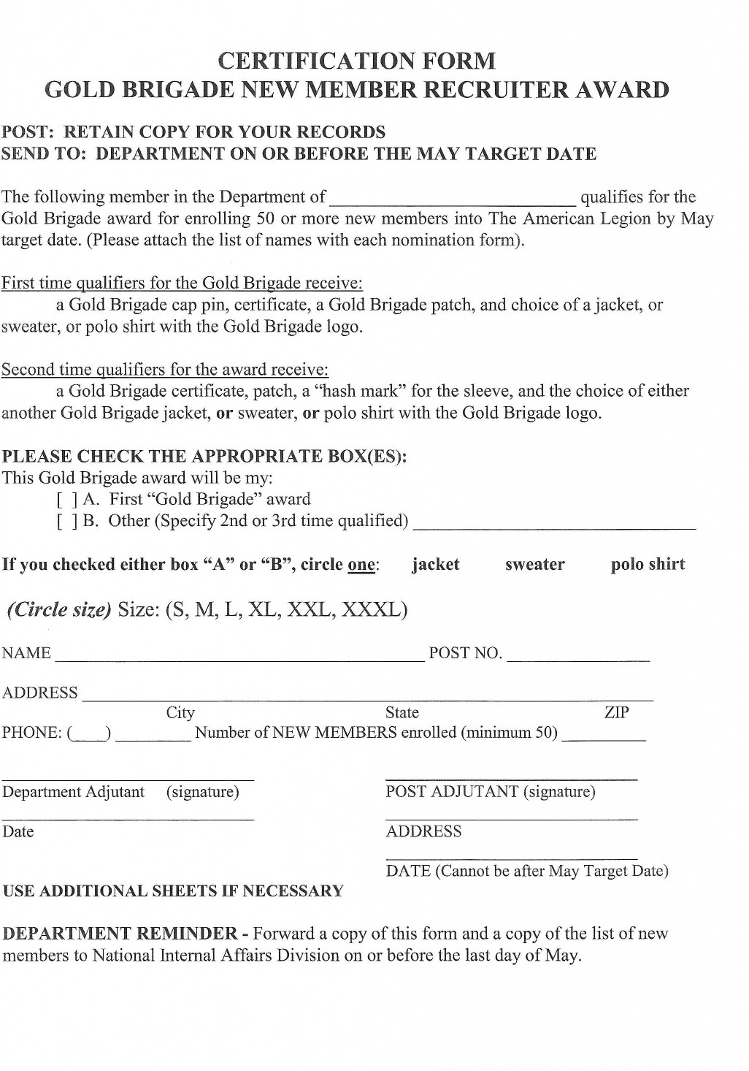

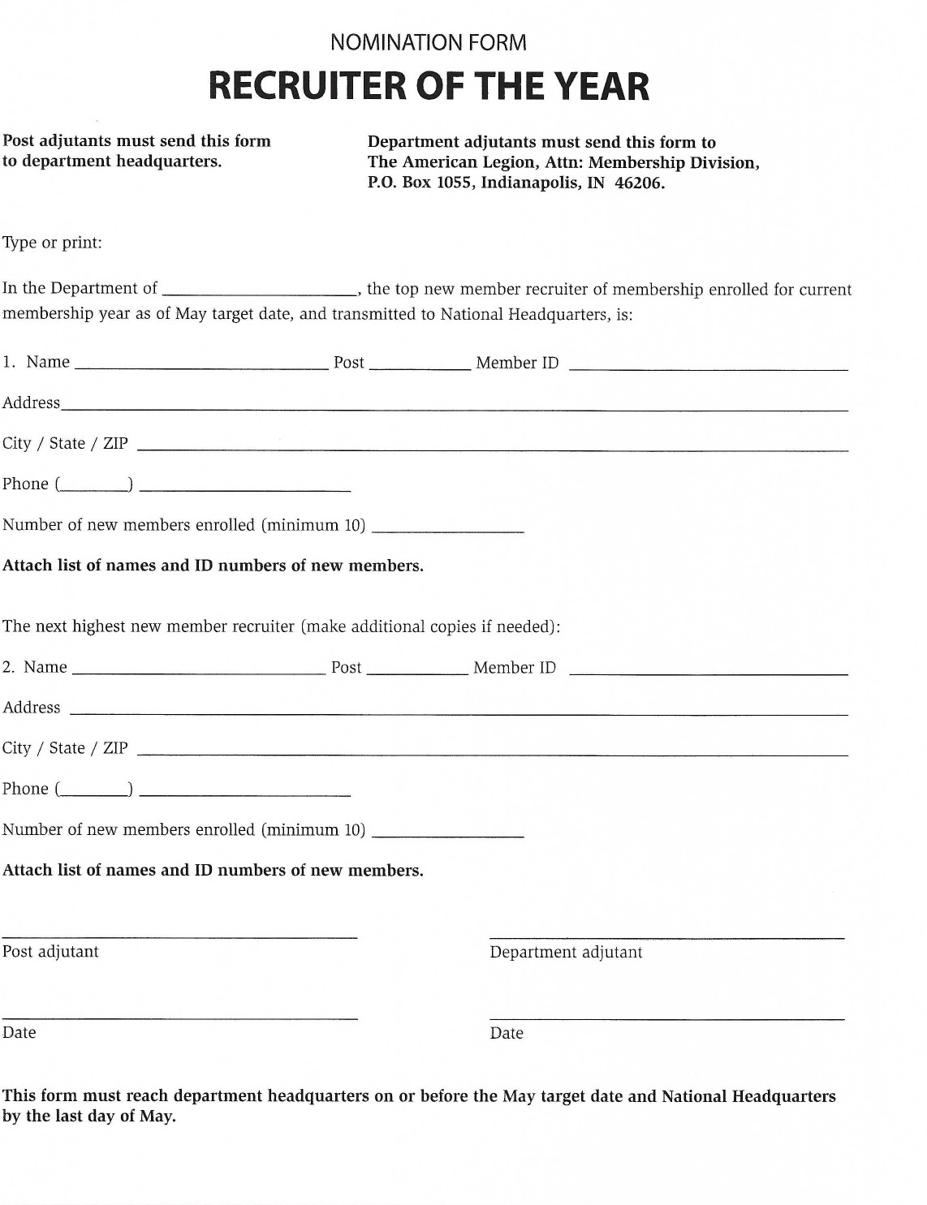

MEMBERSHIP PROCESSING

Thank you for taking on this huge responsibility. The main thing to remember is that we are here at Department and National to answer any of your questions and to help in any way we can. Never hesitate to call us.

National Headquarters 1-800-433-3318
Department of Minnesota 651-291-1900 1-866-259-9163

General Information

Ask to see the Post Adjutant’s manual for complete details on your responsibilities as the head of your Post’s membership team.

Please respond in a timely manner to requests for information from Department.

Report all changes of addresses or deaths promptly, especially if it is for a Post officer.

Sign all Member Data Forms when doing transfers or updating Continuous Years. We will return them for a signature if we catch them, or National will return it to us.

Send all Member Data Forms to Department, not to National.

Changes to a member’s record (address changes, deceased, continuous year) can be done using myLegion.org.
Post Membership Procedures
These comments are intended to provide a quick reference to the overall membership process. For complete details, you will need to refer to the Adjutant’s Manual.

In late June be ready to pick up your post membership packages from your District Vice Commander or County Council Commander.

- The members will receive their renewal notices from National in July.
- Review your membership package and develop a team approach to obtain the membership dues.
- Be aware of your membership goal
- Submit any corrections related to the members’ information on a “Member Data Form” or make the change at myLegion.org.
- Keep your membership roster information current.
- Submit any paid memberships to the Department at least on a weekly basis.
- The department updates the Post/District/Department membership status weekly reports (Bulletins). Bulletins will be available on Thursday on the Department website.
- The members may receive another notice from National if the dues are not sent to Department in a timely manner.

Conduct a membership drive whenever there may be a forthcoming rally.

All Memberships should be paid by the first of the year.
- If not, those members that have not paid become delinquent.
- Review membership status at post meetings.
- Request assistance from the post members to obtain delinquent members.

myLegion.org

The American Legion National Headquarters has designed a secure internet site to assist Post Officers in their day-to-day membership processing duties and record keeping. There is no charge to use this site, but you must register using your email on file at National Headquarters. If you do not know what email you have on file, please contact your Post/District Commander or Adjutant; they can look it up. The Post/District Commander and Adjutant are given access automatically based on the Officer Report submitted to Department Headquarters. They may grant permissions to anyone in their Post/District to use the site.
*MyLegion converted to a new online platform in April 2021. In order to access it, you must first register your email; your previous login and password information will not work.
Within the Post level MyLegion.org site you will be able to:
- Generate Membership Rosters and mailing labels.
- Transmit dues for paying members (renew, new or transfers).
- Find potential members by retrieving lists of Headquarters and expired members in your area.
- Perform “Member Data Form” changes online for your members.
- Look up members not a member of your post (need membership # or full name and Post Number).
- Download Manuals, Brochures and Suggested Speeches.
- Communicate with members of your post that are enrolled in MyLegion.org by publishing your Post newsletter or posting a message.
Again, this site is free of charge. Currently there are some training materials on the Legion.org under resources “How to Use myLegion.org.” Also, as the site develops, Department will have some step by step instructions available on how to use various features. It will also have a schedule for any upcoming zoom training on the site. This can be found under myLegion training. If you are unable to get online or need additional assistance navigating your new mylegion site, we encourage you to contact one of the members of the Training Committee listed below:

Jennifer Havlick
218-206-5796
Jennifer.havlick@outlook.com
Linda Dvorak
952-457-2129
LDvorak56@gmail.com

How to generate membership labels

Step 1: Log on to mylegion.org
(If you have not used the new version of mylegion since April 2021, you must first register with your personal email.)

Step 2: Click on the yellow box “My Account”

Step 3: Click on “My Groups”

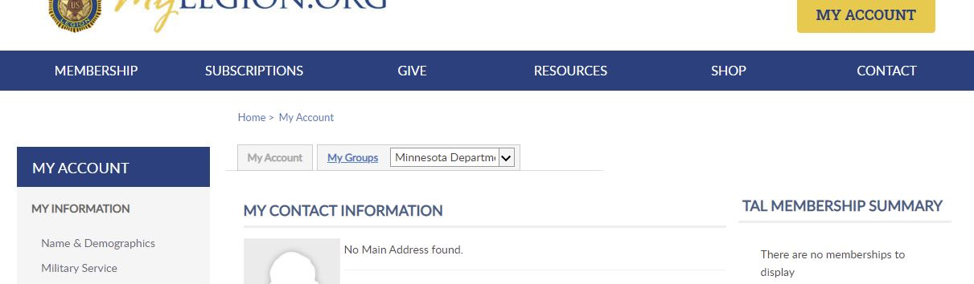

Step 4: On the left side, under MY VIEWS, Select “Reports/Labels”
Step 5: Select “Legion 3x10 labels”

Step 6: From the drop down, select the last paid year and then “view report”

Step 7: Click on the disk icon to export your file in your preferred format. (We would recommend PDF if you do not wish to make adjustments to the data)

Membership Cards

You will receive two kinds of membership cards: pre-printed and blank. Cards were printed for members who were listed on your post’s roster as of April when the records were pulled. The blank cards are to be used for new or transferring members who are paying their dues to your Post or for any member who may have been missed in the pre-printed cards.
A card must be submitted for every member paying his or her dues. You need to send two (2) parts of the card marked “(Current year) The American Legion Record” and “Department Card (Current Year)” to Department. Do not separate the two parts of the card. See the back of the card for instructions on how to complete.
Cards should not be submitted to Department if the Post is processing their membership online through mylegion or if the individual member renews their dues online.

Helpful Hints

- Separate checks and transmittals are needed for EACH year of the TAL membership and SAL membership. Each are recorded into different ledgers and computer programs for each year.

- When filling out new cards, be sure to use the complete name and address. Both parts of the card must be completed.

- Do not send member data forms for new members. Send only the completed two-part card for any new members during the year.

- Only National can assign a membership number.

- Do not make address changes on the cards. This should be done using a Member Data Form, or at National’s website, www.mylegion.org.

- Keep member data forms and membership cards separate. They go to two different departments at National and are separated as soon as we open the envelopes here at Department. Send them in the same envelope if you like, but do not staple/clip the cards and forms together or wrap the forms around the cards.

- Keep a record of cards you send to Department with each transmittal. If you are not sure whether a member has paid or not, please call National or Department or look on MyLegion.

- Please do not send a card unless the member is actually paying their dues to your Post.

- If the member is a Paid Up For Life (PUFL) member, do not send a card for him or her.

- Do not send in cards for members who have paid online either on their own or through the Post Online account with myLegion.

- Posts will now receive credit toward their goal for those paid members transferred from Post 1982-AD (National’s holding Post). This does not include paid transfers from local posts or Department at Large (1982-MN).

- Your Post will receive an annual credit statement in September with credit for all of your Post’s PUFL.

- Please be aware of the membership renewal schedule on page 1. This information will tell you when the next renewal notice will go out and when the information will be extracted from the database for those notices. You will want your membership into Department by noon the day prior to that renewal cut off in order to prevent your members from getting additional billings.

REMEMBER THAT THE POST IS RESPONSIBLE FOR PAYING THE DUES OF ITS HONORARY LIFE MEMBERS. THESE SHOULD BE PAID AS SOON AS YOUR CARDS ARE RECEIVED.
Eligibility

Thanks to the LEGION Act (Let Everyone Get Involved In Opportunities for National Service Act), Congress expanded the current eligibility period to cover Dec. 7, 1941, to the present, and includes the current war campaigns. Previously, there were seven declared war periods. Now there are two, the current war period dating back to World War II and another war era covering World War I.

MEMBER DATA FORMS

The four-part Member Data Form is to be used to report any changes for Legion Members. This form should be used to report TRANSFERS, ADDRESS CHANGES, NAME CHANGES, CONTINUOUS YEARS, or to report a DECEASED member.

For further instruction, please read the back of the form.

Send all forms to Department, not to National—they will be processed at Department then forwarded to National.

Please do not staple or wrap membership cards inside Membership Data Forms. They should be bundled with the rest of the cards with the transmittal.

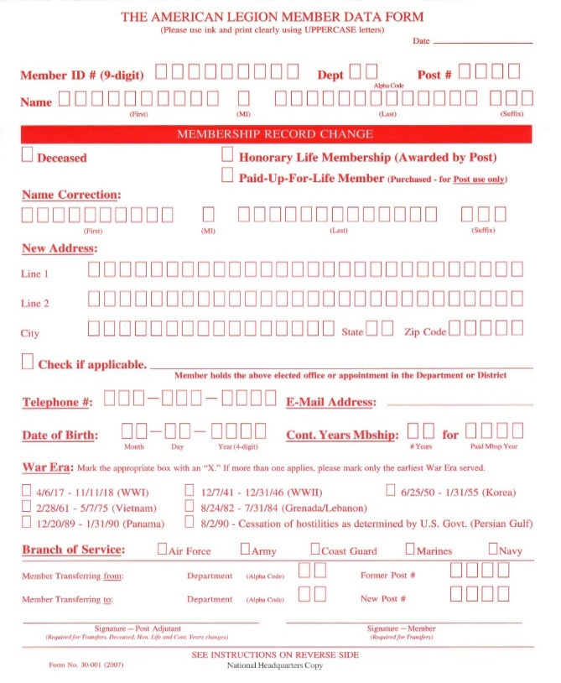

These changes can also be made online at myLegion.org and no paperwork needs to be submitted. The only time a member data form must be submitted to Department is in the case of a membership transfer when the member has already paid their dues to their previous Post.

Online Renewal Processing

American Legion members will receive renewal notices six times a year. When members receive their renewal notice, they will have the option to pay their dues online.
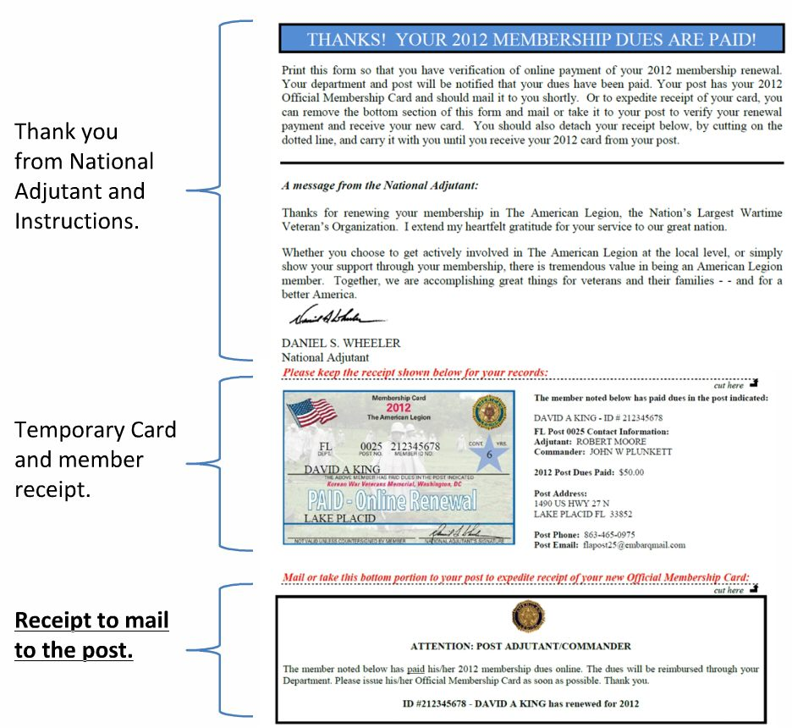

The first portion is a thank you from the National Headquarters. The next portion is a temporary card and a receipt of dues paid. The last portion is a receipt of dues paid that the member can mail to the post to indicate that their dues have been paid. When the post receives this receipt portion, the post should mail the member their official membership card along with any other material the post typically sends to their renewed members that renew through the traditional process. The Post then needs to discard the other two remaining parts of the membership card.

ONLINE POST TRANSMITTALS

All Posts in the Department of Minnesota can now process their membership online through MyLegion.org. If you are not the Commander or Adjutant, you must be granted online management permission by the Post Commander or Adjutant.

The “Process Membership” feature in MyLegion.org allows American Legion Post Officers to renew, add new members and transfer in existing members from other posts. Posts can only transfer in members who have not paid their current years dues. This feature utilizes electronic payment methods and eliminates the need for Post Officers to send the National/Department portion of the (3-part) membership cards and paper checks to Department.

ELECTRONIC CHECK (ECheck) PROCESSING GUIDELINES

The processing time for EChecks is 5-8 business days. During the 5-8 business day period, a “Pending” charge will be placed on the funds in the checking/savings account designated by the American Legion Post. In addition, the “Processed Date” will be blank on the Transmittal History Report and the “Stated # of Members” will reflect the number of members being processed. After a successful transfer of funds to the bank at National Headquarters, the “Processed Date” will change to the date processed and the “Actual # of Members” will reflect the number actually processed. The member information will be applied to the National Database.

Electronic Check (ECheck) is the only payment method available when using this feature. The account must be a valid business checking or savings account held with a US Bank. Credit Cards payments are only accepted for foreign Posts outside the US that do not have a checking/savings account with a US Bank.
In the event a membership batch is declined, an email will be sent to the post and the batch will not be processed. Declined batches can be re-submitted within 14 days. If not re-submitted with the 14-day period, the batch will be deleted.
The Post will be charged all penalty fees levied by the ACH (Automated Clearing House) processor for declined EChecks. Common reasons for declined EChecks are:
- Insufficient Funds
- Bank Account has been closed
- Invalid Bank Information
The American Legion National Headquarters reserves the right to suspend the “Process Membership” feature for a Post at any time due to a high volume of declined transactions, or malicious use of the MyLegion.org site.
STEPS TO PROCESS MEMBERSHIP ONLINE
Log onto MyLeigon.org, select your Post from the drop down in the My Groups section and click on the “My Groups”. On the left had side under My Views, select “Process Membership”

Step 1: Select the members you want to renew by clicking the “select” box next to the member you want to renew.
To add a new member or transfer-in a member select the Add or Transfer Member option. You can add a new member (someone who has never been a member of the Legion or SAL) or you can transfer in a former Legion member or a current member (as long as they have not paid their current years dues). Make sure to enter all the required information (marked with a red “*”). If any required information is missing the addition will not process.

Step 2: Select “Finalize”. You will be asked to confirm the members you wish to renew/add/transfer. It also gives you the total amount that will be automatically deducted from your bank account. Please note that the amount designated to go to the Post is actually the District dues plus $.25 goes to the Legion Hospital Association.
If your banking information has not been set up, you will be asked to set it up prior to finalizing the transmittal.

Step 3: Once you finalize your transmittal, you will receive a confirmation, that you can print. It shows your transmittal number. It will also show, the number of cards submitted, total amount charged to your bank account and the date it was submitted.

Step 4: Mail the member their portion of the three-part membership card. DO NOT send the other two parts to Department.

If additional assistance is needed, please call National at 1-833-253-9995.


Paid Up For Life (PUFL) membership
Anyone who is currently an American Legion member or who is eligible for membership may become a PUFL member.

Legionnaires can apply for membership online at www.legion.org/pufl. After providing a name and member ID number, the member will receive a price quote, then he/she can pay by credit card, or print out a personalized form and mail it in with a check, money order or credit card information. Those without a member ID number can contact Customer Service at 1-800-433-3318 for their personalized offer.

Lifetime membership can be paid either in one single lump sum or over 12 equal, monthly payments. If a member chooses the Time Pay Plan, payment must be made by credit card only. (Check for online promotions if paying in full.) Once a member fulfills the PUFL membership dues, he/she will be protected from any future dues increases at the post, department or national levels.

All PUFL applications must be submitted to National Headquarters by one of three methods:

1. Online applications: The member can obtain a rate quote online at www.legion.org/pufl. Once the quote is received, the member can opt to apply online and their personal information will appear for confirmation. Once confirmed and payment information is entered, the member clicks “Submit” to finish the application process. Note: If no internet access, the post or department can perform the process. A link to the PUFL application page has been added to myLegion.org for posts and departments.

2. Printable applications: The member obtains a rate quote online at www.legion.org/pufl. Once the quote is received, the member can opt to print an application to complete and mail to National Headquarters. The application will be pre-filled with the member’s name, address, birth date, ID number and the total cost of PUFL membership. (Any updates to member’s record can be noted on the application.) The member simply mails the application and payment to National Headquarters at the address on the form. Note: For those without internet access, the application should be printed by the post or department and forwarded to the member for completion. A link to the PUFL application page has been added to myLegion.org for posts and departments.

3. Call Customer Service: Members can speak to a customer service specialist by calling 1-800-433-3318. They can answer questions regarding the PUFL program as well as print and mail PUFL applications or take them over the phone. Note: This should not be considered the primary procedure, as members, posts and departments have this ability.

The rate chart listed below applies to post dues of $48.00 or less (Majority of post dues are $48 and below). If a post’s annual dues are $48.01 or higher, the rate chart does not apply. In that case, the online calculator, located at www.legion.org/pufl, will provide the correct amount to be charged.

Some posts purchase a Paid-Up-For-Life membership for their long-time members, and in calculating the cost to remit, the authorizing post officers may choose to leave out some or all of their share of the post dues which will reduce the amount to submit with the application. If this is an option being considered by the post, the post adjutant must contact Customer Service for the correct fee.

Paid Up for Life Pricing – Effective June 2016
(For post dues of $48.00 or less)
Age | 18-29 | 30-39 | 40-49 | 50-59 | 60-69 | 70-79 | 80-89 | 90+
Fee | $1,535 | $1,399 | $1,229 | $1025 | $815 | $599 | $429 | $329

Effective June 1, 2016 all previous rate charts are superseded.

When paid in full, the member will receive a permanent plastic card identifying him/her as a lifetime member. The PUFL member will also continue to receive an annual American Legion membership card mailed directly on or about July 1st of each year.
If a member chooses the monthly payment option and cancels or defaults, the member will not be eligible to participate in the monthly payment plan in the future. However, the member may resubmit an application with full payment at any time. Any funds previously submitted on the cancelled account will not be credited to the new application.
Once National Headquarters receives and processes an application, the member’s post will be notified and allowed 30 days to challenge. Departments will be copied on the notification.
There will be no refund of dues already paid (time or full pay) if the member chooses to cancel his or her membership, discontinue participation in the monthly payment plan, or if National Headquarters must close an account due to delinquency.
Should a PUFL member hold membership in a post whose charter has been canceled, and is unable to transfer to a local post, the member will be transferred to their respective department headquarters post. In the event that the member is expelled by action of his/her post or department headquarters, the unused portion of the PUFL fee, if any, may be reviewed upon recommendation of the post and department with final decision by National Headquarters for any possible refund. A PUFL member may transfer to another participating post with the acceptance of the gaining post.

Weekly Membership Transmittal Form
A transmittal form like the one copied below must accompany every transmittal you send in from your Post. The forms for the membership year will have the year printed on them and a supply is in your packet. When you need more, call or email to Department. Please discard old transmittal forms, as the monetary amounts have changed and lead to inaccurate totals when submitting the incorrect form. Please keep on hand only the past membership year transmittals and the current year transmittals.
Please be sure to fill the form out completely and correctly. All lines must be completed.
Do not staple your check or cards to this form, simply fold the transmittal in half with the cards and check inside.
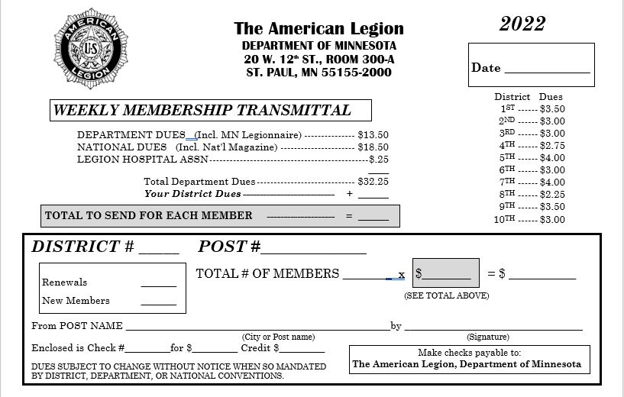

Directions to sign on for the new mylegion.com

My Legion.org:

The first and biggest new thing regarding myLegion.org changes is that you have to use YOUR personal email. The days of the old system of using a common email or a post email are gone. 90% of all issues accessing the site is that people want to use their old username and password. Also, you will not get access unless you have an email.

Two people cannot use the same email address.

The next change is that the Commander and Adjutant now have access, however again, they need to use their own email. Access is given based on title so this makes it even more important to complete the Officer Reporting Forms after elections. If you are a new Commander and don’t have access, verify with the Adjutant that the forms were submitted.

What about other members who need access to the program? The Commander and/or Adjutant can give access, however anyone they give access to must use their personal email to get into the program.

As this is a new program, you will need to enter your bank account information
again, in order to process membership. It will take about 10-14 days to process. Once this transmittal is approved, you will not have to enter it again.

After getting into the program, most of the actions you were able to do in the old program are available in the new. There is a different look but it does flow fairly well.

